**A Project Report**

**On**

**(Project I: PRJ 151)**

**Title of the Project:**

**BANKING MANAGEMENT SYSTEM PROJECT IN C**

**Submitted by:**

|  |  |
| --- | --- |
| **Farhan Alam**  **Bhumika Devkota**  **Khushi Lamichhane** | **Exam Roll NO:22530193**  **Exam Roll NO:22530186**  **Exam Roll NO:22530198** |

**Under the Guidance**

**of**

**Mr. Dipendra Silwal sir**

**Submitted to the Faculty of Science and Technology,**

**OCEM**

**in partial fulfilment of the requirements for**

**Second Semester Bachelor of Computer Application (BCA)**

**Year: 2023**



**Gaindakot-2, Nawalparasi**

**Nepal**

**CERTIFICATE OF AUTHENTICATED WORK**

This is to certify that the project report entitled **BANKING MANAGEMENT SYSTEM PROJECT IN C** submitted to **Department of Bachelor of Computer Application,** **Oxford College of Engineering and Management** in partial fulfilment of second semesteris an original work carried out by:

|  |  |
| --- | --- |
| **Farhan Alam**  **Bhumika Devkota**  **Khushi Lamichhane** | **Exam Roll NO:22530193**  **Exam Roll NO:22530186**  **Exam Roll NO:22530198** |

Under our guidance and supervision. The matter embodied in this project is authentic and genuine work done by the group and has not been submitted in other college/institution/University for the fulfilment of the requirement of any course of study.

|  |  |  |
| --- | --- | --- |
| ……………  Name of the Project G.  Project Guide | ………………..  Name of the External Examiner  External Evaluator | …………………  Dipendra Silwal  HoD, BCA |

**ACKNOWLEDGEMENT**

I would like to express my deep gratitude and sincere gratitude to everyone who contributed to the encouragement and support needed to bring this project to fruition. Special thanks to my supervisor, Mr. Dipendra Silwal, who was of great help to me, whose insightful suggestions and steadfast encouragement were essential in guiding the progress of the project. This. I am sincerely grateful for the opportunity to undertake this difficult task under your guidance.

Furthermore, I would like to express my sincere thanks to the reviewers, especially for their meticulous reviews and feedback throughout the review process. Their insights and suggestions were very valuable in completing and improving the quality of this project. Special thanks to my dear friend Kristina Shrestha, whose technical and emotional support has been integral to this journey. Their unwavering support has significantly contributed to overcoming technical obstacles and maintaining high morale.

I would also like to thank our respected BCA Head and Final Project Coordinator, Mr. Dipendra Silwal, for their kind endorsement and unwavering support throughout this endeavor. Their support is the driving force behind this effort. . I would also like to acknowledge with much appreciation the crucial role of the Examiners who examined this project till this moment.

Finally, I would like to express my sincere thanks to my friends and supporters, whose spiritual support is a constant source of encouragement. Your trust in me has been a driving force and I will be forever indebted to each of you.

In conclusion, I am extremely grateful for the spirit of collaboration that permeated this project. Your shared contributions have enriched this journey and made it possible.

**ROLES AND RESPONSIBILITIES FORM**

**BANKING MANAGEMENT SYSTEM PROJECT IN C 23 August 2023**

|  |  |  |
| --- | --- | --- |
| Name of the team Member | *ROLE | Tasks and Responsibilities |
| 1. Farhan Alam | Overall Operation (Team Coordinator , tester and Designer. | * Overall designing, coding * Testing the project |
| 1. Bhumika Devkota | Overall presentation  (Presenting the project) | * Making the presentation * Giving the presentation |
| 3.Khushi Lamichhane | Overall documentation  ( Making the synopsis and report for the project | * Documenting the project * Making report for the project |

Name and Signature of the Project Team Member/s: Signature

1. Farhan Alam :……………………….
2. Bhumika Devkota :……………………….
3. Khushi Lamichhane:……………………….

Signature of the Project Guide :…………………….. 08 October 2023

**ABSTRACT**

The banking management system, developed through the use of the C programming language, represents a seamless combination of modern technology and smart banking methods. It strives to redefine and improve the operating landscape of banking institutions by offering a comprehensive and accessible solution that covers many essential functions. From its inception, the system welcomes users with a warm and informative intro page, guiding them seamlessly to an intuitive and refined banking experience. After proceeding, the user will be directed to a secure login interface, which will carefully protect sensitive personal information, thereby providing a sense of trust. Upon successful completion of the authentication process, users will see a multifaceted main menu that serves as a gateway to a host of must-have features. These features cover a wide range of operations from ongoing account setup and management to displaying account details. In addition, the system also supports the effective search of the target account, proficiently supervises the careful closing of the account, and coordinates the correct execution of transactions including withdrawals, deposits and transfers between funds. Accounts.

A notable property of the system is the meticulous monitoring of login credentials, an aspect that contributes significantly to the most important principle of data security. In addition, the ability to have a streamlined application exit process underscores the system's unwavering commitment to ensuring user convenience throughout their interactions. This abbreviated overview serves as a window into the fundamental aspirations of the project, illuminating the project's ability to comprehensively address a wide range of banking activities. By seamlessly combining sophisticated technological design with the bank's pragmatic acumen, the system marks a significant step forward in the ongoing modernization of banking procedures, and at the same time adhere to the two pillars of security and user orientation.

Table of Contents

**Chapter 1: Introduction 1**

**1.1 Introduction 1**

**1.2 Objectives: 1**

**1.3 Scope and Limitation: 2**

**Chapter 2 : Requirement Analysis and Feasibility Study 3**

**2.1 Related works 3**

**2.2 Requirement Analysis 4**

**2.2.1 Functional requirements 4**

**2.2.2 Non functional requirements 6**

**2.3 Feasibility analysis 7**

**2.3.1 Economic feasibility 7**

**2.3.2 Operational feasibility 7**

**2.3.3 Technical feasibility 7**

**2.3.4 Schedule Feasibility (Reflection using a PERT chart/Gantt chart) 8**

**2.4 Structuring system requirements 10**

**2.4.1 Process Modeling 10**

**2.4.1.1 Flowchart 11**

**2.4.1.2 DFD (Context level 1, 2, …) 13**

**Chapter 3 : System Design 14**

**3.1 Flowchart 15**

**3.2 Data Flow Diagram 27**

**Chapter 4 : Coding of the System 29**

**Chapter 5 : Implementation and Testing 76**

**5.1 Implementation: 76**

**5.1.1 Tools used: 76**

**5.1.2 Description/class/methods/data structures or any other modules implemented 77**

**5.2 Testing 79**

**5.2.1 Unit testing 79**

**5.2.2 White box testing 79**

**5.2.3 Black box testing 80**

**5.2.3 System Testing 81**

**Chapter 6: Conclusion and Recommendation 82**

**6.1 Conclusion: 82**

**6.2 Recommendations 84**

**References 85**

**Book References 85**

**Web Reference 85**

**Table of Figures**

[**Fig: 1-Use Case Diagram 5**](https://d.docs.live.net/c2961c17404e6f86/Documents/Project%20Report%20Format%20actually.docx#_Toc144491579)

**Fig: 2-Pert Chart 8**

**Fig: 3-Gant Chart 9**

**Fig: 4-Main Module 15**

**Fig: 5-Login Module 16**

**Fig: 6-Menu Module 17**

**Fig: 7-New_acc Module 18**

**Fig: 8-Update_details Module 19**

**Fig: 9-View_all_acc Module 20**

**Fig: 10-Search_acc Module 21**

**Fig: 11 Delete_acc Module 22**

**Fig: 12-Transactions Module 23**

**Fig: 13-Update-Login_Credentials Module 24**

**Fig: 14-Close_app Module 25**

**Fig: 15-Interest_Check Module 26**

**Fig: 16-0 Level DFD 27**

**Fig: 17-Level 1 DFD 28**

**Fig: 18 Welcome Module 83**

**Fig: 19 Login Module (Positive) 84**

**Fig: 20 Login Module (Negative) 84**

**Fig: 21 OTP Module(Positive) 85**

**Fig: 22 OTP Module (Negative) 85**

**Fig: 23 Main Menu (Positive) 86**

**Fig: 24 Main Menu (Negative) 86**

**Fig: 25 New_acc Module_Personal Information(Positive) 87**

**Fig: 26 New_acc Module_Address Information 87**

**Fig: 27 New_acc Module_Account Information 88**

**Fig: 28 New_acc Module(Negative) 88**

**Fig: 29 Update_acc Module_Mobile_no(Positive) 89**

**Fig: 30 Update_acc Module _Address(Positive) 89**

**Fig: 31Update_acc Module (Negative) 90**

**Fig: 32Update_acc Module_Mobile_no(Negative) 90**

**Fig: 33Update_acc Module _Address(Negative) 91**

**Fig: 34 View_all_acc Module(Positive) 92**

**Fig: 35 View_all_acc Module(Negative) 92**

**Fig: 36 Search_acc Module(Positive) 93**

**Fig: 37 Search_acc Module_Account_no(Positive) 93**

**Fig: 38 Search_acc Module_Account_Name(Positive) 94**

**Fig: 39Search_acc Module(Negative) 94**

**Fig: 40 Search_acc Module_Account_no(Negative) 95**

**Fig: 41 Search_acc Module_Account_name(Negative) 95**

**Fig: 42 Delete_acc Module(Positive) 96**

**Fig: 43 Delete_acc Module(Negative) 96**

**Fig: 44 Transaction Module(Positive) 97**

**Fig: 45 Transaction Module_Balance_Enquiry(Positive) 97**

**Fig: 46 Transaction Module_Withdraw(Positive) 98**

**Fig: 47 Transaction Module_Deposit(Positive) 98**

**Fig: 48Transaction Module_Fund_Transfer(Positive) 99**

**Fig: 49 Transaction Module(Negative) 99**

**Fig: 50 Transaction Module_Withdraw(Negative) 100**

**Fig: 51 Transaction Module_Withdraw(Positive) 100**

**Fig: 52 Transaction Module_Fund_Transfer(Negative) 101**

**Fig: 53 Update_Login_Credentials(Positive) 101**

**Fig: 54 Update_Login_Credentials_UserName(Positive) 102**

**Fig: 55 Update_Login_Credentials_Password(Positive) 102**

**Fig: 56 Update_Login_Credentials_UserName&Password(Positive) 103**

**Fig: 57 Update_Login_Credentials(Negative) 103**

**Fig: 58 Update_Login_Credentials_UserName(Negative) 104**

**Fig: 59 Update_Login_Credentials_Password(Negative) 104**

**Fig: 60 Update_Login_Credentials_UserName&Password(Negative) 105**

**Fig: 61 Close_app Module 105**

# Chapter 1: Introduction

## 1.1 Introduction

In a dynamic customer service and financial management landscape, efficient banking systems play a vital role in facilitating secure transactions and personalized customer experiences. The "BFK Bank Management App" project is a comprehensive project aimed at streamlining banking operations, improving customer interaction and providing a user-friendly platform for account management . This report explores the project in-depth, outlining its design, features, and how it positively impacts the banking industry.

## 1.2 Objectives:

The objectives of the "BFK Bank Management Application" project are as follows:

* Develop a user-friendly banking application that allows customers to access and manage their accounts seamlessly.
* Implement a secure and efficient account creation process to enable users to establish their accounts online.
* Provide customers with real-time access to their account balances.
* Enable customers to initiate various types of transactions, including fund transfers, withdrawing funds or depositing funds.
* Incorporate interest calculation mechanisms for different account types to ensure accurate and transparent interest accrual.
* Design an intuitive user interface that enhances the overall user experience and promotes easy navigation.
* Enhance data security by implementing robust authentication mechanisms and encryption protocols.
* Facilitate scalability to accommodate a growing user base and potential future enhancements.

## 1.3 Scope and Limitation:

The "BFK Bank Management Application" project encompasses the following technologies, features, domains, and algorithms:

* **Technologies:** C programming language, File I/O operations, User interface design, Data structures.
* **Features:** Account creation, Account management, Transaction processing, Interest calculation, User authentication, Updating login username and password.
* **Domains:** Banking, Financial management, User experience design.
* **Algorithms:** Interest calculation algorithms, Data validation algorithms.

**Limitations:**

* The project does not involve integration with real banking systems or actual financial transactions.
* While security measures are implemented, the project does not guarantee full protection against all potential security threats.
* The application does not provide real-time market data or investment advice.
* Complex financial scenarios and advanced investment strategies are beyond the project's scope.
* The project does not cover mobile app development or integration with mobile devices.
* Multi-platform compatibility and browser-based access are not within the current scope.
* Language support for languages other than English is not included in this version.

The scope and limitations outlined above define the boundaries and functionalities of the "BFK Bank Management Application" project, ensuring a focused and achievable development process.

# Chapter 2 : Requirement Analysis and Feasibility Study

In this chapter, we delve into the foundational aspects of the "BFK Bank Management Application" project by conducting a comprehensive requirement analysis and feasibility study. This phase is crucial to understand the project's scope, functional and non-functional requirements, and its viability from various angles.

## 2.1 Related works

Modern Banking by Shelagh Heffernan Professor of Banking and Finance, provides an overview of the modern trends that are shaping banking systems. The book explores the technological advances, customer expectations, and regulatory changes that have influenced the development of banking software. The book emphasizes the importance of flexible and adaptable software solutions to meet the dynamic needs of the financial industry.

The work significantly improved understanding of the project's topic in several respects. It highlights modern banking trends such as mobile banking, data security and user-friendly interface. It also highlights the challenges and opportunities of evolving the banking system, including security, compliance, and scalability. This idea laid the foundation for the design of a complete banking management system.

The project is part of existing research, addressing identified challenges through modern technologies such as cloud computing and mobile apps, prioritizing data security, and adopting user-centered design. center. By addressing these aspects, the project enriches the understanding of banking management systems and becomes a valuable resource for financial institutions looking for software improvements.

Combining a variety of sources, such as academic journals, industry reports, and interviews with experts, the project team devised a well-informed plan. Their commitment to a secure, user-friendly and efficient system, as well as the sharing of results, exemplify their dedication to improving banking software. 

## 2.2 Requirement Analysis

A system requirements analysis is a complete description of the behavior of the system to be developed. It includes a set of use cases that describe all of the interactions that the users will have with the system. In addition to use cases, the system requirement analysis contains functional requirements, which define the internal workings of the system: that is, the calculations, technical details, data manipulation and processing, and other specific functionality that shows how the use cases are to be satisfied. It also contains nonfunctional requirements, which impose constraints on the design or implementation (such as performance requirements, quality standards or design constraints).

### 2.2.1 Functional requirements

In this section, we look at the essential functional requirements of the project, described and organized through a use case diagram. Use case diagrams are a valuable tool for visualizing interactions between different actors and the system itself, illustrating how users and external entities will interact with system functionality. .

Use case diagrams capture the main use cases of the system, detailing specific tasks and actions that users and other stakeholders can perform. It describes the different scenarios in which the system will be used and demonstrates the roles of the different actors in these scenarios.

In a nutshell, use case diagrams provide a complete visual representation of functional requirements, acting as a bridge between project goals and technical implementation. It helps align stakeholder expectations, guides the development process, and ensures that the resulting system effectively meets the needs of users and stakeholders.

**Use Case Diagram**

Fig: -Use Case Diagram

**User**

### 

### 2.2.2 Non functional requirements

A system's non-functional requirements define its quality attributes and characteristics that contribute to its overall performance, usability, security, etc. These requirements often underpin the user experience and system reliability.

1. Efficiency:

The system must ensure fast response times to user interactions and transactions, even during peak usage times.

1. Usability:

The user interface should be intuitive and easy to navigate, catering to users with varying levels of technical expertise.

1. Protect:

Systems must comply with industry standard security protocols to protect sensitive customer data and prevent unauthorized access.

1. Ability of extension:

As the user base grows, the system must scale efficiently to accommodate the increased user base and data volume.

1. Compatibility:

The system must be compatible with a variety of devices and platforms to meet different user preferences.

1. Data integrity:

All user data and transaction records must be stored and maintained correctly, to avoid data corruption or loss. Maintainability:

The system should be designed in a modular and organized manner, facilitating future maintenance and updates.

1. Documentation:

Comprehensive documentation should accompany the system, helping users, administrators, and developers understand the system's features and configuration.

This section includes a complete analysis of the functional and non-functional requirements of the project. Use case diagrams visually depict functional aspects, while non-functional requirements highlight various quality attributes that are critical to the success of the system. These requirements provide a solid foundation for the next phases of design, development, and implementation.  

## 2.3 Feasibility analysis

Feasibility analysis is an important stage in project appraisal, which scrutinizes the feasibility of the project from multiple perspectives. This comprehensive assessment involves assessing the economic, operational, technical and planning aspects to determine the feasibility of the project and its potential for successful implementation.

### 2.3.1 Economic feasibility

The economic feasibility study considers the financial viability of the project. It includes cost estimates related to software development, hardware, training, and maintenance. These costs are then weighed against the expected benefits, including improved efficiency, cost savings, and potential revenue growth. By performing this analysis, stakeholders gain a better understanding of the financial implications of the project and whether it aligns with the strategic goals of the organization.

### 2.3.2 Operational feasibility

 Operational Feasibility measures the suitability of the proposed system with the organization's existing processes and resources. This assessment involves looking at factors such as employee training, change management strategies, and the potential impact on day-to-day operations. By ensuring the system can be seamlessly integrated into the existing operational framework, stakeholders can anticipate challenges and proactively address potential disruptions.

### 2.3.3 Technical feasibility

Technical feasibility looks at whether the project can be developed efficiently using available technology and resources. This analysis assesses compatibility with existing IT infrastructure, availability of required technical expertise, and ability to integrate with other systems. Ensuring technical feasibility is essential to avoid potential roadblocks in the development process and to confirm that the proposed project matches the technical capabilities of the organization.

### 2.3.4 Schedule Feasibility (Reflection using a PERT chart/Gantt chart)

Schedule feasibility evaluates the ability of a project to complete on time. Using tools like PERT charts or Gantt charts, this analysis provides a visual representation of task dependencies, critical paths, milestones, and estimated deadlines. By reviewing the project schedule, stakeholders can identify potential bottlenecks, allocate resources efficiently, and make informed decisions to ensure timely project delivery.

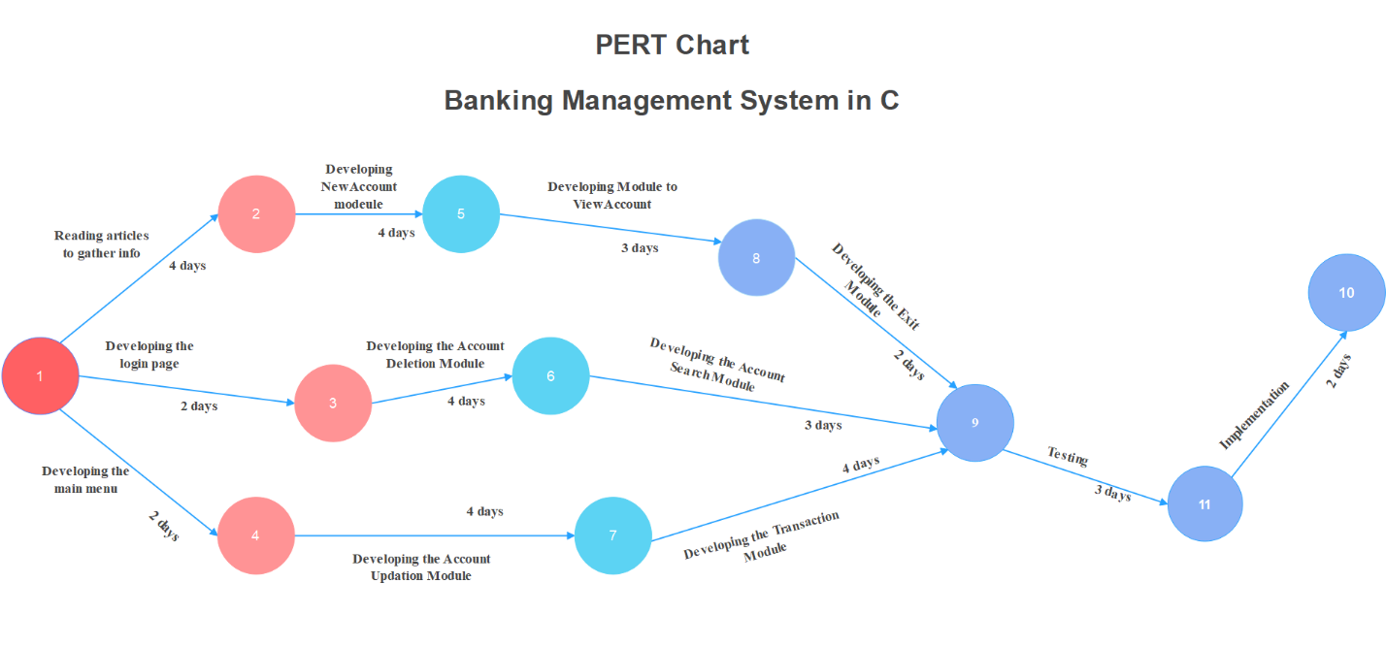

Fig: 2-Pert Chart

**Gant Chart**

**Banking Management System in C**

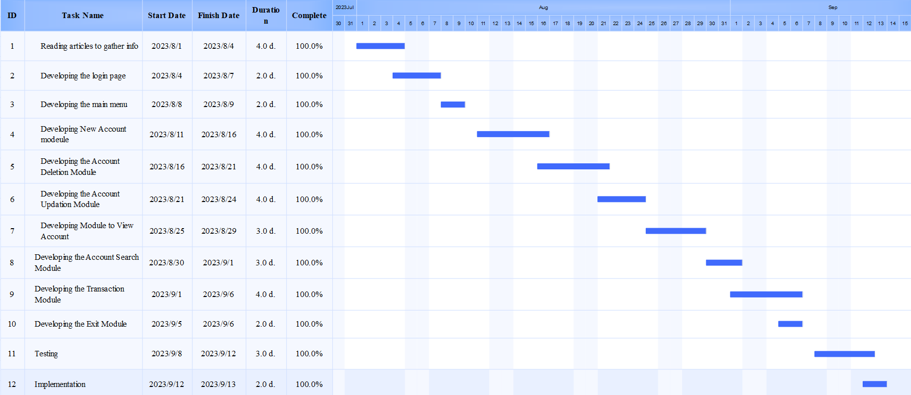

Fig: 3-Gant Chart

Feasibility analysis is an integral part of project planning, providing an overall assessment of a project's viability. By assessing the economic, operational, technical and planning factors, stakeholders gain a comprehensive understanding of the project's strengths, challenges, and potential areas for improvement. . This analysis informs decision-making, helps to reduce risk and establish a strong foundation for successful project execution and implementation.

# 2.4 Structuring system requirements

This includes the development environment and the operating system in which this Banking Management system is build. The type of processors required in the hardware to develop this application ranging from front end to back end.

**Hardware Requirement:**

**Processor:** Intel(R) Core

**Installed Memory:** 8.00GB

**Speed:** 1.70GHz or faster

**Operating System:** 64-Bit Operating system, x64- based processor

**Software Requirement**

**Operating System:** Windows 8.1

**IDE & Tools**: Microsoft Visual Studio, Codeblock

### 2.4.1 Process Modeling

Process modeling is an important aspect of systems analysis and design that deals with representing a system's processes, activities, and workflows in a visual format. It helps stakeholders understand how data and information flows through a system, how different components interact, and how different tasks are performed. Process modeling is essential to improving efficiency, identifying bottlenecks, and designing efficient systems.

There are a number of techniques and notations used in process modeling including flowcharts, data flow diagrams (DFDs), Unified Modeling Language (UML) activity diagrams, and modeling and signing. business process signal (BPMN), etc. Each technique has its own strengths and focuses on different aspects of the process. Here we will discuss two widely used process modeling techniques:

flowcharts and data flow diagrams (DFDs).

## 2.4.1.1 Flowchart

A flowchart is a graphical representation of a process, system, or algorithm that uses various symbols and arrows to illustrate the sequence of steps, decisions, and information flow. It provides an intuitive way to simplify complex procedures, allowing easy understanding and communication between different stakeholders. Flowcharts facilitate problem solving by highlighting process bottlenecks and inefficiencies, which makes them particularly useful in process optimization. They serve as a standardized documentation tool that captures logic and workflow. However, flowcharts have limitations in representing non-linear processes and managing high complexity. Overall, they are a powerful visualization tool for communicating processes, supporting decision-making, and providing a structured roadmap for tasks and projects.

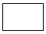

-step process diagram One step process. Step is written inside the box. Usually only one arrow comes out of the box.



- flowchart flow direction the direction of the flow from one step or decision to another.



- decision-making flowcharts Decisions are based on questions. The question is written in the diamond. More than one arrow appears from the diamond, each arrow indicating the direction the process is taking to get a certain answer to the question. (Often the answers are "yes" and "no.")



- delay or wait Delay or wait



- flowchart links to another page or flowchart Links to another page or flowchart. The same icon on the other page indicates the flow is still there.

- entry or exit of the diagram Enter or exit



- start and end points of flowchart Alternate symbols for start and end

**Advantages of Flowchart**

* Easy to make
* Communication becomes effective and easy to understand
* Mistakes can be easily identified
* Analysis becomes effective
* Synthesis becomes effectual
* Debugging becomes possible
* Logics can be easily interpreted.

**Disadvantages of Flowchart**

* Difficulty in presenting complex programs and tasks.
* No scope for alteration or modification
* Reproduction becomes a problem
* It’s a time-consuming process
* Difficult to understand for people who don’t know flowchart symbols.
* No man to computer communication.

## 2.4.1.2 DFD (Context level 1, 2, …)

A data flow diagram (DFD) is a structured graphical representation that illustrates how data moves through a system. It focuses on representing data flows rather than specific sequences of actions. DFD uses different symbols and connectors to visualize interactions between processes, data stores, external entities, and data flows.

At its core, DFDs consist of processes, which represent operations or transformations performed on data. These processes receive input data, process it, and produce output data. Data flows describe the routes by which data travels between processes, data stores (where data is stored temporarily or permanently), and external entities (source or destination of data). .

DFDs are categorized into levels, starting with a context level (level 0) that provides an overview of all the system's interactions with external entities. Subsequent levels (e.g. Level 1, Level 2) break down processes into finer subprocesses, providing a more detailed view of the data flow.

**Advantages:**

• It helps to describe the boundaries of the system.

• Beneficial for imparting existing knowledge of the system to users.

• Simple graphic technique, easy to recognize.

• DFD can provide a detailed representation of system components.

• It is used as part of the system documentation file.

**Disadvantages:**

• It makes the programmer a bit confusing about the system.

• The biggest disadvantage of a DFD is that it takes a long time to create, so long that the analyst may not get management support to complete it.

• Physical considerations are set aside.

# Chapter 3 : System Design

System Design is the process of designing the architecture, components, and

interfaces for a system so that it meets the end-user requirements. It provides the

understanding and procedural details necessary for the implementation. Here we use

flowchart to supplement the working of the new system. The function system design

should have elaborative output design, input design, file design and storing mechanism

inside the computer system, data and program processing and general program flow

design.

System design for banking application in C is based on user-centered design principles and modular architecture. The architecture is structured in layers that separate user interaction from data manipulation, thus creating a consistent and efficient system.

At the core of this design are the main modules responsible for specific functionality. The user management module ensures secure access through user authentication, thus protecting the system from unauthorized intrusion. The account management module supports account-related activities including creating accounts, updating details, and maintaining records. The transaction module manages financial operations such as deposits, withdrawals and transfers, ensuring the accuracy of these important operations. To address data security concerns, the security module implements user authorization and authentication mechanisms, with planned data encryption integration to protect sensitive information .

This design promotes user-friendly interaction, allowing users to easily enter data and obtain relevant results. The dedicated data processing layer manages the processing of account information and the execution of financial transactions. Users can manage their accounts and conduct transactions with confidence, being assured that the system will safely and correctly handle their financial affairs. In summary, system design takes a holistic approach, taking into account user needs, security measures, and modular organization. By integrating these aspects, the design creates a solid foundation for implementing a robust, efficient and secure banking management system in C.

## Flowchart

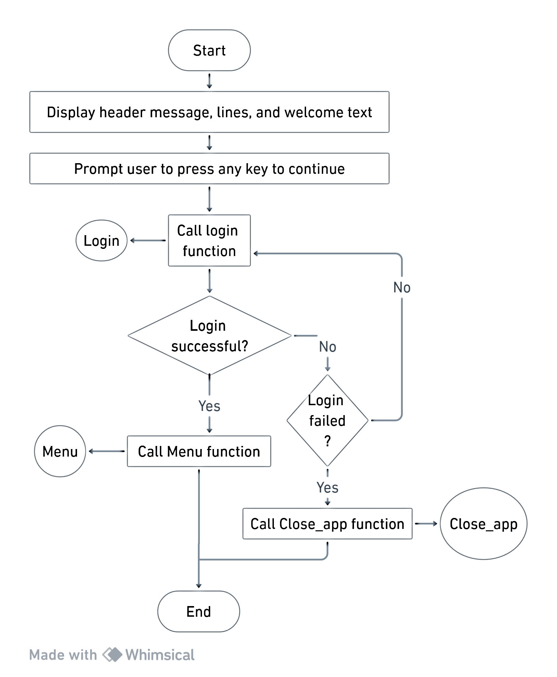

Fig: 4-Main Module

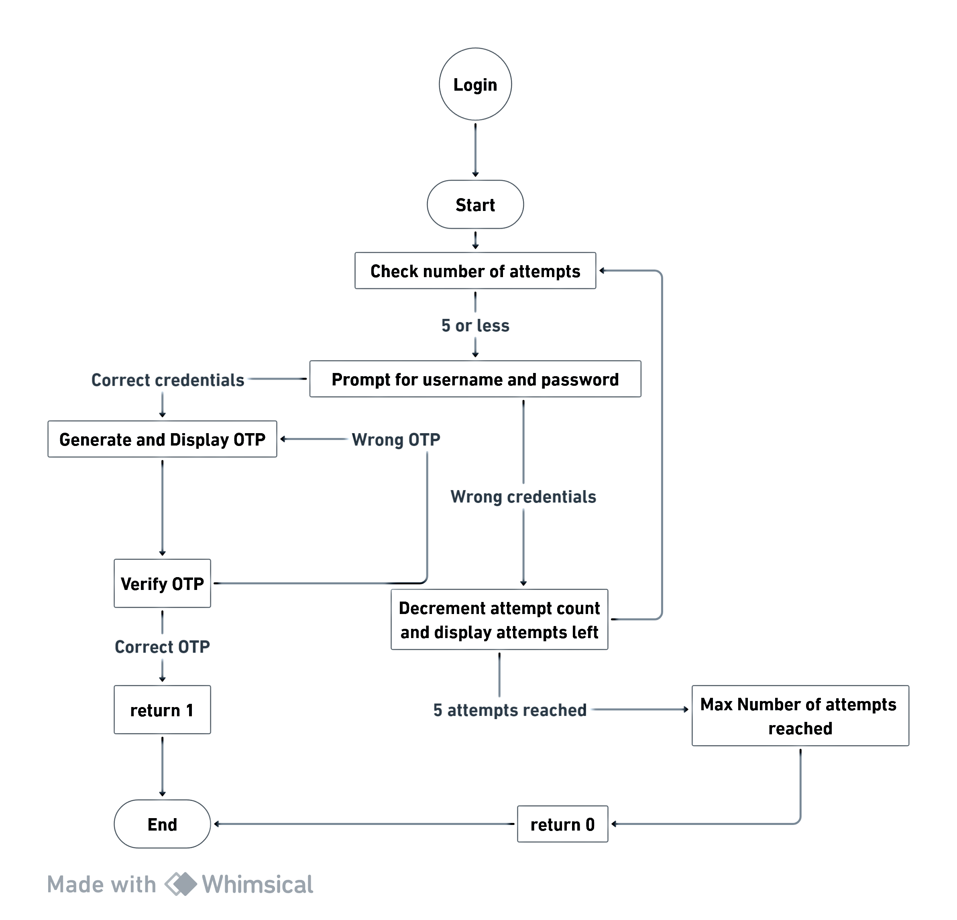

Fig: 5-Login Module

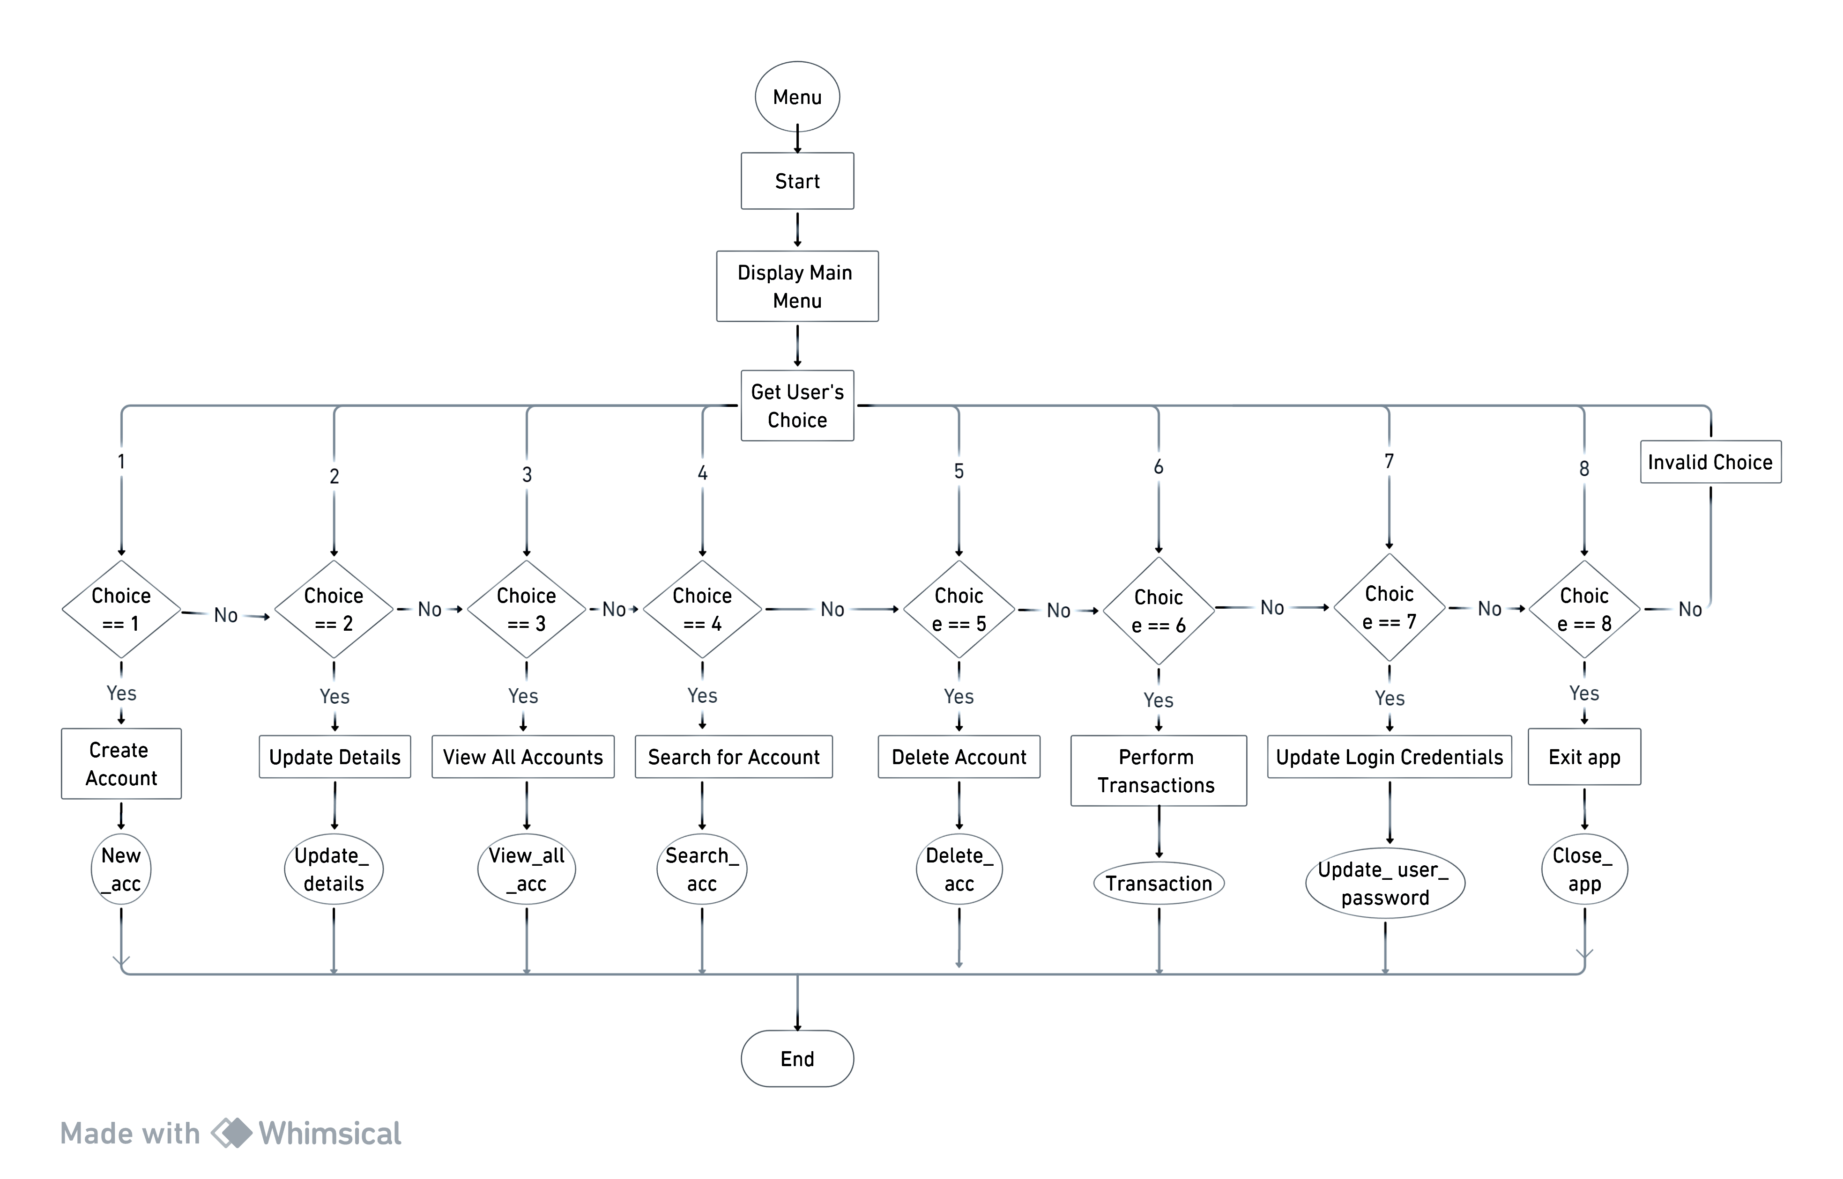

Fig: 6-Menu Module

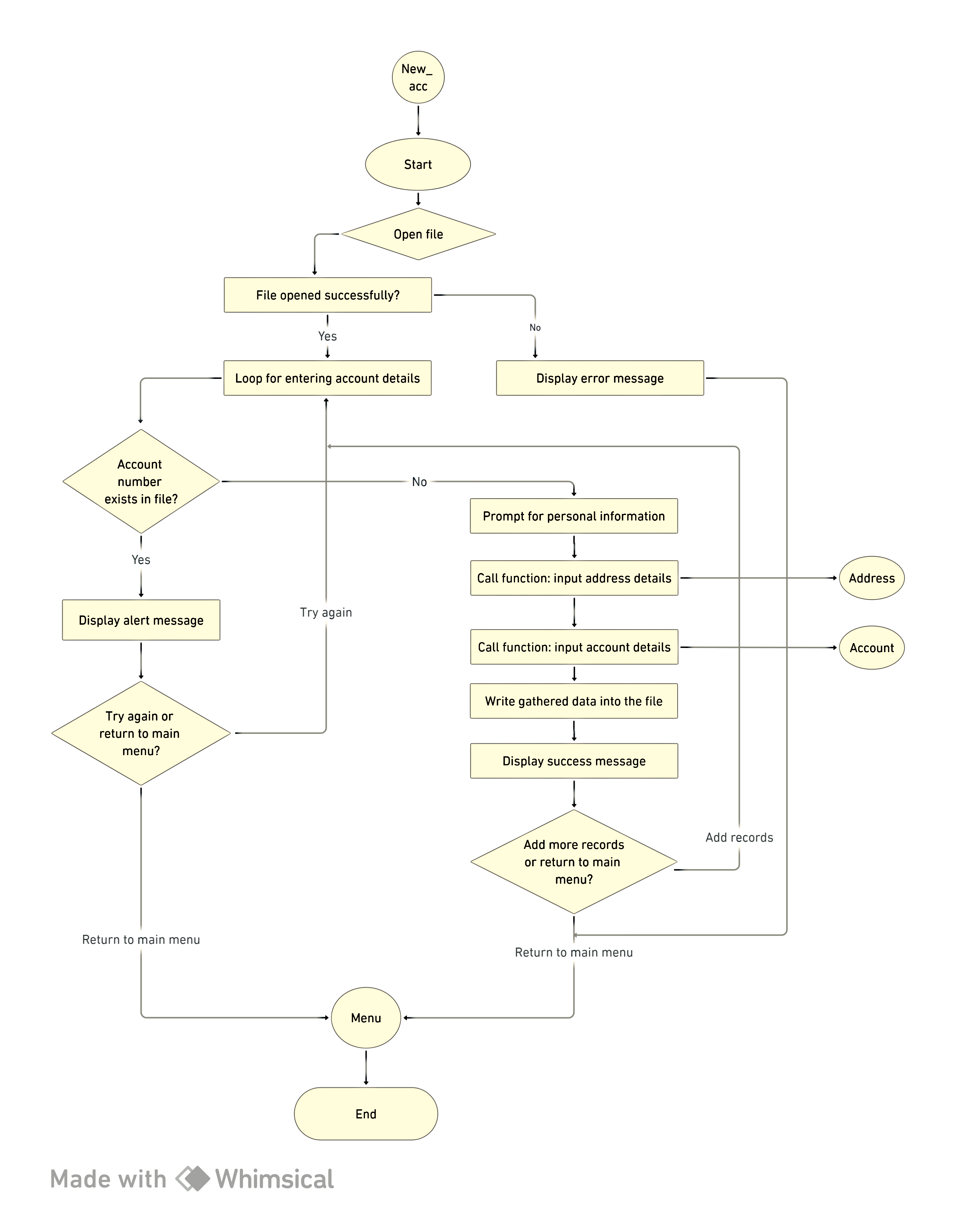

Fig: 7-New_acc Module

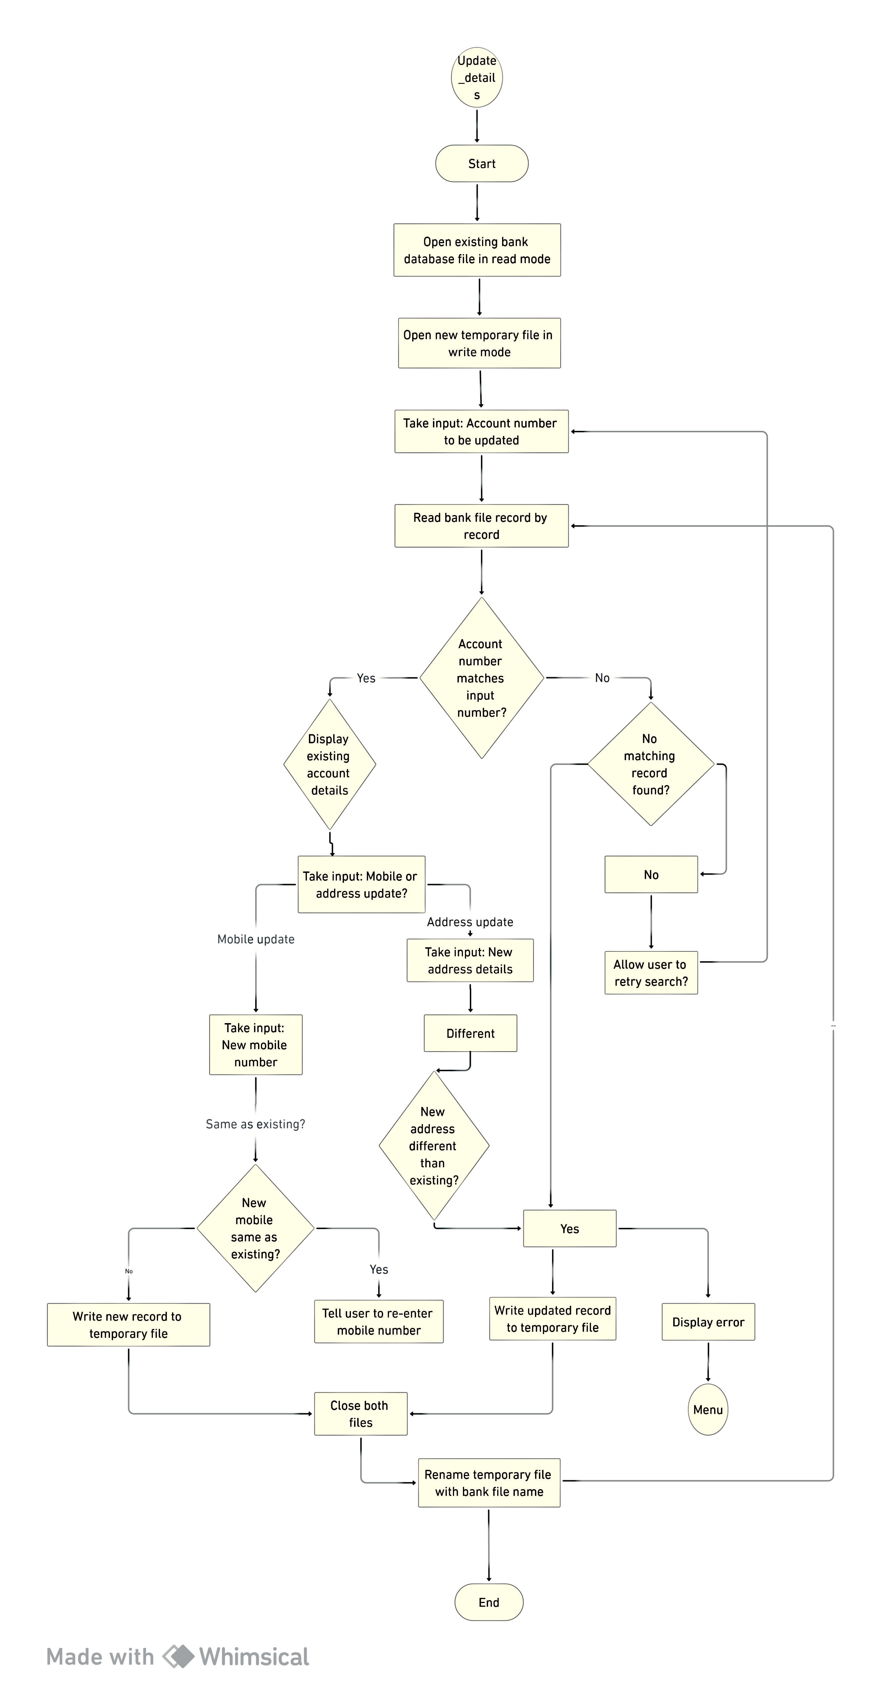

Fig: 8-Update_details Module

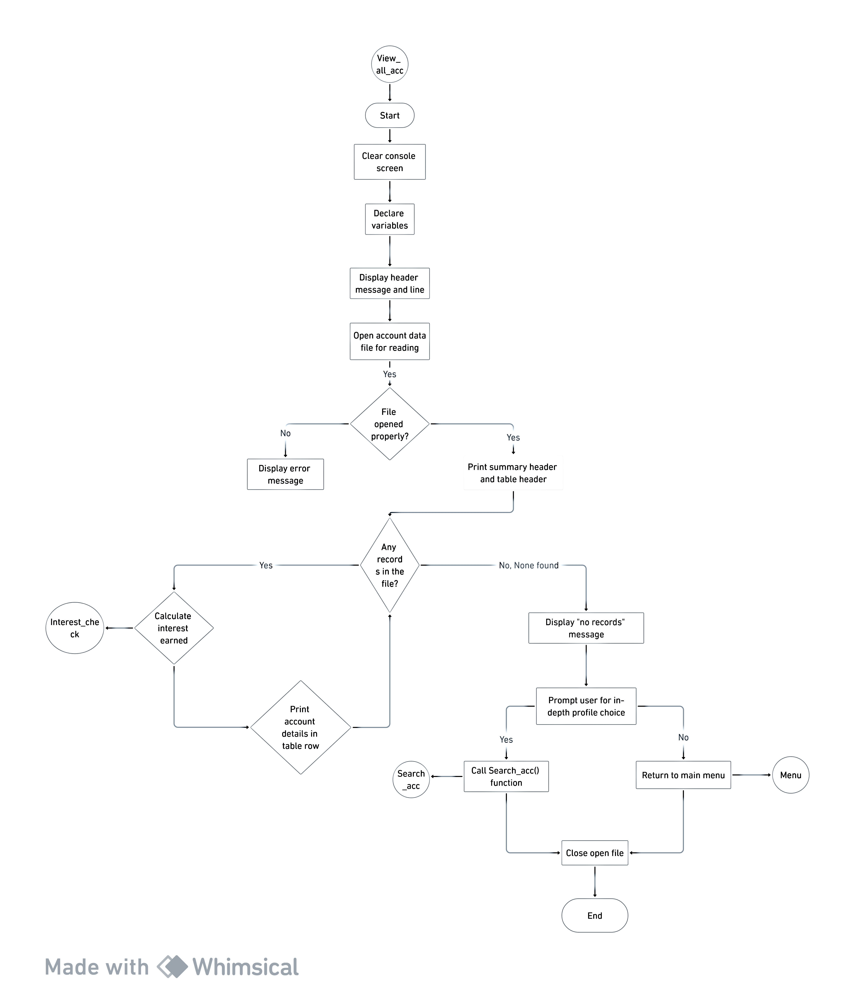

Fig: 9-View_all_acc Module

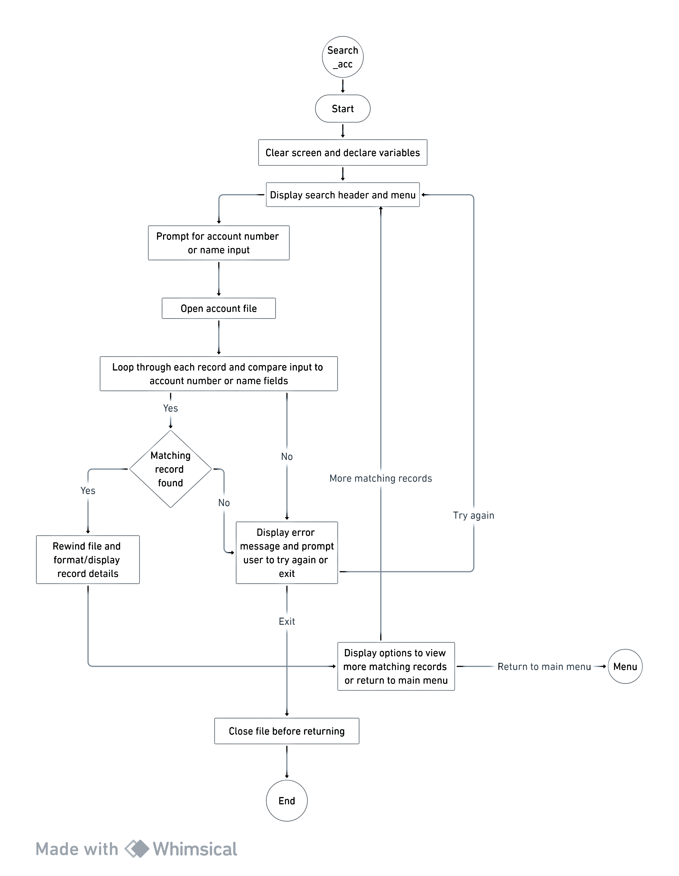

Fig: 10-Search_acc Module

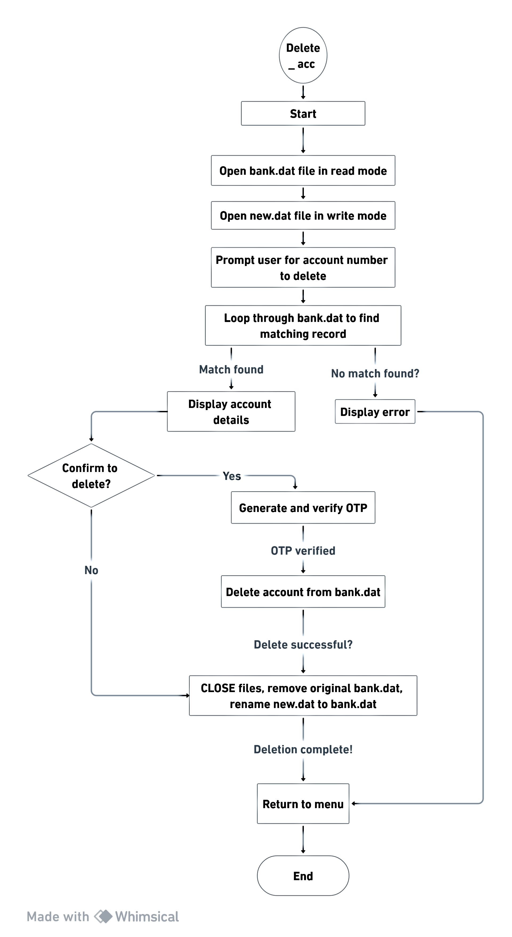

Fig: 11 Delete_acc Module

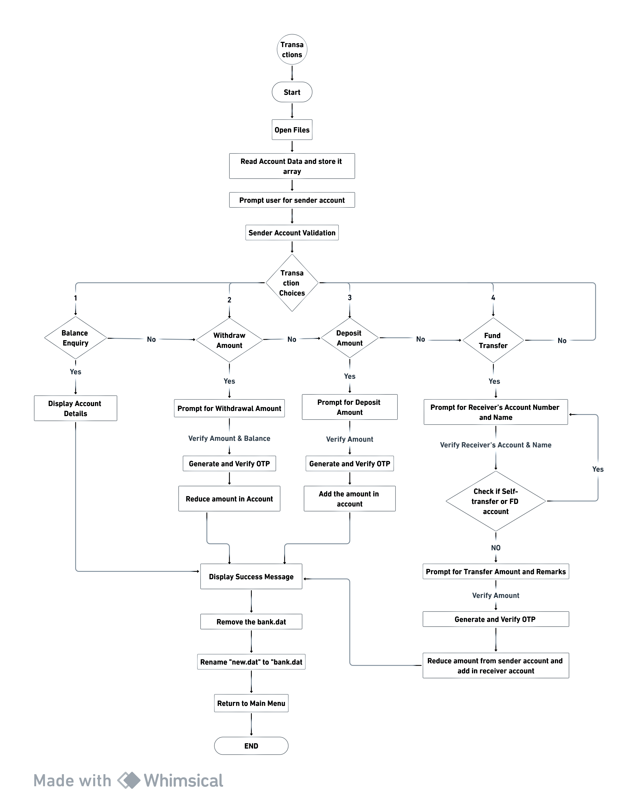

Fig: 12-Transactions Module

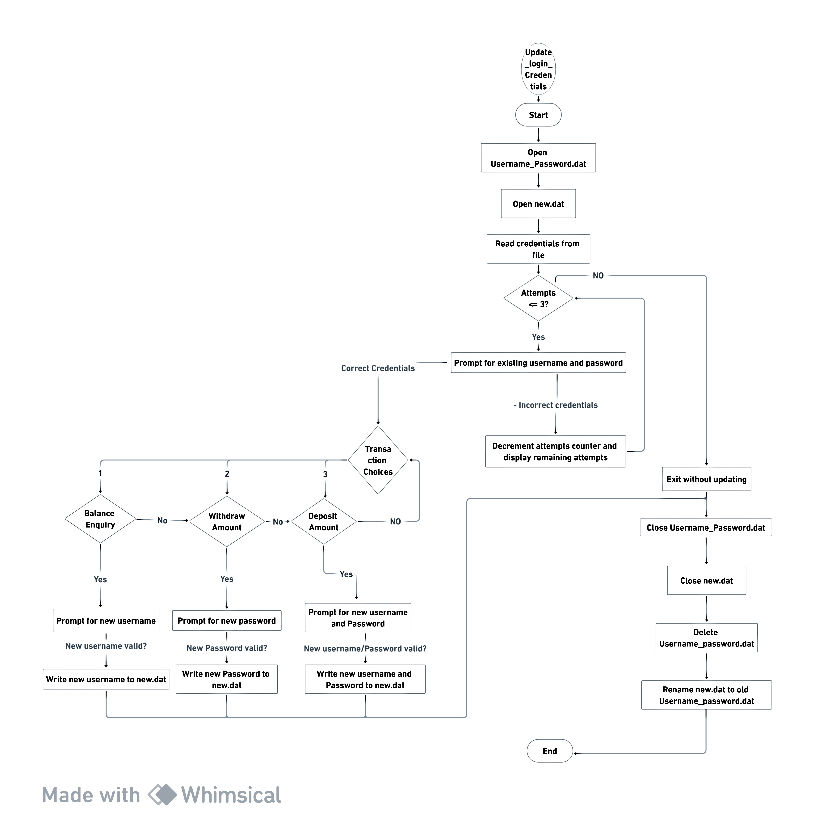

Fig: 13-Update-Login_Credentials Module

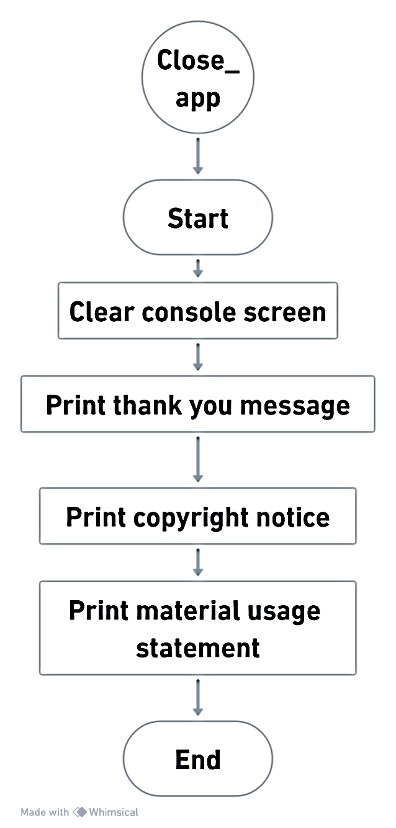

Fig: 14-Close_app Module

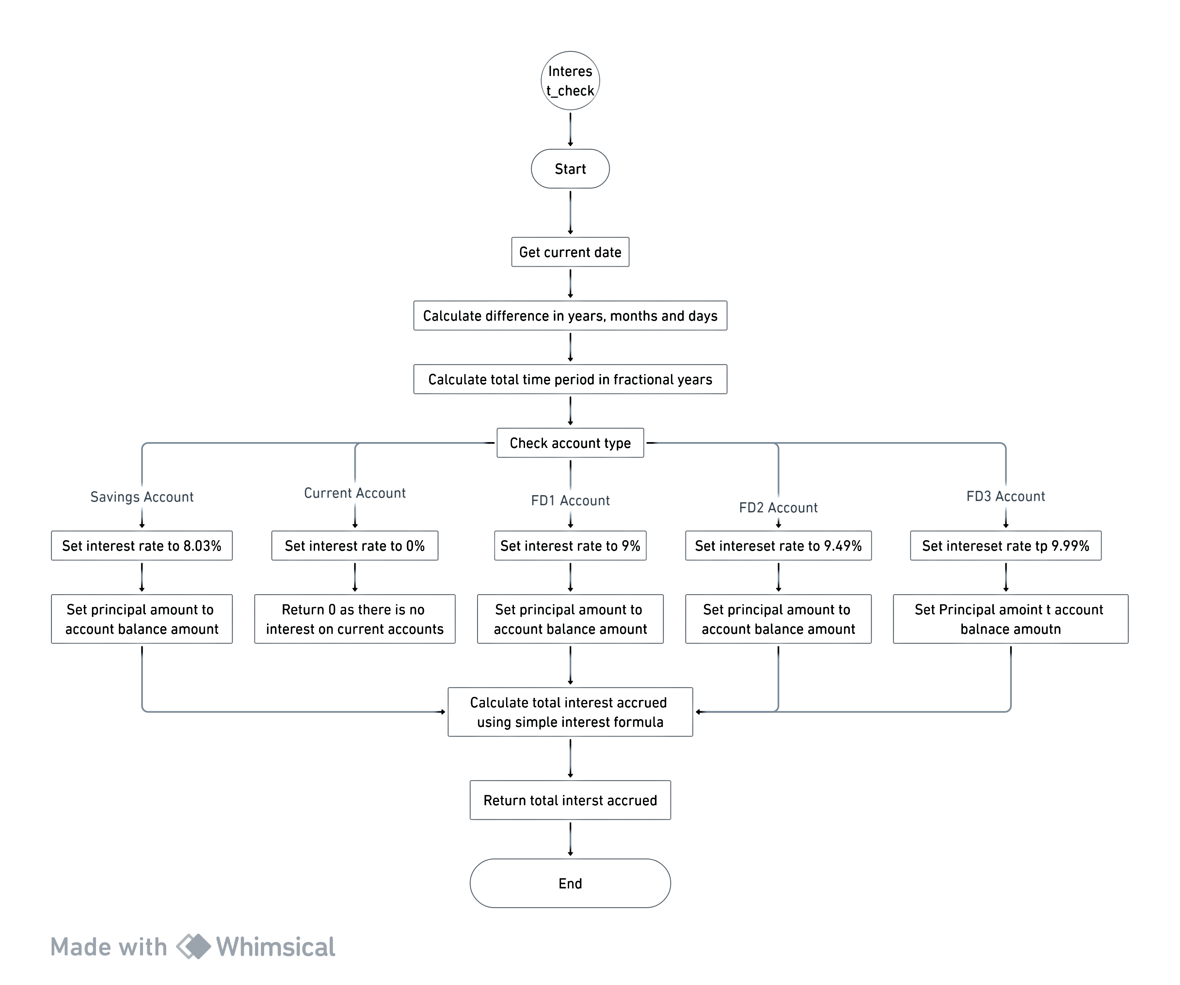

Fig: 15-Interest_Check Module

## Data Flow Diagram

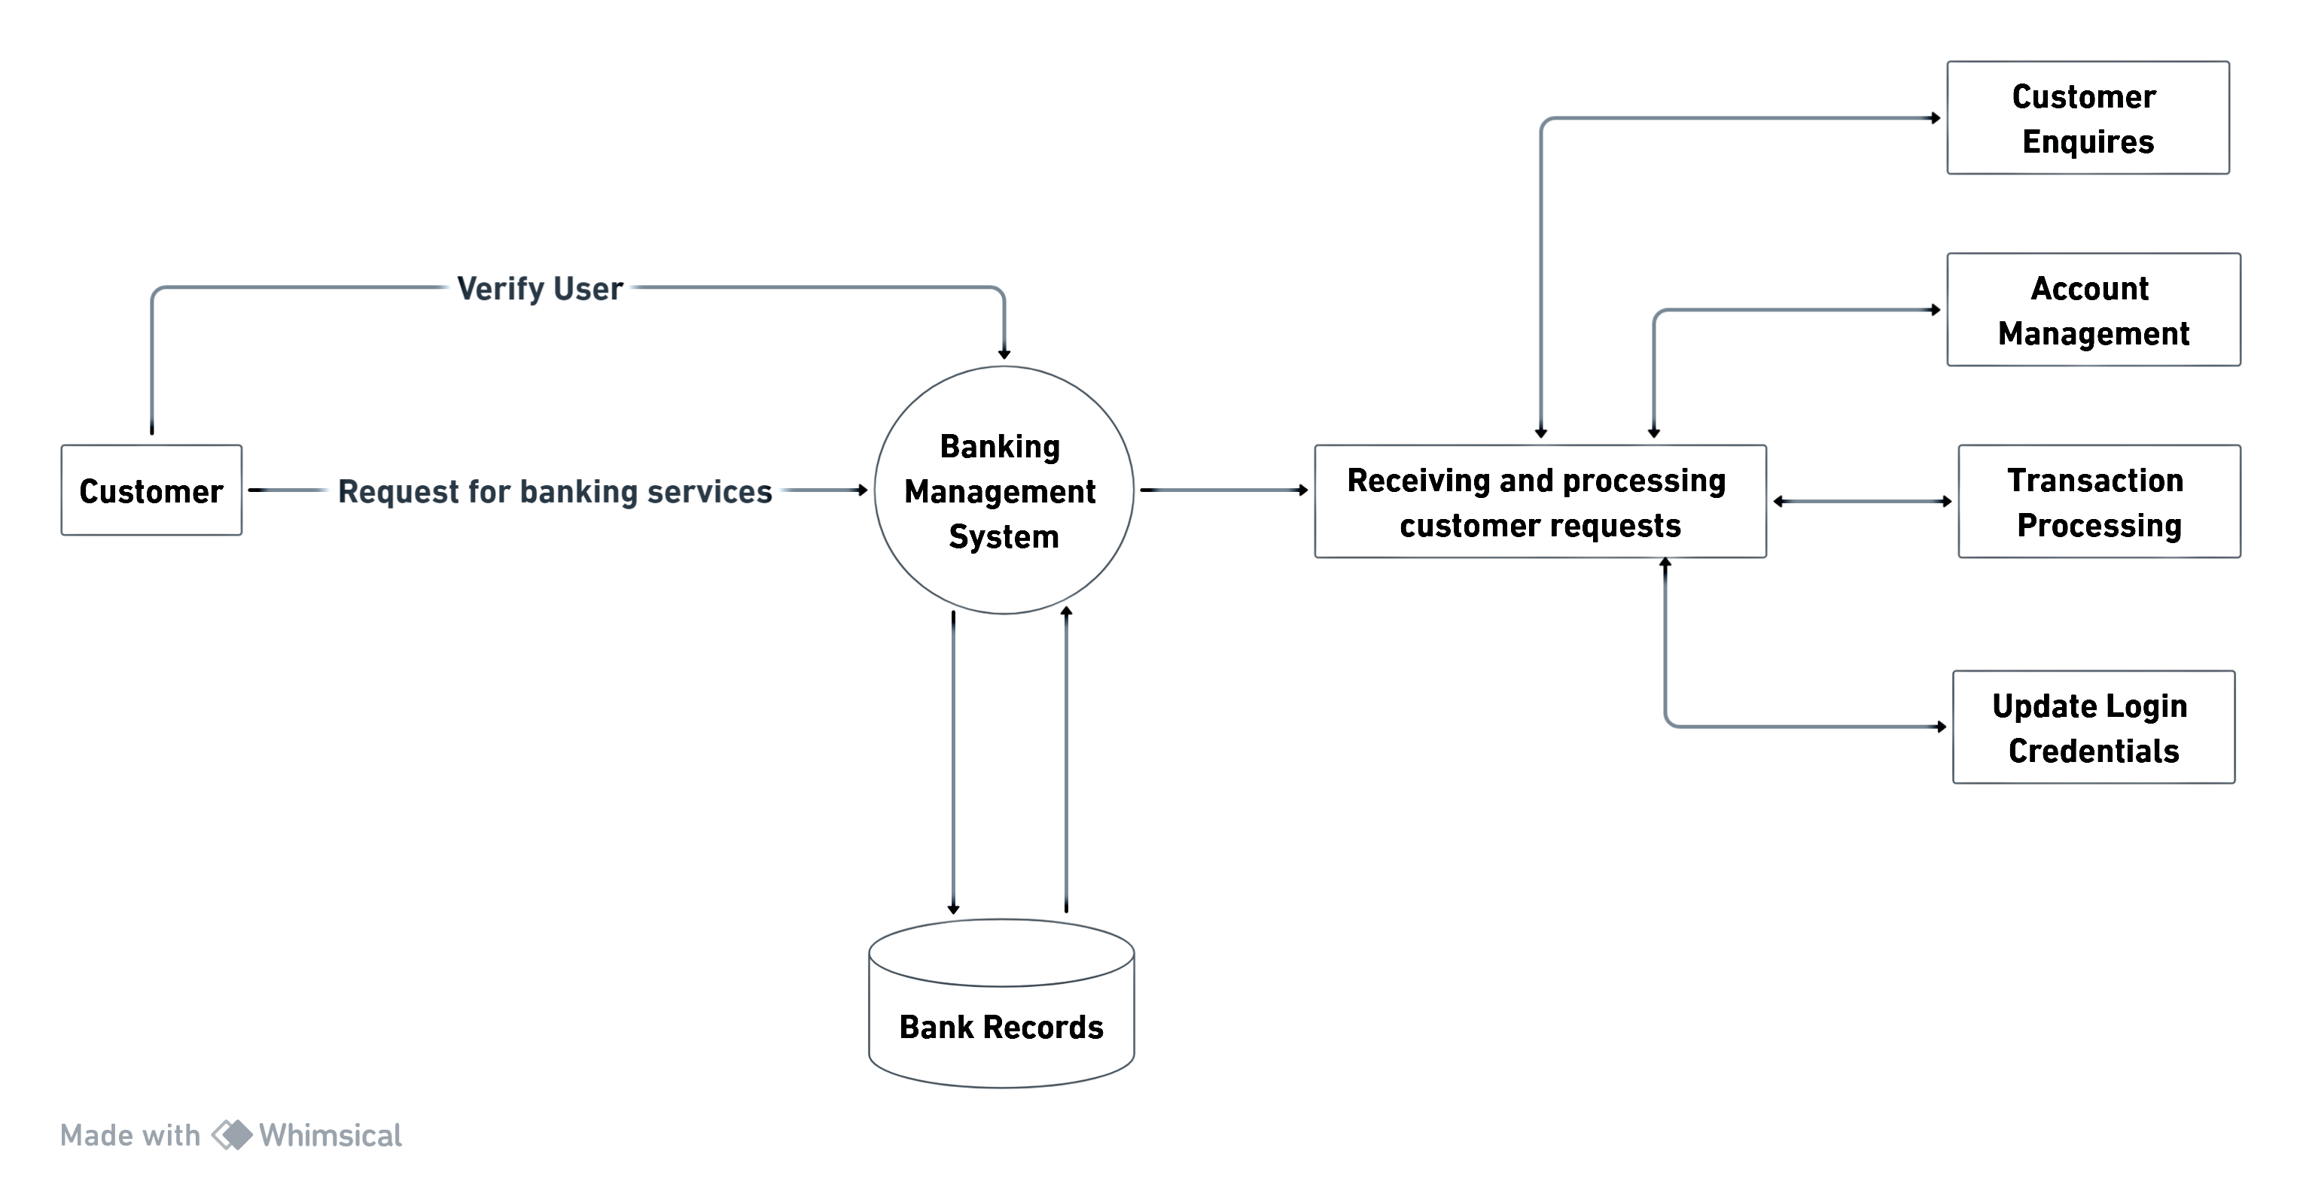

Fig: 16-0 Level DFD

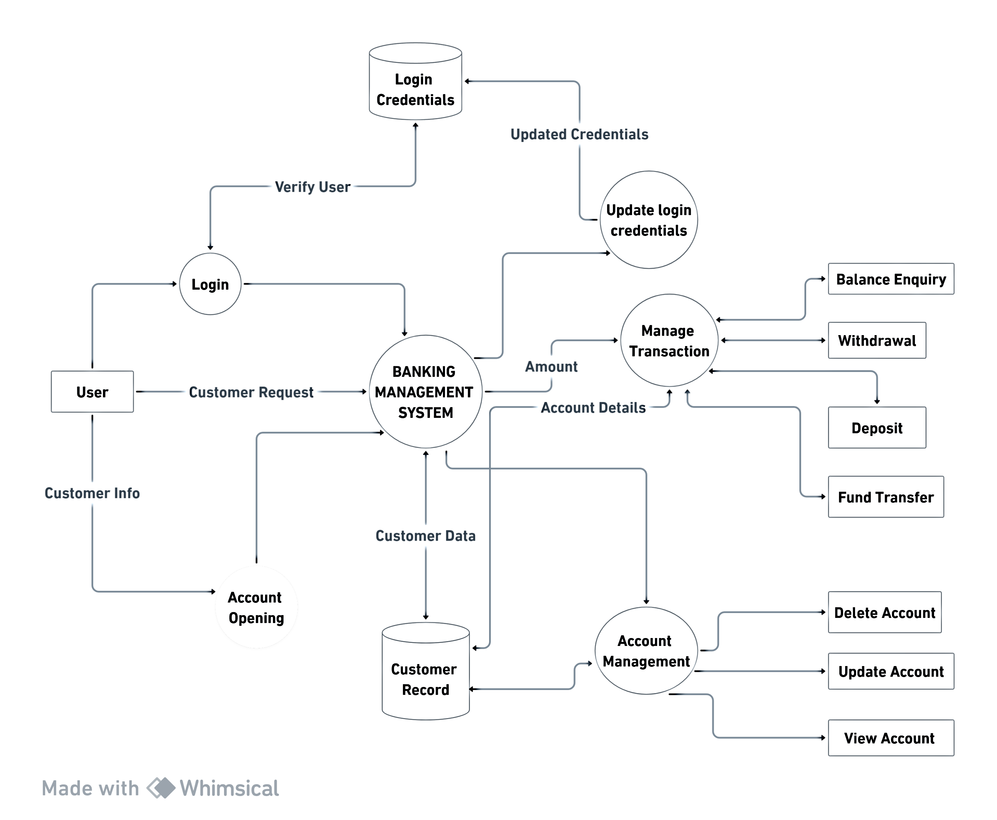

Fig: 17-Level 1 DFD

# Chapter 4 : Coding of the System

//include necessary header file

#include<stdio.h>

#include<conio.h>

#include<string.h>

#include<stdlib.h>

#include<time.h>

//making structure necessary variables

struct personal_details //structure for personal details

{

char name[100],fathers_name[100],mothers_name[100],citizenship_no[10],Gender[10];

char mobile_no[15];

int age;

} prec,ptrn[20]; //declaring structure variable

struct date //structure for time period

{

int day,month,year;

} dob,acc_opendate,dtrn[20],dopentrn[20]; //declaring structure variable

struct address //structure for address variables

{

char country[20],state[20],district[20],muncipality[20];

int ward_no;

} add,atrn[20]; //declaring structure variable

struct account_details //structure for account details

{

int acc_no;

char acc_type[100];

float amt;

} accrec,check,acctrn[20]; //declaring the structure variable

// Main function

void main()

{

int r;

headmsg("BFK BANK LIMITED"); // Display the header msg

line(25,7); // Draw the line

printf("\v\v\v\v\v");

printf("\t\t\t\t\t\t\t\t WELCOME \v\v");

printf("\t\t\t\t\t\t\t\t TO \v\v");

printf("\t\t\t\t\t\t\t\t BFK BANK MANAGEMENT \v\v");

printf("\t\t\t\t\t\t\t\t APPLICATION ");

line(25,7); // Draw the line

printf("\n\t\t\t\t\t\t\t\t -Together we grow");

printf("\n\n\n\n\t\t\t\t Press any key to continue....");

getch();

//Call the login function to validate username and password

r=login();

if(r==1) //Check if login is successfull

{

Menu(); //If login is successful continue to main menu

}

else

{

Close_app(); //If login isnot successfull exit the application

}

}

//function to calculate interest accured in real time

float interest_check(char acc_type[50],float amt,int openy,int openm,int opend)

{

// Declare variables for time and interest calculation

float t,r,p,SI;

float year_diff,month_diff,day_diff;

time_t current_time;

time(&current_time); // Get the current time

struct tm *local_time = localtime(&current_time); // Convert current_time to a struct tm

// Calculate the difference in years, months, and days between account opening date and today's date

year_diff = (local_time->tm_year + 1900 - openy);

month_diff = abs(local_time->tm_mon + 1 - openm) / 12.0;

day_diff= abs(local_time->tm_mday - opend) / 365.0;

// Calculate the difference in time in terms of a fractional year

t=year_diff+month_diff+day_diff;

// Determine interest rate and principal amount based on account type

if(stricmp(acc_type,"Savings")==0)

{

p=amt;

r=8.03;

}

else if(stricmp(acc_type,"Current")==0)

{

p=amt;

r=0;

}

else if(stricmp(acc_type,"FD1")==0)

{

p=amt;

r=9;

}

else if(stricmp(acc_type,"FD2")==0)

{

p=amt;

r=9.49;

}

else if(stricmp(acc_type,"FD3")==0)

{

p=amt;

r=9.99;

}

SI=(p*t*r)/100; //calculate the interest using simple interest formula

return SI; //returning the interest accurred

}

// Function to display and manage the main menu

void Menu()

{

int choice=0;

while(choice!=8) // Loop until the user chooses to exit (choice = 8)

{

system("cls"); // Clear the console screen

system("color 3"); // Set console color

headmsg("MAIN MENU"); // Display the main menu header

line(32, 5); // Draw a line

// Display menu options

printf("\v\v\n\t\t\t\t\t\t\t\t 1.Create new account \v");

printf("\n\t\t\t\t\t\t\t\t 2.Update the details \v");

printf("\n\t\t\t\t\t\t\t\t 3.View all accounts \v");

printf("\n\t\t\t\t\t\t\t\t 4.Search for a account \v");

printf("\n\t\t\t\t\t\t\t\t 5.Delete account\v");

printf("\n\t\t\t\t\t\t\t\t 6.Transactions \v");

printf("\n\t\t\t\t\t\t\t\t 7.Update Login Credentials \v");

printf("\n\t\t\t\t\t\t\t\t 8.Exit \v");

line(32, 5); // Draw a line

printf("\n\t\t\t\t\t\t\t\t Enter your choice....");

scanf("%d", &choice); // Get user's menu choice

// Execute the chosen menu option using a switch statement

switch(choice)

{

case 1:

New_acc(); //Create new account

break;

case 2:

Update_details(); //Update the account details

break;

case 3:

View_all_acc(); //View all accounts details

break;

case 4:

Search_acc(); //Search for a particular account

break;

case 5:

Delete_acc(); //Delete account

break;

case 6:

Transaction(); //Perform various transactions

break;

case 7:

Update_user_password(); //Change the username or password

break;

case 8:

Close_app(); //Exit the application

break;

default:

printf("\n\n\t\t\t\t\t\t\t INVALID CHOICE !!! PLEASE CHOOSE AGAIN");

delay(7000000000); //// Delay to provide user feedback

}

}

}

// Function to create a new account

void New_acc()

{

int check_acc_no,record_found;

char try_return;

int acc_no=0;

int main_exit;

FILE *fp;

// Open the bank.dat file in append and read mode

fp = fopen("bank.dat", "a+");

// Check if the file was opened successfully

if (fp==NULL)

{

printf("\n\n\t\t\t\t !!Error loading the file..!!");

}

//Loop for entering the account details

while(1)

{

system("cls"); // Clear the console screen

headmsg("New Account Form"); // Display the header

line(32, 5); // Draw a line

record_found = 0; // Initialize record_found variable

// Get account number to check its existence

printf("\n\n\t\t\t\t Enter account number:");

scanf("%d",&check_acc_no);

// Loop through the file to check for existing account number

while(fscanf(fp,"%d %d %d %s %s %s %s %d %s %d %d %d %s %s %s %s %s %d %d %s %f",&acc_opendate.year,&acc_opendate.month,&acc_opendate.day,

prec.name,prec.fathers_name,prec.mothers_name,prec.Gender,&prec.age,prec.citizenship_no,&dob.year,&dob.month,&dob.day,prec.mobile_no,

add.country,add.state,add.district,add.muncipality,&add.ward_no,&accrec.acc_no,accrec.acc_type,&accrec.amt)!=EOF)

{

if (check_acc_no == accrec.acc_no)

{

record_found=1;

break;

}

}

rewind(fp); // Move file pointer to the beginning

// If the record is found account number exists

if (record_found == 1)

{

printf("\n\n\t\t\t\t\t\t\t Account number already in use !!");

printf("\n\n\t\t\t\t\t\t\t Press T to try again and anykey to return to main menu....");

scanf(" %c",&try_return);

// If the user wants to try again, continue the loop

if(try_return == 't' || try_return == 'T')

{

continue;

}

else

{

break; // Exit the loop if the user doesn't want to try again

}

}

else

{

accrec.acc_no = check_acc_no; // Assign the entered account number

// Prompt user for personal information

printf("\n\n\n\t\t\t\t\t\t\t\t **** Personal Information **** ");

printf("\n\n\t\t\t\t\t Today's Date(YEAR/MM/DD):");

scanf(" %d %d %d",&acc_opendate.year,&acc_opendate.month,&acc_opendate.day);

printf("\n\n\t\t\t\t\t Name:");

scanf("%s",prec.name);

fgets(prec.name,20, stdin);

printf("\n\n\t\t\t\t\t Father Name:");

scanf("%s",prec.fathers_name);

printf("\n\n\t\t\t\t\t Mother Name:");

scanf("%s",prec.mothers_name);

printf("\n\n\t\t\t\t\t Gender:");

scanf("%s",prec.Gender);

printf("\n\n\t\t\t\t\t Age:");

scanf("%d",&prec.age);

printf("\n\n\t\t\t\t\t Citizenship No:");

scanf("%s",prec.citizenship_no);

printf("\n\n\t\t\t\t\t Date of Birth(YEAR/MM/DD):");

scanf(" %d %d %d",&dob.year,&dob.month,&dob.day);

printf("\n\n\t\t\t\t\t Phone no :");

scanf("%s",&prec.mobile_no);

// Call Address function to input address details

Address_details();

// Call Account function to input account details

Account_details();

//Write the data int the file

fprintf(fp,"%d %d %d %s %s %s %s %d %s %d %d %d %s %s %s %s %s %d %d %s %.2f \n",acc_opendate.year,acc_opendate.month,acc_opendate.day,prec.name,prec.fathers_name,

prec.mothers_name,prec.Gender,prec.age,prec.citizenship_no,dob.year,dob.month,dob.day,prec.mobile_no,add.country,add.state,add.district,add.muncipality,add.ward_no,

accrec.acc_no,accrec.acc_type,accrec.amt);

printf("\n\n\t\t\t\t\t\t **** Account created succesfully ****"); //Display the message to inform user that account has been created successfully

printf("\n\n\t\t\t\t\t\t Press A to add more records and anykey to return to main menu...."); //Ask user if they want to add more record or return to main menu

scanf(" %c",&try_return);

// If the user wants to add more record,continue the loop

if(try_return == 'a' || try_return == 'A')

{

continue;

}

else

{

break; //Exit the loop if the user doesn't want to try again

}

}

}

fclose(fp); //Close the file

}

//Function to input account details

void Account_details()

{

system("cls"); // Clear the console screen

char ch;

int choice;

// Display header and account information section

headmsg("New Account Form");

line(32,5); //Draw a line

printf("\n\n\n\t\t\t\t\t\t\t\t\t **** Account Information **** ");

printf("\n\n\n\t\t\t\t\t Types of account:");

printf("\n\t\t\t\t\t\t 1.Savings");

printf("\n\t\t\t\t\t\t 2.Current");

printf("\n\t\t\t\t\t\t 3.Fixed_Deposit1(3 to 12 months @ 9%%)");

printf("\n\t\t\t\t\t\t 4.Fixed_Deposit2(12 to 24 months @ 9.49%%)");

printf("\n\t\t\t\t\t\t 5.Fixed_Deposit3(above 24 months @ 9.99%%)");

//Get user's choice for account type

account_type:

printf("\n\n\t\t\t\t\t\t Please enter your choice (1-5): ");

scanf("%d",&choice);

//Assign the selected account type based on user's choice

switch (choice)

{

case 1:

strcpy (accrec.acc_type,"Savings");

break;

case 2:

strcpy (accrec.acc_type, "Current");

break;

case 3:

strcpy (accrec.acc_type, "FD1");

break;

case 4:

strcpy (accrec.acc_type, "FD2");

break;

case 5:

strcpy (accrec.acc_type,"FD3");

break;

default:

printf("\n\n\a\t\t\t\t\t Invalid choice. Please select a number from 1 to 5.\n");

goto account_type; //Ask for input again if choice is invalid

}

//Ask the user if they want to make a initial deposit

printf("\n\n\t\t\t\t Do you want to make a deposit now[Y/N]?");

scanf(" %c",&ch);

getchar();

// If user wants to make a deposit,get the deposit amount

if( ch == 'y' || ch == 'Y' )

{

printf("\n\n\t\t\t Enter the amount to deposit:");

scanf(" %f",&accrec.amt);

}

else

{

accrec.amt=0.00; //Set the deposit amount to 0 if no initial deposit is made

}

}

// Function to input the address details

void Address_details()

{

system("cls"); // Clear the console screen

// Display header and address information section

headmsg("New Account Form");

line(32,5);

printf("\n\n\t\t\t\t\t\t\t\t **** Address Information **** ");

printf("\v\n\t\t\t\t\t Country:"); //Get the country name

scanf("%s",add.country);

printf("\v\n\t\t\t\t\t Province:"); // Get the province name

scanf("%s",add.state);

printf("\v\n\t\t\t\t\t District:"); // Get the district name

scanf("%s",add.district);

printf("\v\n\t\t\t\t\t Muncipality:"); // Get the muncipality name

scanf("%s",add.muncipality);

printf("\v\n\t\t\t\t\t Ward No:"); //Get the ward number

scanf("%d",&add.ward_no);

}

//Function to update the account details

void Update_details()

{

char new_state[20],new_district[20],new_muncipality[20],new_mob_no[15],try_return;

int choice,updt_acc_no,new_ward_no,test=0;

float interest_earned;

FILE *fp,*fp1;

// Open the bank.dat file in read mode and new.dat file in write mode

fp=fopen("bank.dat","r");

fp1=fopen("new.dat","w");

// Check if the files were opened successfully

if (fp == NULL || fp1 == NULL)

{

printf("\n\n\t\t\t\t !!Error loading the file..!!");

}

// Loop for account deletion

while(1)

{

system("cls"); // Clear the console screen

headmsg("UPDATING DETAILS"); // Display the header

line(32, 5); // Draw a line

printf("\n\t\t\t\t\t\t Please provide account number to update its details");

printf("\n\n\n\t\t\t\t\t Account Number:");

scanf("%d",&updt_acc_no);

// Loop through the file to find the account to be updated

while (fscanf(fp, "%d %d %d %s %s %s %s %d %s %d %d %d %s %s %s %s %s %d %d %s %f\n", &acc_opendate.year, &acc_opendate.month, &acc_opendate.day,

prec.name, prec.fathers_name, prec.mothers_name, prec.Gender, &prec.age, prec.citizenship_no, &dob.year, &dob.month, &dob.day, prec.mobile_no,

add.country, add.state, add.district, add.muncipality, &add.ward_no, &accrec.acc_no, accrec.acc_type, &accrec.amt) != EOF)

{

if(updt_acc_no == accrec.acc_no)

{

test++; //increase the test value to check record was found or not later

interest_earned=interest_check(accrec.acc_type,accrec.amt,acc_opendate.year,acc_opendate.month,acc_opendate.day); //call the interest function to get the interest accured

printf("\n\n\n +----------------------+-----------------+--------------+------------------+--------------+----------------------+---------------+-----------------+\n");

printf(" | %-20s | %-10s | %-10s | %-15s | %-10s | %-15s | %-10s | %-9s |",

"Account Name", "Account Number", "Account Type", "Account Balance", "Interest", "Account Opening Date", "Mobile Number", "Address");

printf("\n +----------------------+-----------------+--------------+------------------+--------------+----------------------+---------------+-----------------+\n");

printf(" | %-20s | %-10d | %-10s | Rs. %-12.2f | Rs. %-8.2f | %02d/%02d/%04d | %-10s | %s-%-2d |\n",

prec.name, accrec.acc_no, accrec.acc_type, accrec.amt, interest_earned, acc_opendate.day, acc_opendate.month, acc_opendate.year, prec.mobile_no, add.district, add.ward_no);

printf(" +----------------------+-----------------+--------------+------------------+--------------+----------------------+---------------+-----------------+\n");

//Loop to choose the detail to be updated

while(1)

{

printf("\n\n\t\t\t\t\t\t 1.Update Mobile No:");

printf("\n\n\t\t\t\t\t\t 2.Update Address:");

printf("\n\n\n\t\t\t\t\t\t Which details would you like to update...?");

scanf("%d",&choice);

//Update the mobile number

if(choice == 1)

{

diff_mob:

printf("\n\n\t\t\t\t\t\t New Mobile No:");

scanf("%s",new_mob_no);

// Check if the new mobile number is the same as the old one

if(stricmp(prec.mobile_no,new_mob_no)==0)

{

printf("\n\n\n\n\a\t\t\t\t\t\t\t\t\t **** Cannot use same Mobile Number ****");

printf("\n\n\n\n\t\t\t\t\t\t\t\t\t Please Select different Mobile Number");

delay(50000000);

goto diff_mob;

}

else

{

// Write the updated details to the new file

fprintf(fp1,"%d %d %d %s %s %s %s %d %s %d %d %d %s %s %s %s %s %d %d %s %.2f \n",acc_opendate.year,acc_opendate.month,acc_opendate.day,prec.name,prec.fathers_name,

prec.mothers_name,prec.Gender,prec.age,prec.citizenship_no,dob.year,dob.month,dob.day,new_mob_no,add.country,add.state,add.district,add.muncipality,add.ward_no,

accrec.acc_no,accrec.acc_type,accrec.amt);

printf("\n\n\n\n\t\t\t\t\t\t\t\t\t **** Account Details Updated Successfully ****");

break; // Exit the loop after successful updating the details

}

}

//Update the address

else if( choice == 2)

{

//Get the new address details

diff_cred:

printf("\n\n\t\t\t\t\t\t New Province:");

scanf("%s",new_state);

printf("\n\n\t\t\t\t\t\t New District:");

scanf("%s",new_district);

printf("\n\n\t\t\t\t\t\t New Metropolitan/Muncipality:");

scanf("%s",new_muncipality);

printf("\n\n\t\t\t\t\t\t New Ward No:");

scanf("%d",&new_ward_no);

// Check if the new credentials are the same as the old ones

if(stricmp(add.state,new_state)==0 && stricmp(add.district,new_district)==0 && stricmp(add.muncipality,new_muncipality)==0 && add.ward_no == new_ward_no)

{

printf("\n\n\n\t\t\t\t\t\t\t\t **** Cannot use same Credentials ****");

printf("\n\n\n\t\t\t\t\t\t\t\t Please Select different Credentials");

delay(50000000); // delay to get user feedback

goto diff_cred; // Go back to entering new credentials

}

else

{

// Write the updated details to the new file

fprintf(fp1,"%d %d %d %s %s %s %s %d %s %d %d %d %s %s %s %s %s %d %d %s %.2f \n",acc_opendate.year,acc_opendate.month,acc_opendate.day,prec.name,prec.fathers_name,

prec.mothers_name,prec.Gender,prec.age,prec.citizenship_no,dob.year,dob.month,dob.day,prec.mobile_no,add.country,new_state,new_district,new_muncipality,new_ward_no,

accrec.acc_no,accrec.acc_type,accrec.amt);

printf("\n\n\n\n\n\t\t\t\t\t\t\t\t **** Account Details Updated Successfully ****");

break; // Exit the loop after successful update

}

}

else

{

printf("\n\n\a\t\t\t\t\t\t\t Invalid choice Please choose carefully!!!");

delay(50000000); //delay to get user feedback

}

}

}

else

{

// Retain other accounts and write them to the new file

fprintf(fp1,"%d %d %d %s %s %s %s %d %s %d %d %d %s %s %s %s %s %d %d %s %.2f \n",acc_opendate.year,acc_opendate.month,acc_opendate.day,prec.name,prec.fathers_name,

prec.mothers_name,prec.Gender,prec.age,prec.citizenship_no,dob.year,dob.month,dob.day,prec.mobile_no,add.country,add.state,add.district,add.muncipality,add.ward_no,

accrec.acc_no,accrec.acc_type,accrec.amt);

}

}

rewind(fp); //Return the file pointer to initial position

// If the test is 0, account record was not found

if (test == 0)

{

printf("\n\n\n\n\a\t\t\t\t\t\t\t\t Record not found!!!");

printf("\n\n\t\t\t\t\t\t\t\t Please check credentials properly!");

delay(50000000);

printf("\n\n\t\t\t\t\t\t\t Press T to try again and anykey to return to main menu....");

scanf(" %c",&try_return);

// If the user wants to try again, continue the loop

if(try_return == 't' || try_return == 'T')

{

continue;

}

else

{

break; // Exit the loop if the user doesn't want to try again

}

}

else

{

printf("\n\n\t\t\t\t\t\t Press any key to return to main menu....");

getch();

break; // Exit the loop when the operation is completed

}

}

fclose(fp); //Close the original file

fclose(fp1); //Close the new file

remove("bank.dat");//remove the new file to bank.dat

rename("new.dat","bank.dat");// rename the new.dat to bank.dat

}

//Function to view records of all customer or account

void View_all_acc()

{

system("cls"); //Clear the console screen

// Initialize variables for testing,interest calculation and user choice.

int test=0;

float interest_earned=0;

char choice;

// Display a header message and a dividing line.

headmsg("ALL ACCOUNT DETAILS");

line(32,5);

FILE *fp;

fp=fopen("bank.dat","r"); //Open the file to read the data

//Check if file was opened properly or not

if (fp==NULL)

{

printf("\n\n\t\t\t\t !!Error loading the file..!!");

}

// Display header of summary of all accounts.

printf("\n\n\t\t\t\t\t\t\t\t **** Summary of all Accounts ****");

printf("\n\n\n +----------------------+-----------------+--------------+------------------+--------------+----------------------+---------------+-----------------+\n");

printf(" | %-20s | %-10s | %-10s | %-15s | %-10s | %-15s | %-10s | %-9s |",

"Account Name", "Account Number", "Account Type", "Account Balance", "Interest", "Account Opening Date", "Mobile Number", "Address");

printf("\n +----------------------+-----------------+--------------+------------------+--------------+----------------------+---------------+-----------------+\n");

// Loop through each account in the data file.

while (fscanf(fp, "%d %d %d %s %s %s %s %d %s %d %d %d %s %s %s %s %s %d %d %s %f\n", &acc_opendate.year, &acc_opendate.month, &acc_opendate.day,

prec.name, prec.fathers_name, prec.mothers_name, prec.Gender, &prec.age, prec.citizenship_no, &dob.year, &dob.month, &dob.day, prec.mobile_no,

add.country, add.state, add.district, add.muncipality, &add.ward_no, &accrec.acc_no, accrec.acc_type, &accrec.amt) != EOF)

{

test++; // Increment the test variable to indicate records were found.

interest_earned=interest_check(accrec.acc_type,accrec.amt,acc_opendate.year,acc_opendate.month,acc_opendate.day); //Call the function to get interest accured

//Display the account information in a formatted manner

printf(" | %-20s | %-10d | %-10s | Rs. %-12.2f | Rs. %-8.2f | %02d/%02d/%04d | %-10s | %s-%-2d |\n",

prec.name, accrec.acc_no, accrec.acc_type, accrec.amt, interest_earned, acc_opendate.day, acc_opendate.month, acc_opendate.year, prec.mobile_no, add.district, add.ward_no);

printf(" +----------------------+-----------------+--------------+------------------+--------------+----------------------+---------------+-----------------+\n");

}

// If no records were found, display a message.

if (test == 0)

{

printf("\n\n\t\t\t\t **** Records not found ****");

}

// Ask the user if they want more in-depth profiles.

more:

printf("\n\n\t\t\t\t\t\t\t Would you like a more in-depth profile of individual[Y/N]?");

scanf(" %c",&choice);

if(choice == 'y' || choice == 'Y')

{

Search_acc();

}

else if(choice == 'n' || choice == 'N')

{

printf("\n\n\t\t\t\t\t Press any key to return to main menu....");

getch();

}

else

{

printf("\n\n\t\t\t\t\t Invalid choice Please choose carefully!!!");

goto more;

}

fclose(fp); //Close the file

}

// Function to search account details

void Search_acc()

{

system("cls"); // Clear the console screen

//Declare and Initialize the variable

int check_acc_no=0,choice=0,record_found=0;

float interest_earned=0;

char check_acc_name[20],try_return;

headmsg("Search Account Details"); // Display the header message

line(32,5); // Draw the line

FILE *fp;

//Open the file in reading mode to read the data

fp=fopen("bank.dat","r");

// Check if file was opened successfully or not

if (fp==NULL)

{

printf("\n\n\t\t\t\t !!Error loading the file!!");

}

//Display the available option to search

printf("\n\n\t\t\t\t\t\t 1.Search by Account no:");

printf("\n\n\t\t\t\t\t\t 2.Search by Account Name:");

printf("\n\n\t\t\t\t\t\t Do you want to search account details by....");

scanf(" %d",&choice);

//Search by account number section

if (choice == 1)

{

//Loop for valid account number

while(1)

{

system("cls"); // Clear the console screen

headmsg("Search Account Details"); // Display the header

line(32,5); // Draw the line

record_found=0;

printf("\v\n\n\n\t\t\t\t Enter account number:");

scanf("%d",&check_acc_no);

//Read the data from file

while (fscanf(fp, "%d %d %d %s %s %s %s %d %s %d %d %d %s %s %s %s %s %d %d %s %f\n", &acc_opendate.year, &acc_opendate.month, &acc_opendate.day,

prec.name, prec.fathers_name, prec.mothers_name, prec.Gender, &prec.age, prec.citizenship_no, &dob.year, &dob.month, &dob.day, prec.mobile_no,

add.country, add.state, add.district, add.muncipality, &add.ward_no, &accrec.acc_no, accrec.acc_type, &accrec.amt) != EOF)

{

if (check_acc_no == accrec.acc_no)

{

record_found=1;

break; // If record is found stop searching and break from loop

}

}

rewind(fp); // Return the file cursor at the beginning of file

if (record_found == 1)

{

system("cls"); // Clear the console screen

headmsg("CUSTOMER RECORD"); // Display the header

line(32,5); // Draw the line

interest_earned = interest_check(accrec.acc_type, accrec.amt, acc_opendate.year, acc_opendate.month, acc_opendate.day); // call the interest function to get the interest accured

// Display Personal Details

printf("\n\n\n\t\t\t\t\t\t\t\t **** Personal Details **** \n");

printf("\n\t\t\t\t+----------------------+--------------------+--------------------+-------------+------------+\n");

printf("\t\t\t\t| %-13s | %-18s | %-18s | %-7s | %-5s |\n",

"Name","Father's Name","Mother's Name","Gender","Age");

printf("\t\t\t\t+----------------------+--------------------+--------------------+-------------+------------+\n");

printf("\t\t\t\t| %-20s | %-18s | %-18s | %-7s | %-5d |\n",

prec.name, prec.fathers_name, prec.mothers_name, prec.Gender, prec.age);

printf("\t\t\t\t+----------------------+--------------------+--------------------+-------------+------------+\n");

printf("\n\t\t\t\t Citizenship No: %d", prec.citizenship_no);

printf("\n\t\t\t\t Mobile Number : %s\n", prec.mobile_no);

// Display Address Details

printf("\n\n\n\n\n\t\t\t\t\t\t\t\t **** Address Details ****\n");

printf("\n\t\t\t\t\t+------------+---------------+---------------+----------------+-------------+\n");

printf("\t\t\t\t\t| Country | Province | District | Jurisdiction | Ward No |\n");

printf("\t\t\t\t\t+------------+---------------+---------------+----------------+-------------+\n");

printf("\t\t\t\t\t| %-10s | %-13s | %-13s | %-14s | %-11d |\n",

add.country, add.state, add.district, add.muncipality, add.ward_no);

printf("\t\t\t\t\t+------------+---------------+---------------+----------------+-------------+\n");

// Display Account Details

printf("\n\n\n\n\n\t\t\t\t\t\t\t\t **** Account Details ****\n");

printf("\n\t\t\t+-----------------------+---------------+---------------+-----------------+-------------------+-----------------+\n");

printf("\t\t\t| Account Opening Date | Account No | Account Type | Actual Balance | Available Balance | Interest |\n");

printf("\t\t\t+-----------------------+---------------+---------------+-----------------+-------------------+-----------------+\n");

printf("\t\t\t| %-4d/%-2d/%-2d | %-13d | %-8s | Rs. %-10.2f | Rs. %-12.2f | Rs. %-10.2f |\n",

acc_opendate.year, acc_opendate.month, acc_opendate.day, accrec.acc_no, accrec.acc_type, accrec.amt - 1000, accrec.amt, interest_earned);

printf("\t\t\t+-----------------------+---------------+---------------+-----------------+-------------------+-----------------+\n");

printf("\n\n\t\t\t\t\t\t\t\t\t -Together we grow"); // Display the bank tag line

//Prompt the user to view more records or return to main menu

printf("\n\n\n\n\t\t\t\t\t\t Press V to view more records and anykey to return to main menu....");

scanf(" %c",&try_return);

//If user confirms, continue the loop

if(try_return == 'v' || try_return == 'V')

{

continue;

}

else

{

break; // Exit the loop

}

}

else

{

printf("\n\n\n\n\a\t\t\t\t\t\t\t\t Record not found!!!");

printf("\n\n\t\t\t\t\t\t\t\t Please check credentials properly!");

delay(50000000);

printf("\n\n\t\t\t\t\t\t\t Press T to try again and anykey to return to main menu....");

scanf(" %c",&try_return);

//Prompt the user to ask to try again or return to main menu

if(try_return == 't' || try_return == 'T')

{

continue; //If use confirm ,continue the loop

}

else

{

break; // Exit the function

}

}

}

}

// Search by account name section

else if(choice == 2)

{

while(1) // Loop for valid account number

{

system("cls"); // Clear the console screen

headmsg("Search Account Details"); // Display the header

line(32, 5); // Draw the line

record_found=0;

printf("\n\n\t\t\t\t Enter account name:");

scanf("%s",&check_acc_name);

//Read the data from file

while (fscanf(fp, "%d %d %d %s %s %s %s %d %s %d %d %d %s %s %s %s %s %d %d %s %f\n", &acc_opendate.year, &acc_opendate.month, &acc_opendate.day,

prec.name, prec.fathers_name, prec.mothers_name, prec.Gender, &prec.age, prec.citizenship_no, &dob.year, &dob.month, &dob.day, prec.mobile_no,

add.country, add.state, add.district, add.muncipality, &add.ward_no, &accrec.acc_no, accrec.acc_type, &accrec.amt) != EOF)

{

if (stricmp(check_acc_name, prec.name)==0)

{

record_found=1;

break; // If record is found stop searching and break from loop

}

}

rewind(fp); // Return the file cursor to the beginning of the file

if (record_found == 1)

{

system("cls"); // Clear the console screen

headmsg("CUSTOMER RECORD"); // Display the header

line(32,5); // Draw the line

interest_earned=interest_check(accrec.acc_type,accrec.amt,acc_opendate.year,acc_opendate.month,acc_opendate.day); // Call the interest function to get the interest accured

// Display Personal Details

printf("\n\n\n\t\t\t\t\t\t\t\t **** Personal Details **** \n");

printf("\n\t\t\t\t+----------------------+--------------------+--------------------+-------------+------------+\n");

printf("\t\t\t\t| %-13s | %-18s | %-18s | %-7s | %-5s |\n",

"Name","Father's Name","Mother's Name","Gender","Age");

printf("\t\t\t\t+----------------------+--------------------+--------------------+-------------+------------+\n");

printf("\t\t\t\t| %-20s | %-18s | %-18s | %-7s | %-5d |\n",

prec.name, prec.fathers_name, prec.mothers_name, prec.Gender, prec.age);

printf("\t\t\t\t+----------------------+--------------------+--------------------+-------------+------------+\n");

printf("\n\t\t\t\t Citizenship No: %d", prec.citizenship_no);

printf("\n\t\t\t\t Mobile Number : %s\n", prec.mobile_no);

// Display Address Details

printf("\n\n\n\n\n\t\t\t\t\t\t\t\t **** Address Details ****\n");

printf("\n\t\t\t\t\t+------------+---------------+---------------+----------------+-------------+\n");

printf("\t\t\t\t\t| Country | Province | District | Jurisdiction | Ward No |\n");

printf("\t\t\t\t\t+------------+---------------+---------------+----------------+-------------+\n");

printf("\t\t\t\t\t| %-10s | %-13s | %-13s | %-14s | %-11d |\n",

add.country, add.state, add.district, add.muncipality, add.ward_no);

printf("\t\t\t\t\t+------------+---------------+---------------+----------------+-------------+\n");

// Display Account Details

printf("\n\n\n\n\n\t\t\t\t\t\t\t\t **** Account Details ****\n");

printf("\n\t\t\t+-----------------------+---------------+---------------+-----------------+-------------------+-----------------+\n");

printf("\t\t\t| Account Opening Date | Account No | Account Type | Actual Balance | Available Balance | Interest |\n");

printf("\t\t\t+-----------------------+---------------+---------------+-----------------+-------------------+-----------------+\n");

printf("\t\t\t| %-4d/%-2d/%-2d | %-13d | %-8s | Rs. %-10.2f | Rs. %-12.2f | Rs. %-10.2f |\n",

acc_opendate.year, acc_opendate.month, acc_opendate.day, accrec.acc_no, accrec.acc_type, accrec.amt - 1000, accrec.amt, interest_earned);

printf("\t\t\t+-----------------------+---------------+---------------+-----------------+-------------------+-----------------+\n");

printf("\n\n\t\t\t\t\t\t\t\t\t -Together we grow"); // Display the bank tag line

//Prompt the user to view other records or exit to main menu

printf("\n\n\t\t\t\t\t\t Press v to view more records and anykey to return to main menu....");

scanf(" %c",&try_return);

// Continue the loop if user wish to view more records

if(try_return == 'v' || try_return == 'V')

{

continue;

}

else

{

break; // Exit the function

}

}

else

{

printf("\n\n\n\n\a\t\t\t\t\t\t\t\t Record not found!!!");

printf("\n\n\t\t\t\t\t\t\t\t Please check credentials properly!");

delay(50000000);

printf("\n\n\n\n\t\t\t\t\t\t\t Press T to try again and anykey to return to main menu....");

scanf(" %c",&try_return);

// Prompt the user to try again or exit to main menu

if(try_return == 't' || try_return == 'T')

{

continue;

}

else

{

break; // Exit the function

}

}

}

}

else

{

printf("\n\n\a\t\t\t\t\t\t\t Invalid choice please select appropriate method!!");

delay(500000000);

Search_acc();

}

fclose(fp); // Close the file after operation

}

//Function to delete the account

void Delete_acc()

{

int rem_acc_no,test=0,otp,user_otp;

char choice,try_return;

float interest_earned;

FILE *fp,*fp1;

// Open the bank1.dat file in read mode and new.dat file in write mode

fp = fopen("bank.dat", "r");

fp1 = fopen("new.dat", "w");

// Check if the files were opened successfully

if (fp==NULL || fp1 == NULL)

{

printf("\n\n\t\t\t\t !!Error loading the file..!!");

}

//Loop for account deletion until user confirm to delete account

while(1)

{

system("cls"); // Clear the console screen

headmsg("DELETE ACCOUNT"); // Display the header

line(32, 5); // Draw a line

test = 0; // Initialize the test variable

// Get account number to be deleted

printf("\n\t\t\t\t\t\t Please provide account number to remove its details");

printf("\n\n\n\t\t\t\t\t Account Number:");

scanf("%d",&rem_acc_no);

// Loop through the file to find the account to be deleted

while(fscanf(fp,"%d %d %d %s %s %s %s %d %s %d %d %d %s %s %s %s %s %d %d %s %f",&acc_opendate.year,&acc_opendate.month,&acc_opendate.day,

prec.name,prec.fathers_name,prec.mothers_name,prec.Gender,&prec.age,prec.citizenship_no,&dob.year,&dob.month,&dob.day,prec.mobile_no,

add.country,add.state,add.district,add.muncipality,&add.ward_no,&accrec.acc_no,accrec.acc_type,&accrec.amt)!=EOF)

{

if(rem_acc_no == accrec.acc_no)

{

test++; //Increase the test to check whether record is found or not later

//Display the account details in brief

printf("\n\n\n +----------------------+-----------------+--------------+------------------+--------------+----------------------+---------------+-----------------+\n");

printf(" | %-20s | %-10s | %-10s | %-15s | %-10s | %-15s | %-10s | %-9s |",

"Account Name", "Account Number", "Account Type", "Account Balance", "Interest", "Account Opening Date", "Mobile Number", "Address");

printf("\n +----------------------+-----------------+--------------+------------------+--------------+----------------------+---------------+-----------------+\n");

printf(" | %-20s | %-10d | %-10s | Rs. %-12.2f | Rs. %-8.2f | %02d/%02d/%04d | %-10s | %s-%-2d |\n",

prec.name, accrec.acc_no, accrec.acc_type, accrec.amt, interest_earned, acc_opendate.day, acc_opendate.month, acc_opendate.year, prec.mobile_no, add.district, add.ward_no);

printf(" +----------------------+-----------------+--------------+------------------+--------------+----------------------+---------------+-----------------+\n");

//Ask for confirmation to delete the account

confirmation:

printf("\n\n\n\t\t\t\t\t\t\t Are you sure you want to delete this account[Y/N]?");

scanf(" %c",&choice);

//If user confirms,ask for OTP verification

if(choice == 'y' || choice == 'Y')

{

askotp:

otp=otp_generator();

printf("\n\n\t\t\t\t\t\t\t\t Your OTP is %d",otp);

printf("\n\n\t\t\t\t\t Enter OTP:");

scanf("%d",&user_otp);

//If OTP is correct , delete the account

if(user_otp == otp)

{

printf("\n\n\n\t\t\t\t\t\t\t\t **** Account Deleted Successfully ****");

}

else

{

printf("\n\n\a\t\t\t\t\t\t\t\t Incorrect OTP !!! TRY AGAIN");

delay(5000000000);

goto askotp;

}

}

// If user cancels the deletion, retain the account in new file also

else if(choice == 'n' || choice == 'N')

{

fprintf(fp1,"%d %d %d %s %s %s %s %d %s %d %d %d %s %s %s %s %s %d %d %s %.2f \n",acc_opendate.year,acc_opendate.month,acc_opendate.day,prec.name,prec.fathers_name,

prec.mothers_name,prec.Gender,prec.age,prec.citizenship_no,dob.year,dob.month,dob.day,prec.mobile_no,add.country,add.state,add.district,add.muncipality,add.ward_no,

accrec.acc_no,accrec.acc_type,accrec.amt);

printf("\n\n\n\t\t\t\t\t\t\t\t **** Account Not Deleted ****");

}

else

{

printf("\n\n\n\a\t\t\t\t\t\t\t Invalid choice Please choose carefully!!!");

goto confirmation;

}

}

else

{

// Retain other accounts and write them to the new file

fprintf(fp1,"%d %d %d %s %s %s %s %d %s %d %d %d %s %s %s %s %s %d %d %s %.2f \n",acc_opendate.year,acc_opendate.month,acc_opendate.day,prec.name,prec.fathers_name,

prec.mothers_name,prec.Gender,prec.age,prec.citizenship_no,dob.year,dob.month,dob.day,prec.mobile_no,add.country,add.state,add.district,add.muncipality,add.ward_no,

accrec.acc_no,accrec.acc_type,accrec.amt);

}

}

rewind(fp); //Return the file pointer to initial position

if (test == 0) //If test is 0,account record was not found and display message accordingly

{

printf("\n\n\n\n\a\t\t\t\t\t\t\t\t Record not found!!!");

printf("\n\n\t\t\t\t\t\t\t\t Please check credentials properly!");

delay(50000000);

printf("\n\n\t\t\t\t\t\t\t Press T to try again and anykey to return to main menu....");

scanf(" %c",&try_return);

//If the user wants to try again,continue the loop

if(try_return == 't' || try_return == 'T')

{

continue;

}

else

{

break; // Exit the loop if the user doesnot want to try again

}

}

else

{

printf("\n\n\n\t\t\t\t\t Press any key to return to main menu....");

getch();

break; // Exit the loop when the operation is complete

}

}

fclose(fp); //Close the original file

fclose(fp1); //Close the new file

remove("bank.dat");//remove the new file to bank.dat

rename("new.dat","bank.dat");// rename the new.dat to bank.dat

}

//Function to make different type of transactions

void Transaction()

{

int i=0,total_acc_num=0,s_index=-1,r_index=-1,vf,otp,user_otp,choice;

int sender_acc_no,receiver_acc_no,sender_check,receiver_check=0;

float tamount,interest_earned;

char receiver_acc_name[20],remarks[100],ch,try_return;

FILE *fp,*fp1;

// Open data files for reading and writing.

fp=fopen("bank.dat","r");

fp1=fopen("new.dat","w");

// Check for file opening errors.

if (fp==NULL || fp1==NULL)

{

printf("\n\n\t\t\t\t !!Error loading the file..!!");

}

// Read data from the file and count the total number of accounts.

while (fscanf(fp, "%d %d %d %s %s %s %s %d %s %d %d %d %s %s %s %s %s %d %d %s %f\n",

&dopentrn[i].year, &dopentrn[i].month, &dopentrn[i].day,

ptrn[i].name, ptrn[i].fathers_name, ptrn[i].mothers_name, ptrn[i].Gender,

&ptrn[i].age, ptrn[i].citizenship_no, &dtrn[i].year, &dtrn[i].month, &dtrn[i].day,

ptrn[i].mobile_no, atrn[i].country, atrn[i].state, atrn[i].district, atrn[i].muncipality,

&atrn[i].ward_no, &acctrn[i].acc_no, acctrn[i].acc_type, &acctrn[i].amt) != EOF)

{

i++;

total_acc_num++;

}

// Loop for sender account input until a valid account number is entered.

while (1)

{

system("cls"); //clear the console screen

headmsg("TRANSACTION PAGE"); // display the header

line(32,5); //draw the line

printf("\n\n\t\t\t\t\t Enter Sender A/c no:");

scanf("%d",&sender_acc_no);

// Check if the entered sender account number exists in the data.

for (i=0; i<total_acc_num; i++)

{

if (acctrn[i].acc_no == sender_acc_no)

{

s_index=i;

}

}

// Handle case when sender account is not found.

if(s_index == -1 )

{

printf("\n\n\t\t\t\t\t\t\t\t Sender Account not found!! ");

printf("\n\n\t\t\t\t\t\t\t **** Please check details properly ****");

delay(500000000);

continue;

}

break;

}

// Loop for transaction choices until a valid choice is entered.

while(1)

{

system("cls"); //clear the console screen

headmsg("TRANSACTION PAGE"); //display the header

line(32,5); //draw the line

printf("\n\n\t\t\t\t\t 1.Balance Enquiry");

printf("\n\n\t\t\t\t\t 2.Withdraw Cash");

printf("\n\n\t\t\t\t\t 3.Deposit Cash");

printf("\n\n\t\t\t\t\t 4.Transfer Cash");

printf("\n\n\t\t\t\t\t What do you want to do?");

scanf("%d",&choice);

if(choice==1)

{

system("cls"); //clear the console screen

headmsg("BALANCE ENQUIRY"); //display the header

line(32,5); //draw the line

interest_earned=interest_check(acctrn[s_index].acc_type,acctrn[s_index].amt,dopentrn[s_index].year,dopentrn[s_index].month,dopentrn[s_index].day); //call the interest function to get the interest accured

//Display the account balance details

printf("\n\n\t\t\t\t\t\t\t\t **** Account Details ****");

printf("\n\n\t\t\t\t\t\t\t+-----------------------+-----------------------+\n");

printf("\t\t\t\t\t\t\t| Account Holder Name: %-21s |\n", ptrn[s_index].name);

printf("\t\t\t\t\t\t\t| Account Number : %-21d |\n", acctrn[s_index].acc_no);

printf("\t\t\t\t\t\t\t| Available Balance : Rs.%-18.2f |\n", acctrn[s_index].amt - 1000);

printf("\t\t\t\t\t\t\t| Actual Balance : Rs.%-18.2f |\n", acctrn[s_index].amt);

printf("\t\t\t\t\t\t\t| Account Type : %-21s |\n", acctrn[s_index].acc_type);

// Display interest rate based on account type

if ( stricmp(acctrn[s_index].acc_type,"savings")==0)

{

printf("\t\t\t\t\t\t\t| Interest Rate : 8.03%% \t\t|\n");

}

else if ( stricmp(acctrn[s_index].acc_type,"current")==0)

{

printf("\t\t\t\t\t\t\t| Interest Rate : N/A \t\t|\n");

}

else if ( stricmp(acctrn[s_index].acc_type,"FD1")==0)

{

printf("\t\t\t\t\t\t\t| Interest Rate : 9%% \t\t|\n");

}

else if ( stricmp(acctrn[s_index].acc_type,"FD2")==0)

{

printf("\t\t\t\t\t\t\t| Interest Rate : 9.49%% \t\t|\n");

}

else if ( stricmp(acctrn[s_index].acc_type,"FD3")==0)

{

printf("\t\t\t\t\t\t\t| Interest Rate : 9.99%% \t\t|\n");

}

printf("\t\t\t\t\t\t\t| Interest Accured : Rs.%-18.2f |\n",interest_earned);

printf("\t\t\t\t\t\t\t+-----------------------+-----------------------+\n");

printf("\n\n\t\t\t\t\t\t\t\t\t -Together We Grow");

}

//amount withdrawal section

else if (choice==2)

{

properamt: // Label to handle validation of withdrawal amount

printf("\n\n\n\n\t\t\t\t\t Enter the amount to Withdraw:");

scanf("%f",&tamount);

printf("\n\n\t\t\t\t\t\t\t\t\t Verifying,please wait ");

for(int j=0; j<4; j++)

{

printf(".");

delay(300000000);

}

// Validate withdrawal amount

if(tamount <=0)

{

printf("\n\n\t\t\t\t\t\t\t\t Invalid amount Please enter proper amount!!");

delay(50000000);

goto properamt; //retry input

}

else if(tamount > (acctrn[s_index].amt-1000))

{

printf("\n\n\t\t\t\t\t\t\t Insufficient Balance!!");

delay(50000000);

return;

}

// Check if account type is FD and disallow withdrawal

if(stricmp(acctrn[s_index].acc_type,"FD1")==0 || stricmp(acctrn[s_index].acc_type,"FD2")==0 || stricmp(acctrn[s_index].acc_type,"FD3")==0)

{

printf("\n\n\t\t\t\t\t\t\t\t Cannot Withdraw Money from FD account!!");

delay(800000000);

return; //Exit the function

}

//Ask the user to confirm the withdrawal and loop until valid response is found

while (ch != 'y' && ch != 'Y' && ch != 'n' && ch != 'N')

{

printf("\n\n\t\t\t\t\t\t\t\t Please Confirm the transaction[Y/N]:");

scanf(" %c",&ch);

if(ch=='y' || ch=='Y')

{

//Generate the OTP and validate it

w_askotp:

otp=otp_generator();

printf("\n\n\t\t\t\t\t\t\t\t Your OTP is %d",otp);

printf("\n\n\t\t\t\t\t Enter OTP:");

scanf("%d",&user_otp);

if(user_otp == otp)

{

printf("\n\n\t\t\t\t\t\t\t\t\t Please wait Processing");

for(int j=0; j<4; j++)

{

printf(".");

delay(300000000);

}

acctrn[s_index].amt=acctrn[s_index].amt-tamount; //withdraw the amount from acount

printf("\n\n\t\t\t\t\t\t\t\t **** Amount withdraw successfully ****");

}

else

{

printf("\n\n\a\t\t\t\t\t\t\t\t Incorrect OTP !!! TRY AGAIN");

delay(5000000000);

goto w_askotp; //retry OTP input

}

}

else if (ch=='n' || ch=='N')

{

printf("\n\n\a\t\t\t\t\t\t\t\t **** Transaction Cancelled ****");

}

else

{

printf("\n\n\a\t\t\t\t\t\t\t Invalid Choice!!");

}

}

}

//Deposit section

else if (choice==3)

{

// Prompt the user to enter the amount to deposit

d_properamt:

printf("\n\n\n\n\t\t\t\t\t Enter the amount to Deposit:");

scanf("%f",&tamount);

// Display verification progress

printf("\n\n\t\t\t\t\t\t\t\t\t Verifying,please wait ");

for(int j=0; j<4; j++)

{

printf(".");

delay(100000000);

}

// Check for invalid deposit amount

if(tamount <=0)

{

printf("\n\n\t\t\t\t\t\t\t\t Invalid amount Please enter proper amount!!");

goto d_properamt;

}

// Check if the account type is FD Fixed Deposit

if(stricmp(acctrn[s_index].acc_type,"FD1")==0 || stricmp(acctrn[s_index].acc_type,"FD2")==0 || stricmp(acctrn[s_index].acc_type,"FD3")==0)

{

printf("\n\n\t\t\t\t\t\t\t\t Cannot Deposit Money into FD account!!");

delay(800000000);

return;

}

// Confirm the deposit transaction with the user

while (ch != 'y' && ch != 'Y' && ch != 'n' && ch != 'N')

{

printf("\n\n\t\t\t\t\t\t\t\t Please Confirm the transaction[Y/N]:");

scanf(" %c",&ch);

// If confirmed, proceed with OTP verification

if(ch=='y' || ch=='Y')

{

// Generate OTP and prompt the user

d_askotp:

otp=otp_generator();

printf("\n\n\t\t\t\t\t\t\t\t Your OTP is %d",otp);

printf("\n\n\t\t\t\t\t Enter OTP:");

scanf("%d",&user_otp);

//Verify the OTP

if(user_otp == otp)

{

//Display processing progress

printf("\n\n\t\t\t\t\t\t\t\t\t Please wait Processing");

for(int j=0; j<4; j++)

{

printf(".");

delay(100000000);

}

// Update account balance and display success message

acctrn[s_index].amt=acctrn[s_index].amt+tamount;

printf("\n\n\t\t\t\t\t\t\t\t **** Amount Deposited successfully ****");

}

else

{

// Incorrect OTP, prompt user to try again

printf("\n\n\t\t\t\t\t\t\t\t Incorrect OTP !!! TRY AGAIN");

delay(5000000000);

goto d_askotp;

}

}

else if (ch=='n' || ch=='N')

{

printf("\n\n\t\t\t\t\t\t\t\t **** Transaction Cancelled ****");

}

else

{

printf("\n\n\t\t\t\t\t\t\t\t\t Invalid Choice!!");

delay(700000000);

}

}

}

//Fund transfer section

else if (choice == 4)

{

do

{

system("cls"); //clear console screen

headmsg("FUND TRANSFER PAGE"); //display header

line(32,5); //Draw a line with =

//Input receiver account details

printf("\n\n\t\t\t\t\t Enter the receiver account no:");

scanf("%d",&receiver_acc_no);

printf("\n\n\t\t\t\t\t Enter the receiver account name:");

scanf("%s",receiver_acc_name);

r_index=-1;

vf=0;

// Find the receiver account index

for (i=0; i<total_acc_num; i++)

{

if (acctrn[i].acc_no == receiver_acc_no)

{

r_index=i;

}

}

//Check receiver account existence and match details

if(r_index == -1 )

{

printf("\n\n\n\n\t\t\t\t\t\t\t\t Receiver Account not found!! ");

printf("\n\n\t\t\t\t\t\t\t **** Please check details properly ****");

vf=1;

}

else if(stricmp(receiver_acc_name,ptrn[r_index].name)!=0) //Check if receiver account name and account number matches or not

{

printf("\n\n\t\t\t\t\t\t Receiver account name doesnot match with receiver account number!!");

printf("\n\n\t\t\t\t\t\t\t **** Please check details properly ****");

vf=1;

}

else if(stricmp(acctrn[r_index].acc_type,"FD1")==0 || stricmp(acctrn[r_index].acc_type,"FD2")==0 || stricmp(acctrn[r_index].acc_type,"FD3")==0) //Check if the receiver account is FD account

{

printf("\n\n\t\t\t\t\t\t\t\t Cannot Transfer fund to FD account!!");

vf=1;

}

else if (sender_acc_no == receiver_acc_no)

{

printf("\n\n\t\t\t\t\t\t\t\t Cannot Transfer fund to Same account!!");

vf=1;

}

if(vf==1)

{

//Prompt to retry or return

printf("\n\n\t\t\t\t\t\t Press T to try again and anykey to return to main menu....");

scanf(" %c",&try_return);

//If user choose to try again continue the loop

if(try_return == 't' || try_return == 'T')

{

continue;

}

else

{

return; //Exit the function and return to main menu

}

}

break; //End the loop after the operation

}

while (1);

// Loop until proper amount is entered

while(1)

{

printf("\n\n\t\t\t\t\t Enter the amount to transfer:");

scanf("%f",&tamount);

printf("\n\n\t\t\t\t\t Remarks:");

scanf("%s",remarks);

printf("\n\n\t\t\t\t\t\t\t\t\t Verifying,please wait ");

for(int j=0; j<4; j++)

{

printf(".");

delay(300000000);

}

if(tamount <=0)

{

printf("\n\n\t\t\t\t\t\t\t\t Invalid amount Please enter proper amount!!");

}

else if(tamount > (acctrn[s_index].amt-1000))

{

printf("\n\n\t\t\t\t\t\t\t Insufficient Balance!!"); // Check if account have sufficient balance or not

delay(800000000);

return; // Return to main menu

}

else

{

break;

}

}

while (ch != 'y' && ch != 'Y' && ch != 'n' && ch != 'N')

{

printf("\n\n\n\t\t\t\t\t\t\t\t\t **** Disclaimer ****");

printf("\n\n\t\t\t\t\t\t\t +-------------------+---------------------------+\n");

printf("\t\t\t\t\t\t\t | |\n");

printf("\t\t\t\t\t\t\t | Sender A/c No : %-21d |\n", sender_acc_no);

printf("\t\t\t\t\t\t\t | Receiver A/c No : %-21d |\n", receiver_acc_no);

printf("\t\t\t\t\t\t\t | Receiver A/c Name: %-21s |\n", receiver_acc_name);

printf("\t\t\t\t\t\t\t | Amount : Rs. %-17.2f |\n", tamount);

printf("\t\t\t\t\t\t\t | Remarks : %-21s |\n", remarks);

printf("\t\t\t\t\t\t\t | |");

printf("\n\t\t\t\t\t\t\t +-------------------+---------------------------+\n");

// Display the details for confirmation

printf("\n\n\t\t\t\t\t\t\t\t Please Confirm the fund transfer[Y/N]:");

scanf(" %c",&ch);

//Ask the user for confirmation

if(ch=='y' || ch=='Y')

{

//If user confirms ask for the OTP

taskotp:

otp=otp_generator(); // Generate the OTP

printf("\n\n\t\t\t\t\t\t\t\t Your OTP is %d",otp);

printf("\n\n\t\t\t\t\t Enter OTP:");

scanf("%d",&user_otp);

// Validate entered OTP

if(user_otp == otp)

{

printf("\n\n\t\t\t\t\t\t\t\t\t Please wait Processing");

for(int j=0; j<4; j++)

{

printf(".");

delay(200000000);

}

//Update the balance from sender and receiver account

acctrn[s_index].amt=acctrn[s_index].amt-tamount;

acctrn[r_index].amt=acctrn[r_index].amt+tamount;

printf("\n\n\t\t\t\t\t\t\t\t **** Fund transfer successfully ****");

}

else

{

printf("\n\n\a\t\t\t\t\t\t\t\t Incorrect OTP !!! TRY AGAIN");

delay(5000000000);

goto taskotp; //retry the otp input

}

}

else if (ch=='n' || ch=='N')

{

printf("\n\n\t\t\t\t\t\t\t\t **** Fund Transfer Cancelled ****");

}

else

{

printf("\n\n\a\t\t\t\t\t\t\t\t\t Invalid Choice!!");

}

}

}

// Validate the user choice

else if (choice < 1 || choice > 4)

{

printf("\n\n\a\t\t\t\t\t\t Invalid choice. Please select a valid option.\n");

delay(500000000);

continue; //Retry if not valid choice

}

break; // break the loop if valid choice

}

// Write the details into the new file

for (i=0; i<total_acc_num; i++)

{

fprintf(fp1, "%d %d %d %s %s %s %s %d %s %d %d %d %s %s %s %s %s %d %d %s %f\n",

dopentrn[i].year, dopentrn[i].month, dopentrn[i].day,

ptrn[i].name, ptrn[i].fathers_name, ptrn[i].mothers_name, ptrn[i].Gender,

ptrn[i].age, ptrn[i].citizenship_no, dtrn[i].year, dtrn[i].month, dtrn[i].day,

ptrn[i].mobile_no, atrn[i].country, atrn[i].state, atrn[i].district, atrn[i].muncipality,

atrn[i].ward_no, acctrn[i].acc_no, acctrn[i].acc_type, acctrn[i].amt);

}

fclose(fp); //close the original file

fclose(fp1); // close the new file

remove("bank.dat"); // Remove the bank.dat file

rename("new.dat","bank.dat"); // Rename the new file to bank.daat

// Ask user to return to main menu

printf("\n\n\t\t\t\t\t Press any key to return to main menu...");

getch();

}

// Function to update the username or password

void Update_user_password()

{

system("cls"); // Clear the console screen

// Declare variable to store username and password

char USER[20];

char PASS[16];

int attempts = 3,i,choice;

char username[20],password[16],new_username[15],new_password[16];

FILE *fp,*fp1;

// Open Password.dat file to read username and password and new.dat file to store new username and password

fp=fopen("Username_Password.dat","r");

fp1=fopen("new.dat","w");

fscanf(fp,"%s %s",USER,PASS);

// Allow a maximun number of login attempts

while (attempts > 0)

{

headmsg("Updating Credentials"); // Display the header

line(31,5); // Draw the line

// Get user input for existing username and password

printf("\n\n\n\t\t\t\t\t\t Existing Username: ");

scanf("%19s", username);

printf("\n\n\n\t\t\t\t\t\t Existing Password: ");

scanf("%15s", password);

printf("\n\n\t\t\t\t\t\t\t\t PLEASE WAIT VERIFYING"); // Display verifying message

for(i=0; i<4; i++)

{

delay(300000000);

printf(".");

}

start:

system("cls"); // clear the console screen

headmsg("Updating Credentials"); // Display the header

line(31,5); // Display the line

if (strcmp(username, USER) == 0 && strcmp(password, PASS) == 0) // Validate username and password

{

printf("\n\n\t\t\t\t 1.Change Username");

printf("\n\n\t\t\t\t 2.Change Password");

printf("\n\n\t\t\t\t 3.Both");

printf("\n\n\t\t\t\t What do you want to do....");

scanf("%d",&choice);

// updating username section

if(choice == 1)

{

guser:

printf("\n\n\n\t\t\t\t New Username:");

scanf(" %15s", new_username);

printf("\n\n\t\t\t\t\t\t\t\t\t Please wait Processing");

for(int j=0; j<4; j++)

{

printf(".");

delay(200000000);

}

if (stricmp(USER,new_username)==0) // check if current username and new username are same

{

printf("\n\n\n\t\t\t\t\t\t\t\t **** Cannot use same Username ****");

printf("\n\n\n\t\t\t\t\t\t\t\t Please Select different username");

delay(50000000);

goto guser; // try again to enter username

}

else

{

fprintf(fp1,"%s %s",new_username,PASS); // Update the new username into file

printf("\n\n\t\t\t\t\t\t\t\t **** Username Updated Successfully ****");

printf("\n\n\t\t\t\t\t Press any key to return to main menu....");

getch();

break;

}

}

// Updating password section

else if (choice == 2)

{

gpassword:

printf("\n\n\n\t\t\t\t New Password:");

scanf(" %15s", new_password);

printf("\n\n\t\t\t\t\t\t\t\t\t Please wait Processing");

for(int j=0; j<4; j++)

{

printf(".");

delay(200000000);

}

if (stricmp(PASS,new_password)==0) // Check if current password and new password are same

{

printf("\n\n\n\t\t\t\t\t\t\t\t **** Cannot use same Password ****");

printf("\n\n\n\t\t\t\t\t\t\t\t Please Select different Password");

delay(50000000);

goto gpassword;

}

else

{

fprintf(fp1,"%s %s",USER,new_password); // Update new password into the file

printf("\n\n\t\t\t\t\t\t\t\t **** Password Updated Successfully ****");

printf("\n\n\t\t\t\t\t Press any key to return to main menu....");

getch();

break;

}

}

// Updating both username and password

else if (choice == 3)

{

guser_gpass:

printf("\n\n\n\t\t\t\t New Username:");

scanf(" %15s", new_username);

printf("\n\n\n\t\t\t\t New Password:");

scanf(" %15s", new_password);

printf("\n\n\t\t\t\t\t\t\t\t\t Please wait Processing");

for(int j=0; j<4; j++)

{

printf(".");

delay(200000000);

}

if (stricmp(USER,new_username)==0 || stricmp(PASS,new_password)==0) // Check if current credentials matches with new credentials

{

printf("\n\n\n\t\t\t\t\t\t\t **** Cannot use same Username or Password ****");

printf("\n\n\n\t\t\t\t\t\t\t Please Select different Different Credentials");

delay(500000000);

goto guser_gpass;

}

else

{

fprintf(fp1,"%s %s",new_username,new_password); // Update the new credentials into the file

printf("\n\n\t\t\t\t\t\t\t **** UserName and Password Updated Successfully ****");

printf("\n\n\t\t\t\t\t Press any key to return to main menu....");

getch();

break;

}

}

else

{

printf("\n\n\a\t\t\t\t\t\t\t\t Invalid Choice please choose appropriate options!!");

delay(700000000);

goto start;

}

}

else

{

attempts--; // Decrement the remaining login attempts

printf("\v\n\t\t\t\t\t\t\t Incorrect credentials! Please try again.\n");

printf("\n\t\t\t\t\t\t\t %d attempts remaining...\n", attempts);

delay(800000000); // Delay to provide user feedback

}

}

// Display message if maximun attempts are reached

if(attempts==0)

{

system("cls");

fprintf(fp1,"%s %s",USER,PASS); // Update the new credentials into the file

printf("\n\t\t\t\t\t\t\t Too many unsuccessful attempts!!!\n");

printf("\n\n\t\t\t\t\t\t For security reasons you cannot change UserName and Password now!!\n");

printf("\n\n\n\t\t\t\t\t Press any key to return to main menu...");

getch();

}

fclose(fp); // Close the password.dat file

fclose(fp1); // Close the new.dat file

remove("Username_Password.dat"); //Remove the original Username_Password.dat

rename("new.dat", "Username_Password.dat"); // Rename new.dat file to Username_Password.dat

}

// Function to close the application

void Close_app()

{

system("cls"); // Clear the console screen

printf("\n\n\t\t\t\t\t\t THANK YOU FOR USING OUR APPLICATION !!!!");

printf("\n\n\t\t\t\t\t\t Copyright \xC2\xA9 2023 BFK Group, All rights reserved.");

printf("\n\n\t This material may not be reproduced, displayed, modified, or distributed without the express prior written permission of BFK Group \n\n");

}

//function to display the header

void headmsg(char msg[100])

{

system("cls"); // Clear the console screen

system("color 9"); // Change the system font color

printf("\t\t\t\t***************************************************************************************************\n");

printf("\t\t\t\t********************** **********************\n");

printf("\t\t\t\t********************** **********************\n");

printf("\t\t\t\t********************** BANKING MANGEMENT SYSTEM PROJECT **********************\n");

printf("\t\t\t\t********************** **********************\n");

printf("\t\t\t\t********************** **********************\n");

printf("\t\t\t\t***************************************************************************************************\n");

printf("\n\n\n\n\t\t\t\t\t\t\t\t **** %s ****\n",msg); // Display the page message

}

//function to make delay

void delay(int nanoseconds)

{

int i;

for (i=0; i<nanoseconds; i++)

{

int k=k+i;

}

}

//function to display line

void line(int n,int t)

{

int i;

printf("\v\v\v");

for (i=0; i<n; i++)

{

if (i<t) //to display tab space initially before printing line

{

printf("\t");

}

else

{

printf("==="); //print line using = symbol

}

}

}

//Function to handle user login

int login()

{

system("cls"); //Clear the console screen

//Declare variables to store username and password

char USER[20];

char PASS[16];

FILE *fp;

fp=fopen("Username_Password.dat","r"); //Open the file for reading the username and password

fscanf(fp,"%s %s",USER,PASS); // Read the last username and password from the file

const int MAX_ATTEMPTS = 5;

int attempts = MAX_ATTEMPTS,i,val=0;

char username[20], password[16];

while (attempts > 0) // Allow a maximum number of login attempts

{

headmsg("Login Page"); // Display the login page header

line(31, 5); // Draw a line

// Get user input for username and password

printf("\n\n\n\t\t\t\t\t\t Username: ");

scanf("%19s", username);

printf("\n\n\n\t\t\t\t\t\t Password: ");

scanf("%15s", password);

printf("\n\n\t\t\t\t\t\t\t\t PLEASE WAIT VERIFYING"); // Display "Verifying" message with a loading animation

for(i=0; i<4; i++)

{

delay(400000000);

printf(".");

}

// Compare input credentials with stored credentials

if (strcmp(username, USER) == 0 && strcmp(password, PASS) == 0)

{

printf("\n\n\t\t\t\t\t\t\t Check your email for OTP!! \n");

delay(600000000); // Delay to prompt user to check email

val=otp_check(); // Call the OTP check function

fclose(fp); //Close the file

return val; //terminate the function with a true value

}

else

{

attempts--; // Decrement the remaining login attempts

printf("\v\n\t\t\t\t\t\t\t\a Incorrect credentials! Please try again.\n");

printf("\n\t\t\t\t\t\t\t %d attempts remaining...\n", attempts);

delay(600000000); // Delay to provide user feedback

}

}

// Display message if maximum attempts are reached

if(attempts==0)

{

system("cls");

printf("\n\t\t\t\t\t\t\t Too many unsuccessful attempts!!!\n");

printf("\n\n\t\t\t\t\t\t Account has been blocked. Please try again after 24 hours.\n");

printf("\n\n\t\t\t\t Press any key to continue....");

getch();

fclose(fp); //Close the file

return val;

}

}

// Function to generate the OTP

int otp_generator()

{

// Set a new seed value based on the current time

srand(time(0));

// Generate a random integer between 100000 and 999999

int g_otp = rand() % (999999 - 100000 + 1) + 100000;

return g_otp;

}

// Function to check the OTP

int otp_check()

{

int user_otp,otp;

do

{

system("cls");

headmsg("Login Page");// Display the login page header

line(31, 6); // Draw a line

// Generate a random OTP and display it to the user

otp=otp_generator();

printf("\n\n\t\t\t\t\t\t\t\t Your OTP is %d",otp);

printf("\n\n\t\t\t\t\t OTP:");

scanf("%d",&user_otp); // Get user input for OTP

// Compare user-provided OTP with generated OTP

if(user_otp == otp)

{

return 1;

}

else

{

printf("\n\n\t\t\t\t\t\t\t Incorrect OTP !!! TRY AGAIN");

delay(5000000000); // Delay to provide user feedback

}

}

while(1); //run loop infinitely until the otp matches

}

/* **** This code is developed by BFK GROUP and they have copyright to this ****

Copyright © 2023 BFK Group All rights reserved.

This material may not be reproduced, displayed, modified, or distributed without the express prior written permission of BFK Group*/

# Chapter 5 : Implementation and Testing

## 5.1 Implementation:

The banking management system is realized as a desktop application using the C programming language. To ensure a systematic and efficient development process, an iterative and progressive approach was applied. This approach involves gradually sifting the software through development cycles, where each cycle adds new functionality while incorporating user feedback.

In this approach, each iteration focuses on improving specific components of the system. Starting with platform modules such as user login and basic account management, subsequent iterations will introduce features such as transaction processing, user interface enhancements, and security measures. advanced secret. This approach not only allows for early and participatory testing but also reduces project risk by addressing potential issues in a controlled manner.

With incremental development, the application will grow steadily as new features are integrated into the existing system. This promotes adaptability to changing requirements and drives continuous improvement based on user needs. Overall, an iterative and incremental approach ensures a structured and adaptive development process that results in a progressively improved and user-oriented banking management system.

### 5.1.1 Tools used:

* The application is implemented in C programming language using procedural programming approach. C was chosen for its high performance, low resource usage, and ability to directly access system functions.
* The GCC compiler is used to compile the C code and generate the executable. GCC can optimize the compiled code well for the target architecture.
* For portability across operating systems, only standard C libraries and POSIX system calls are used. No external libraries or frameworks are used.
* For the user interface, basic C console input/output via printf and scanf is used. The console is cleared and formatted using ANSI escape sequences.
* The data is stored in simple text files, with each account record on a separate line. File handling is done using C standard library functions like fopen, fscanf, fprintf, etc.
* The code is developed using Codeblock as the IDE. It provides a good C/C++ extension for code editing, debugging and project management.

### 5.1.2 Description/class/methods/data structures or any other modules implemented

**User Login Module**

The user login module is responsible for validating the user's credentials during the login process. It reads username and password information from files, and can generate and verify one-time passwords (OTP) for two-factor authentication. This module improves security by ensuring that only authorized users can access the system.

**Account Management Module**

The account management module manages various aspects of user accounts. It includes functions to open a new account, update account details (such as address or contact details), view all account records, search for specific accounts, and delete accounts. The system maintains the account data in a file, and new records are added to this file when the account is created.

**Transaction Module**

The Transactions module facilitates financial transactions within the banking system. It provides functions for withdrawals, deposits and transfers. Input validation ensures that transactions are correct and secure. This module also updates the account balance after a successful transaction, thus maintaining data consistency. User Interface Module

The User Interface (UI) module contains reusable functions that present information to the user in a clear and organized manner. The functions in this module handle tasks such as formatting screens, printing headers and lines, creating delays between outputs, and managing visual elements to improve user interaction.

**Security module**

The Security module is responsible for implementing security related functions. It includes OTP generation and verification using the C rand() and time() functions. OTP is commonly used for two-factor authentication, improving overall application security. In addition, this module outlines plans to implement encryption in the future to better protect sensitive data.

**Error handling module**

The error handling module ensures that the system can delicately handle unexpected situations and user errors. It validates user input before performing operations, reducing the risk of erroneous or unintended actions. When an error occurs, this module provides friendly prompts and messages to guide users and help them understand and solve the problem

**Modular approach**

The entire bank management system is designed in a modular approach. These modules are distinct and focus on specific functionality, such as user interface, security, data management and transactions. This separation allows incremental improvements and updates to individual modules without affecting the overall stability of the system. It also makes debugging and maintenance easier because changes to one module are less likely to cause problems in other parts of the application.

## 5.2 Testing

This chapter provides an in-depth exploration of the different testing methods used when developing a bank management system. It dives into the concepts of unit testing, white box testing, and black box testing, highlighting how each method helps ensure system reliability, accuracy, and security.

### 5.2.1 Unit testing

Unit testing is a basic testing method that focuses on testing individual units or modules of the system separately. Each unit, be it a function, method, or class, is evaluated independently to verify its correctness and expected behavior. Unit tests are designed to detect bugs early in the development cycle, which improves code quality and system reliability. As part of the Bank Management System, the unit tests include the following steps:

Isolation:

The device under test has been isolated from the rest of the system to ensure that its operation can be observed without interference by other components.

Design test cases:

Various test cases have been designed to cover a wide range of scenarios and inputs, including valid inputs, boundary cases, and potential error conditions.

Perform and confirm:

The unit behavior was tested against each test case. Actual results are compared with expected results and any difference is identified as an error.

### 5.2.2 White box testing

"This is a test strategy. Developers take into account the internal mechanics of a system, application, or component to check if the source code works as expected or not. White box testing strategy combines coverage of written code, branches, paths, instructions, and internal logic of the code, etc. However, to implement the white box testing strategy, testers must deal with code and therefore must own knowledge of coding and logic, i.e. the inner workings of encrypted. It is also known as structural testing, glass or transparent box testing, or clear-box testing. For example, when a developer develops applications (such as this Bank's customer management system), the developer first tests all components by testing every line of code and also integrates all the components to run tests together to check if the system has any errors. During the implementation, if there are errors, developers have to start from scratch by testing and tracing the cause of the error."

**Advantages of White box testing strategy**

1. Having the knowledge of the source code is beneficial to thorough testing.

2. Optimization of code by revealing hidden errors and being able to remove these possible defects.

3. Give the programmers deep thought, because developers carefully describe any new implementation.

4. Provides traceability of tests from the source, allowing future changes to the software to be easily captured in changes to the tests.

5. White box tests are easy to automate.

### 5.2.3 Black box testing

Black box testing focuses on evaluating the behavior of the system without knowing about its internal implementation. Testers design test cases based on system specifications and requirements. This approach is effective in confirming that the system meets the intended and expected functions of the user.

In the Bank Management System project, black box testing includes:

Functional testing:

Test cases have been designed to verify that the functionality of the system conforms to the specified requirements. This includes situations such as account creation, balance updates, transaction processing, and customer interaction. Limit test:

Test cases are created to test the behavior of the system at its limits, such as maximum and minimum values ​​of account balances, transaction amounts and customer data.

Test use:

Testers interact with the user interface like an end user, ensuring that the system is intuitive, user-friendly, and provides a seamless experience.

**Advantages of black box testing strategy:**

1. Testers don't need any implementation knowledge including

specific programming language, i.e. testers may not be technical.

2. Black box testing is used to check for inconsistencies

system and specifications.

3. Test cases can be designed as soon as functionality

Completed specifications.

4. The running environment is also checked

5. Effective Black Box testing when used on larger systems

In summary, a combination of unit testing, white box testing and black box testing was used to comprehensively evaluate the banking management system. Unit testing ensures the correctness of individual components, white box testing checks the internal logic and black box testing validates the overall functionality from a user perspective.

### 5.2.3 System Testing

System testing is the positive activity that seeks to demonstrate that the program is correct and does in facts meets its design specifications. System testing has a systematic planning and time period. System testing begins from the first phase of system development life cycle. In each and every stage testing is necessary. Once the analyst is through the coding stage s/he tests the systems and sees whether it is working as per the expectations or not. S/he then corrects the flaws in the system if any.

Once the system is developed, the testing of the system is necessary as it helps us to know whether the program is executable or not. The bugs/errors should be debugged as soon as possible to run the system smoothly

**Test Result(Positive and Negative) of all modules is shown below:**

1.Welcome module

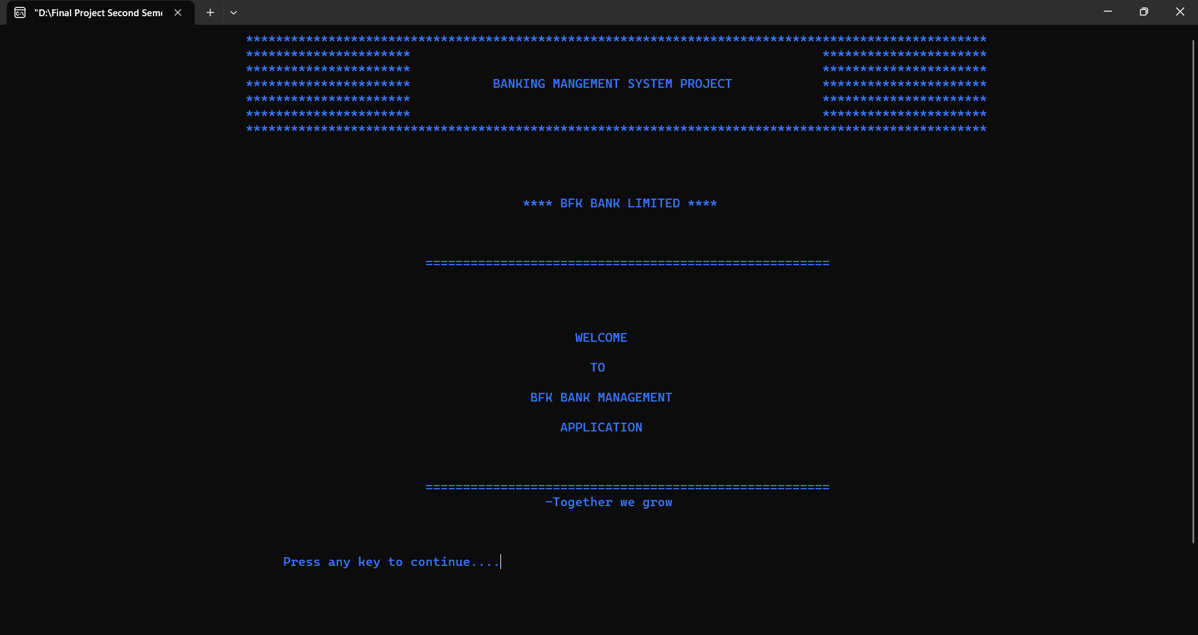

Fig: 18 Welcome Module

2. Login Module

Positive Result:

When the user provides correct Username and Password

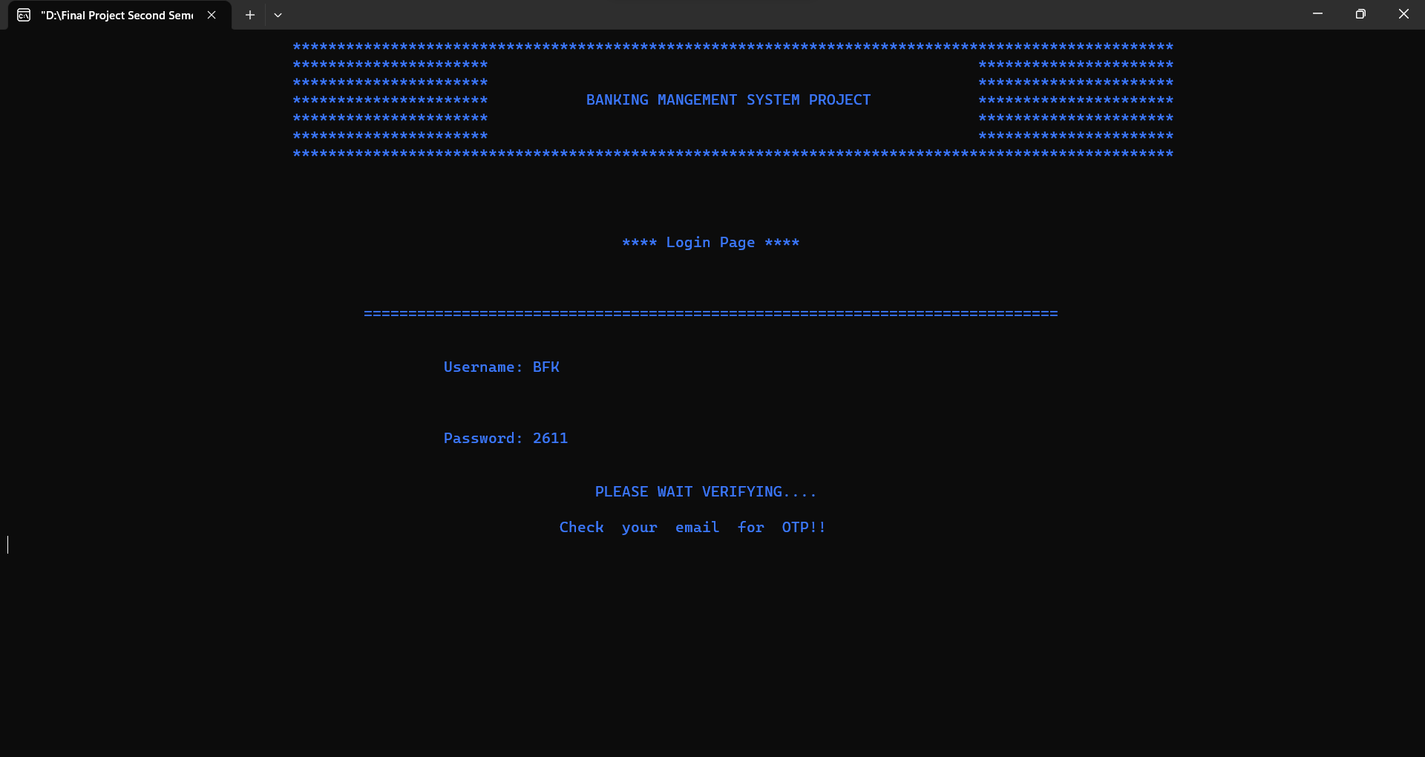

Fig: 19 Login Module (Positive)

Negative Result:

When the user provides wrong Username and Password

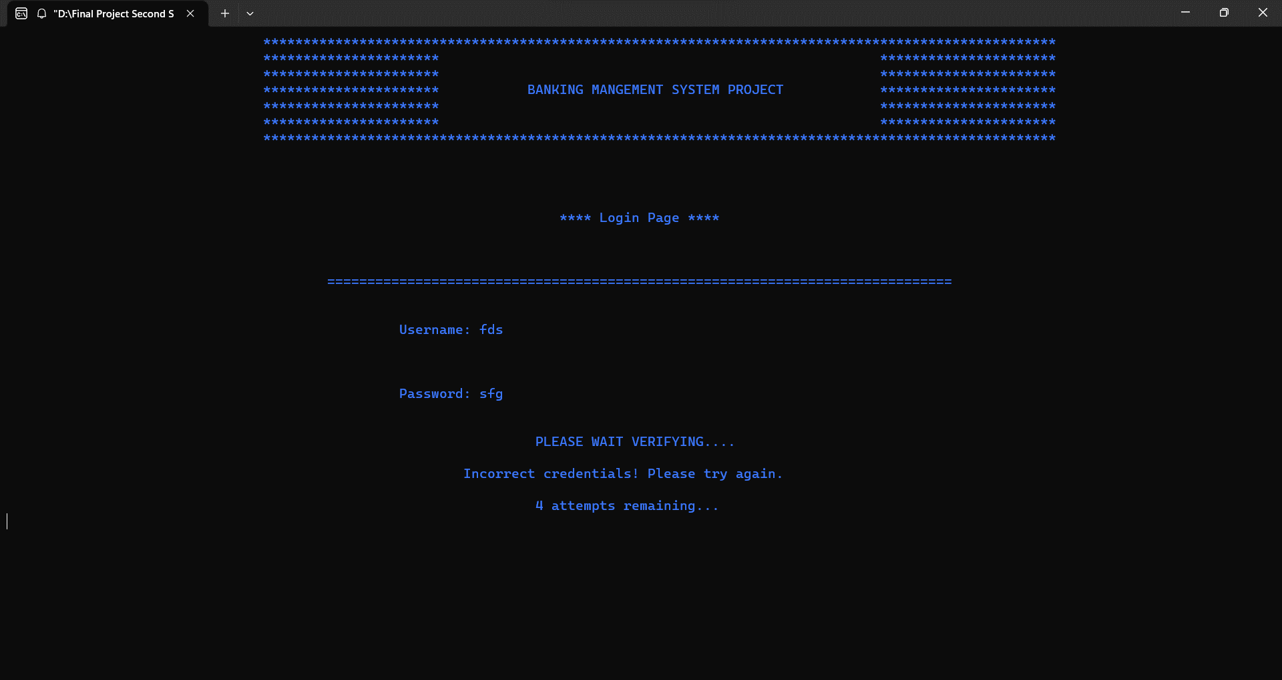

Fig: 20 Login Module (Negative)

3.OTP Module

Positive Result:

When User provide Correct OTP

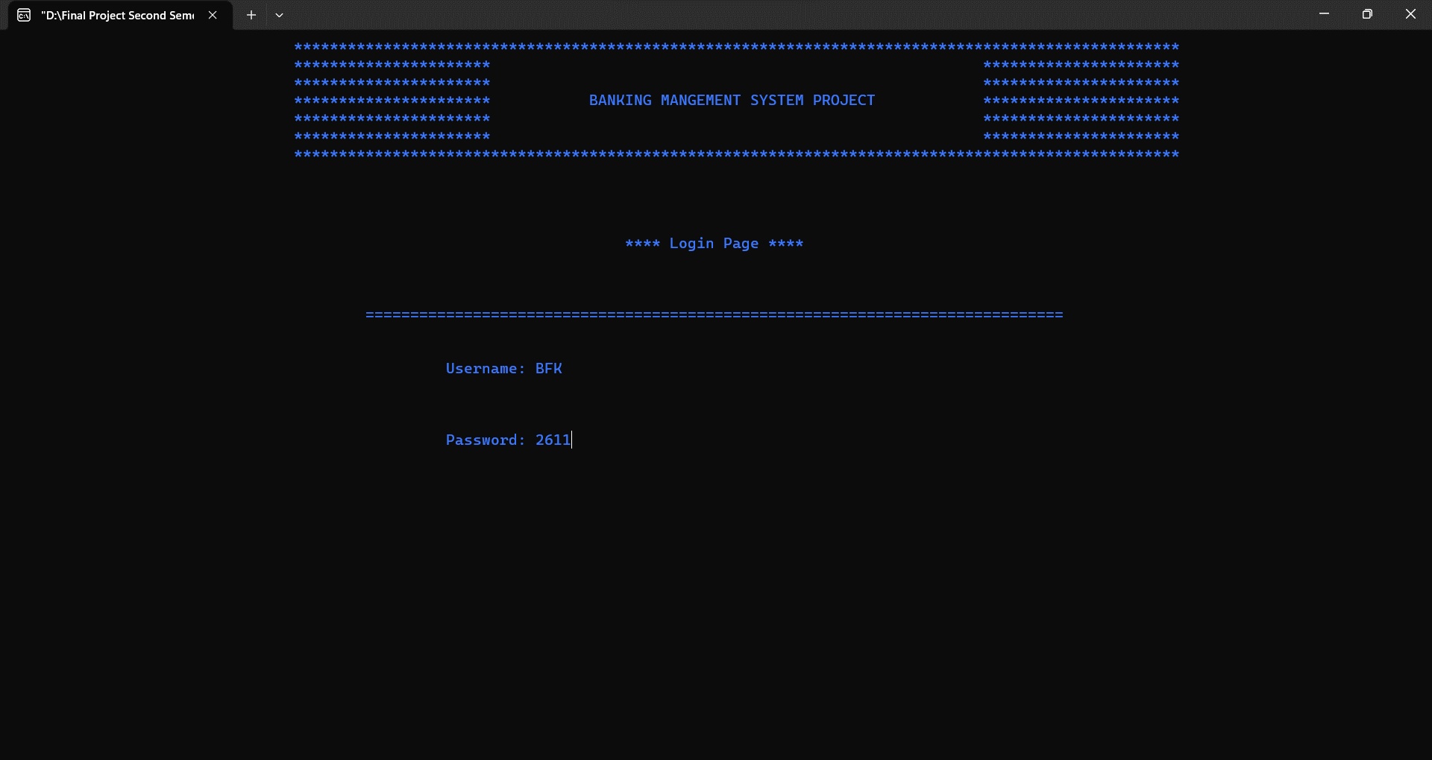

Fig: 21 OTP Module(Positive)

Negative Result:

When User provides incorrect OTP

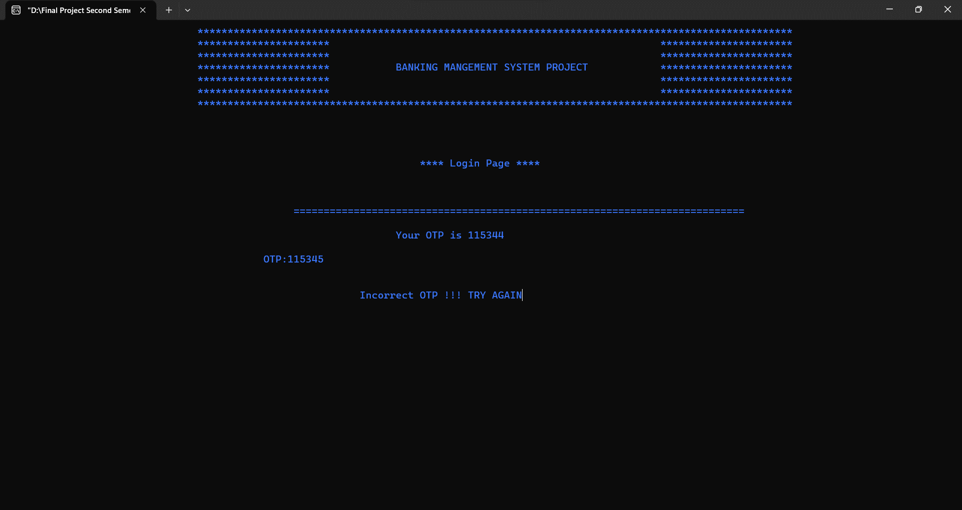

Fig: 22 OTP Module (Negative)

4.Main Menu

Positive Result:

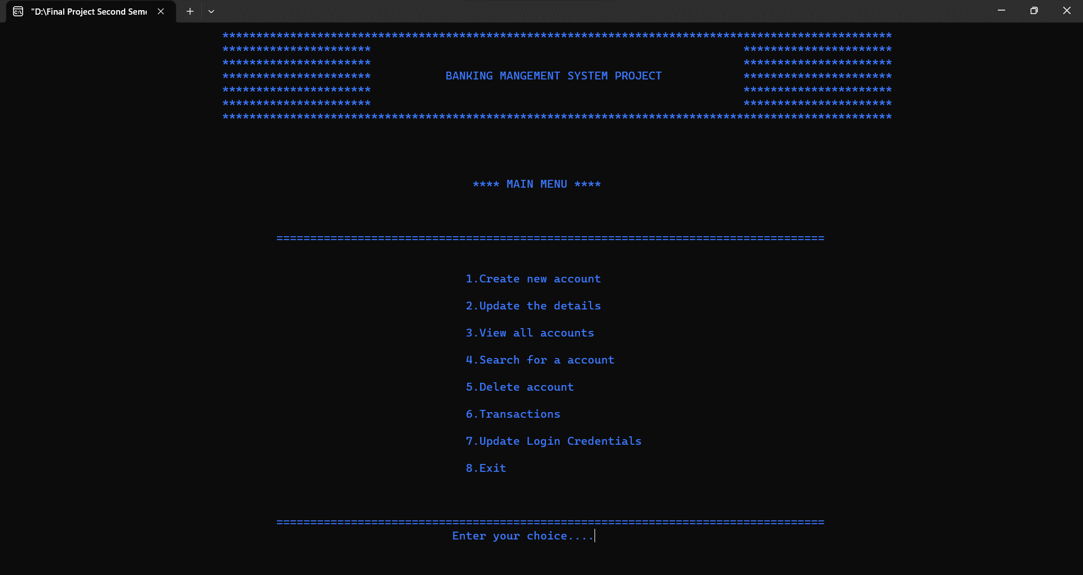

Fig: 23 Main Menu (Positive)

Negative Result:

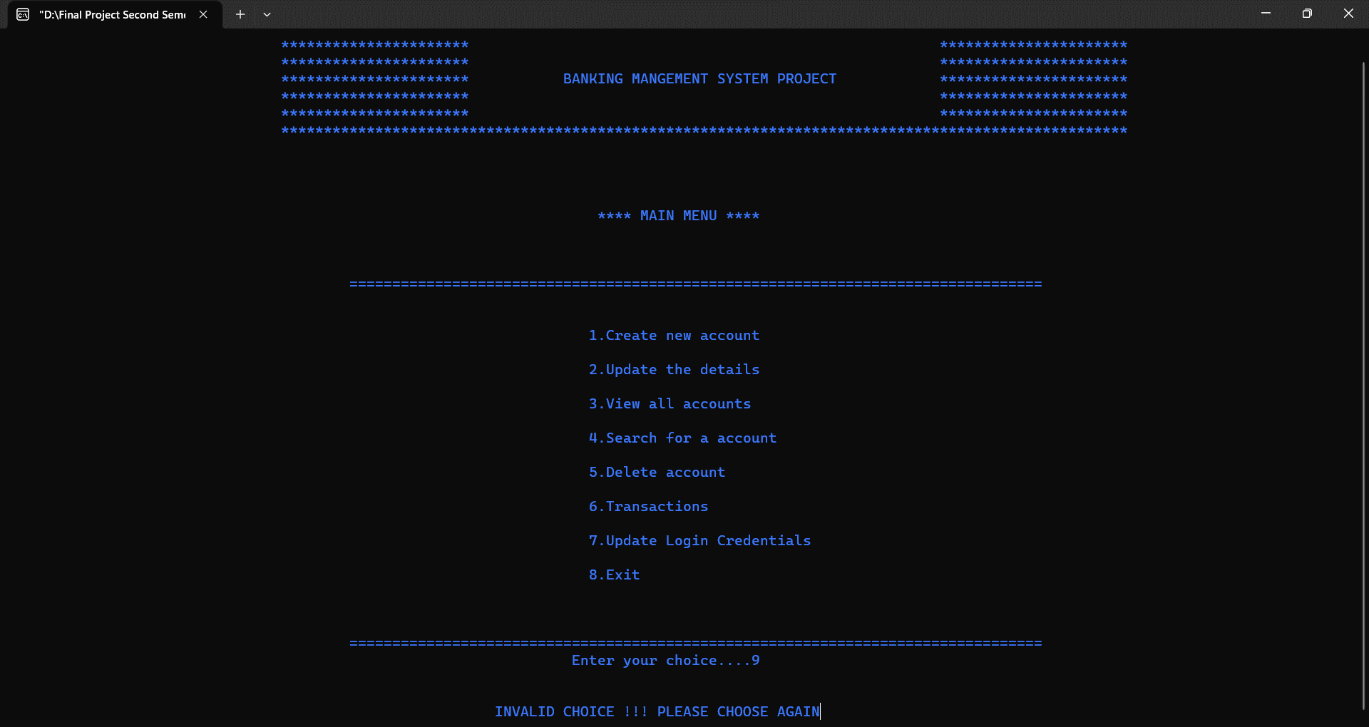

Fig: 24 Main Menu (Negative)

5.New_acc Module

Positive Result:

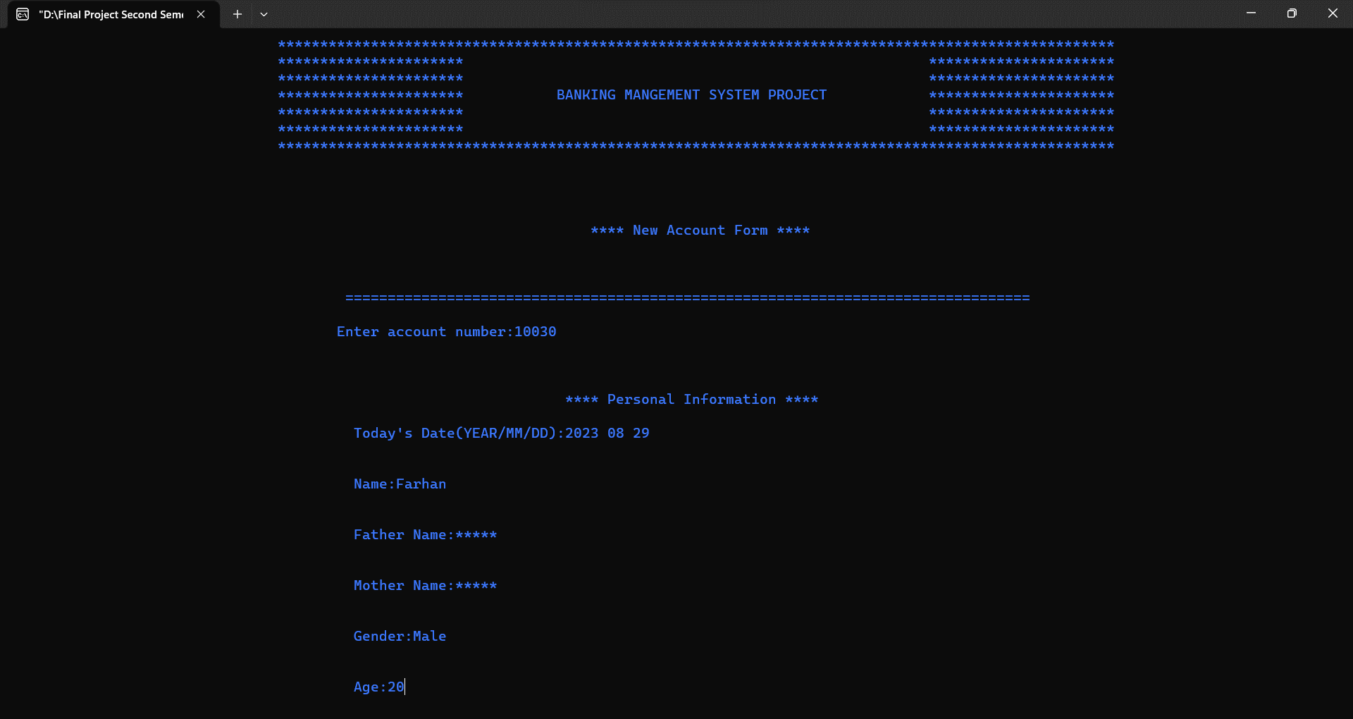

Fig: 25 New_acc Module_Personal Information(Positive)

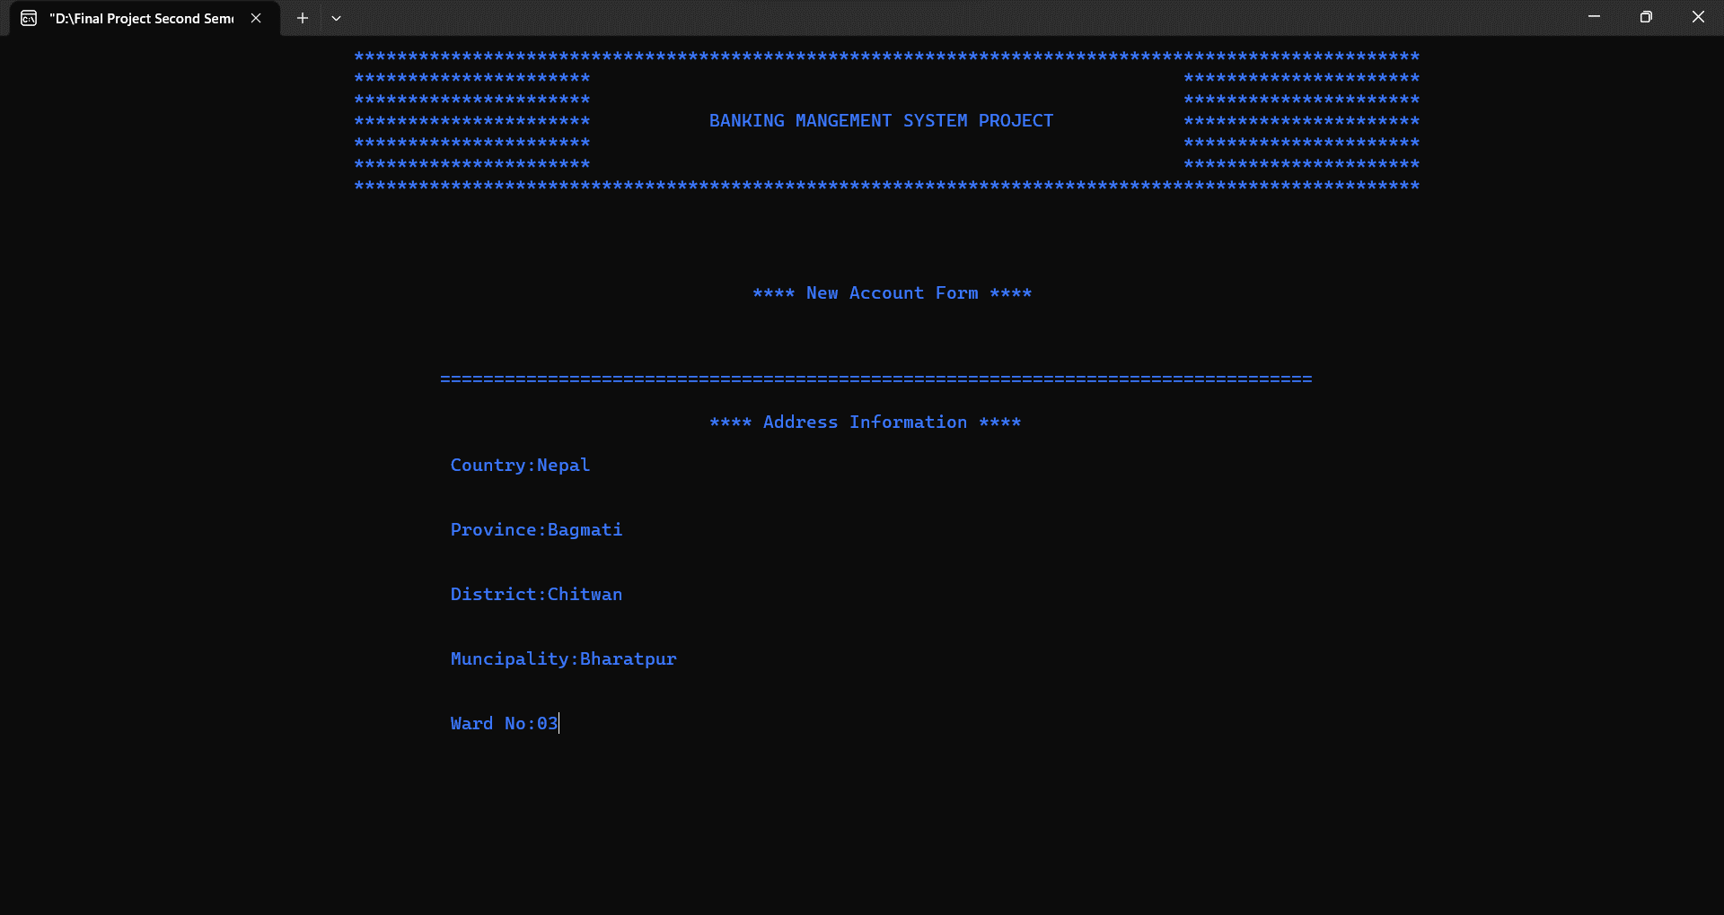

Fig: 26 New_acc Module_Address Information

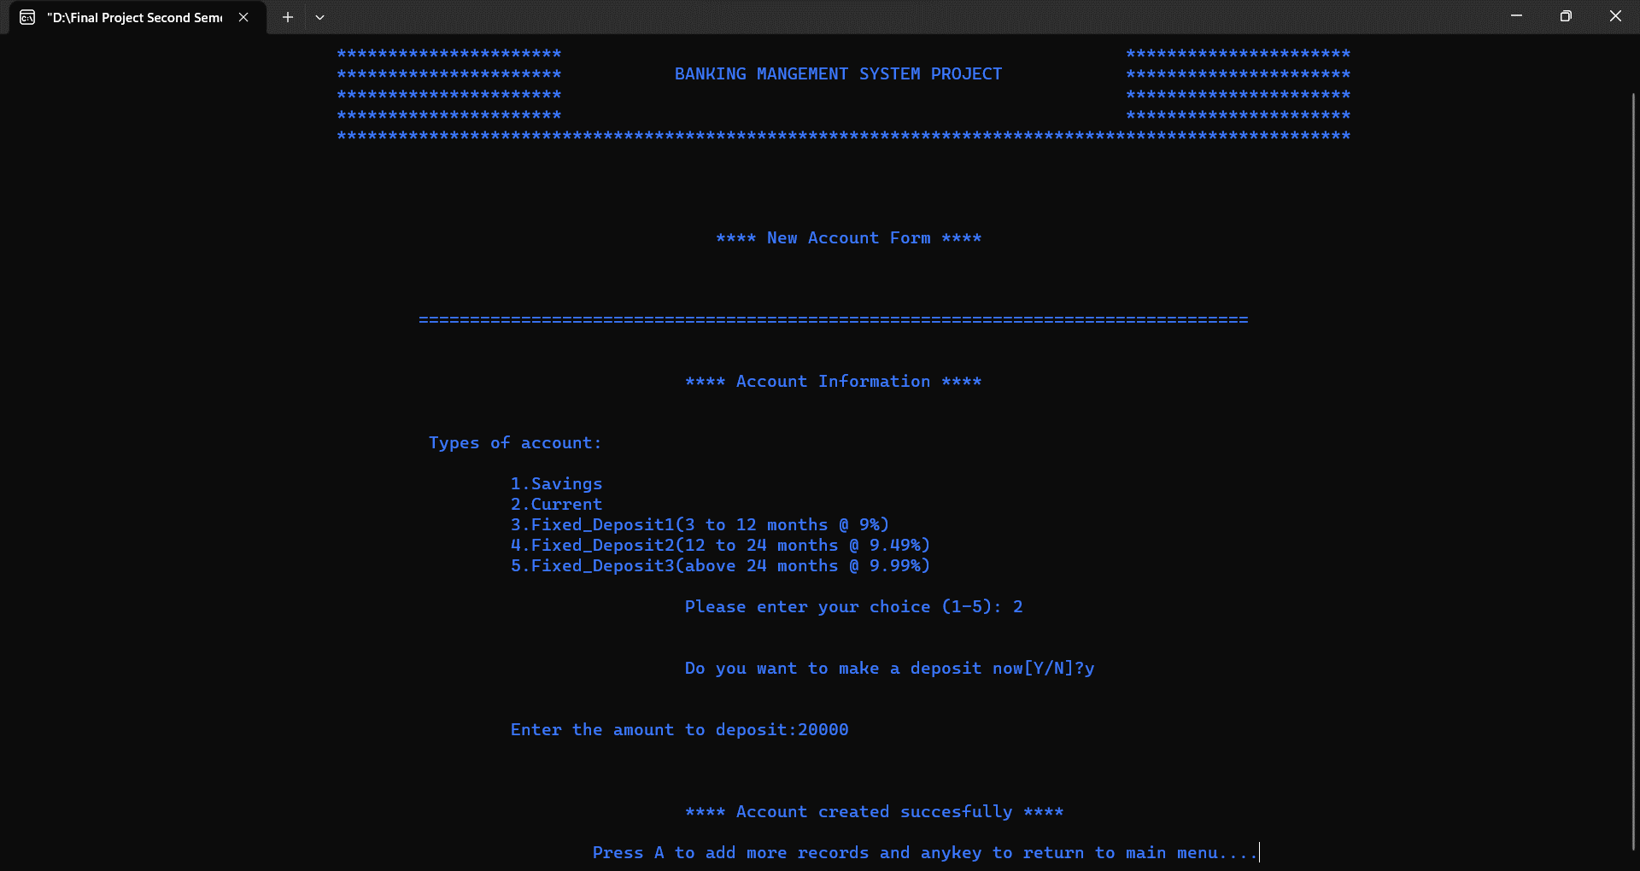

Fig: 27 New_acc Module_Account Information

Negative Result:

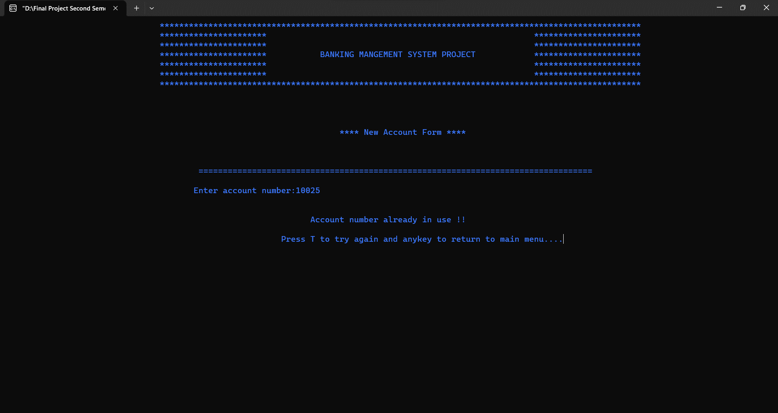

Fig: 28 New_acc Module(Negative)

6.Update_acc Module

Positive Result:

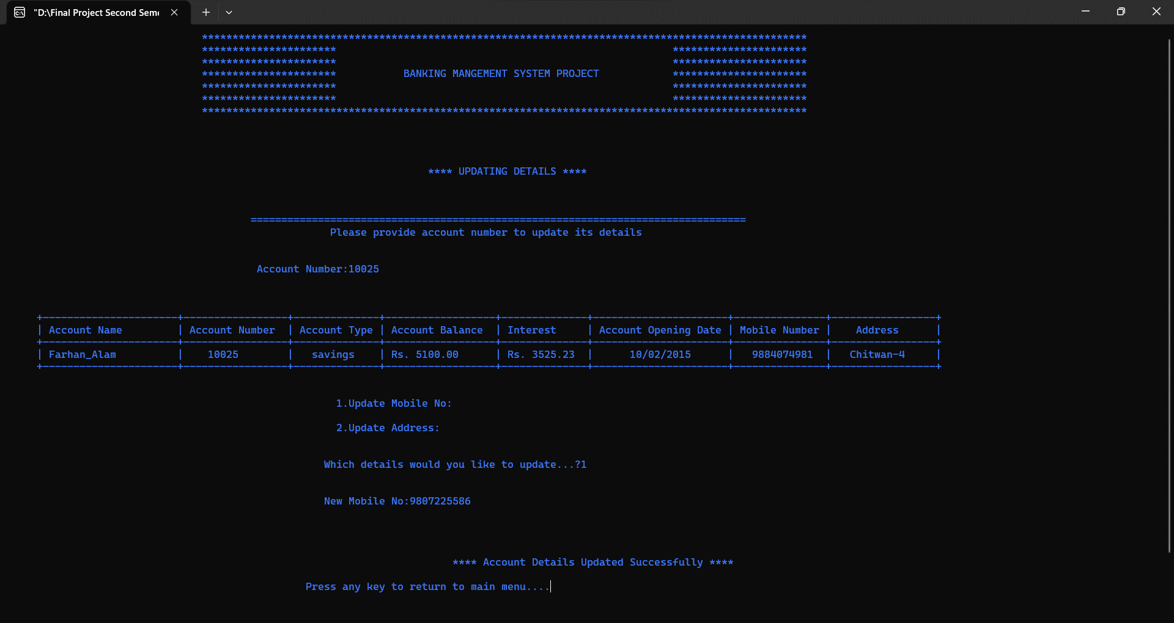

Fig: 29 Update_acc Module_Mobile_no(Positive)

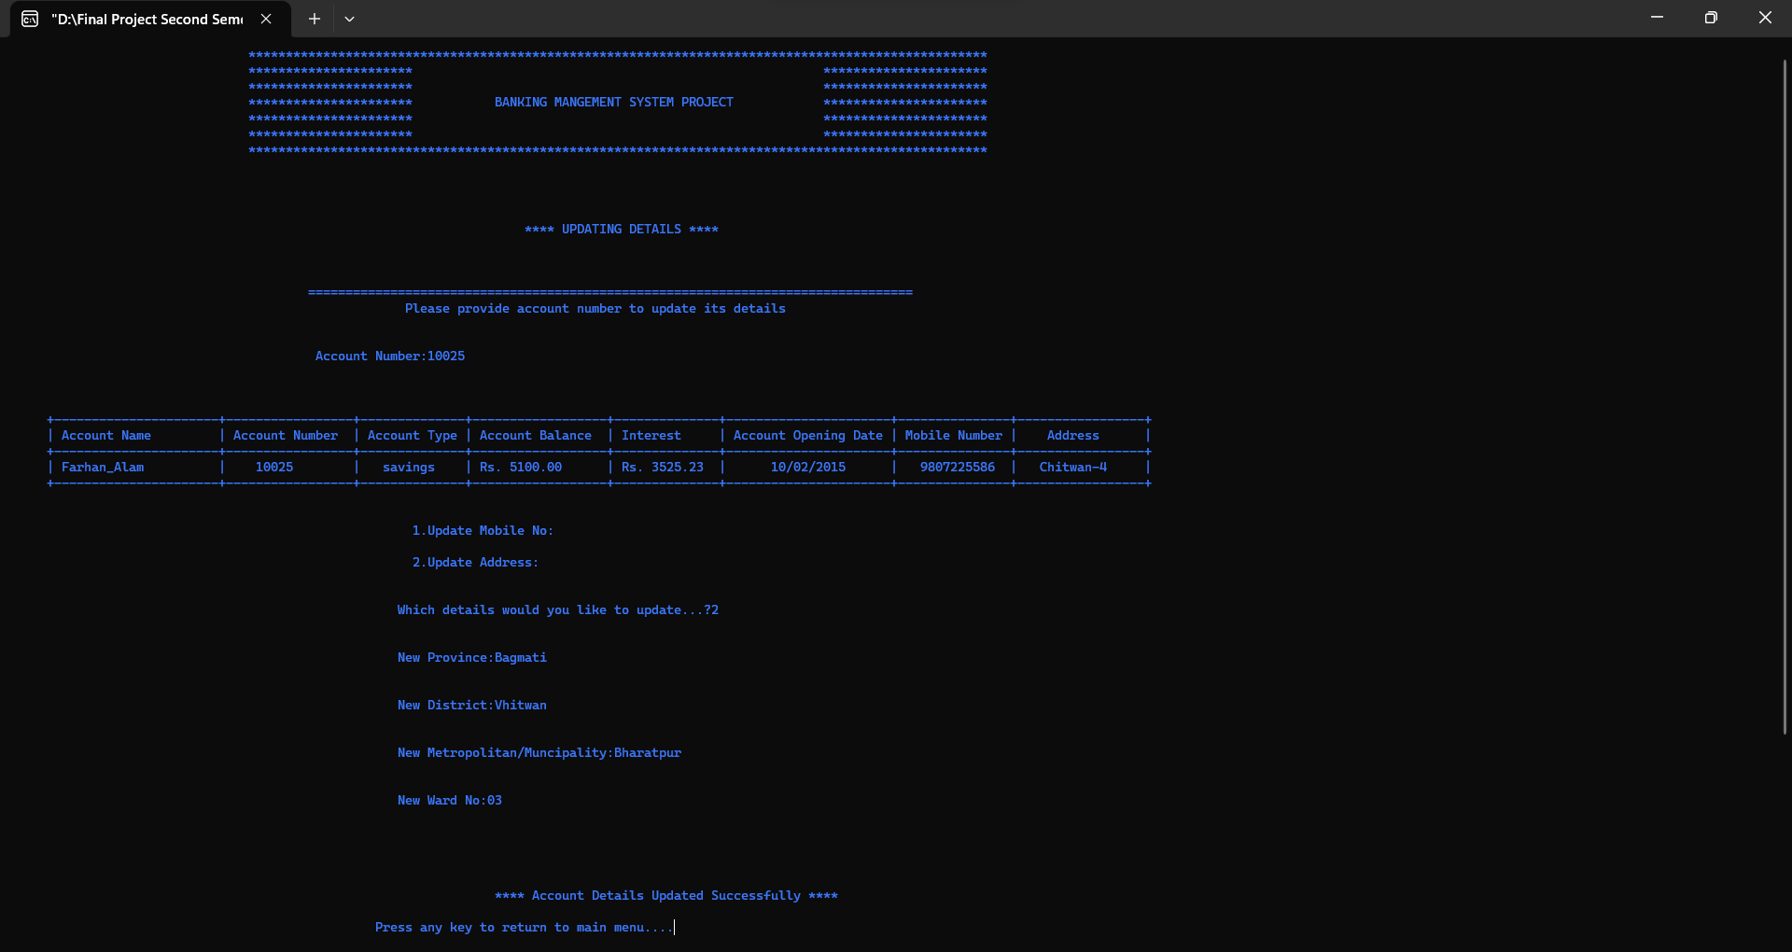

Fig: 30 Update_acc Module _Address(Positive)

Negative Results:

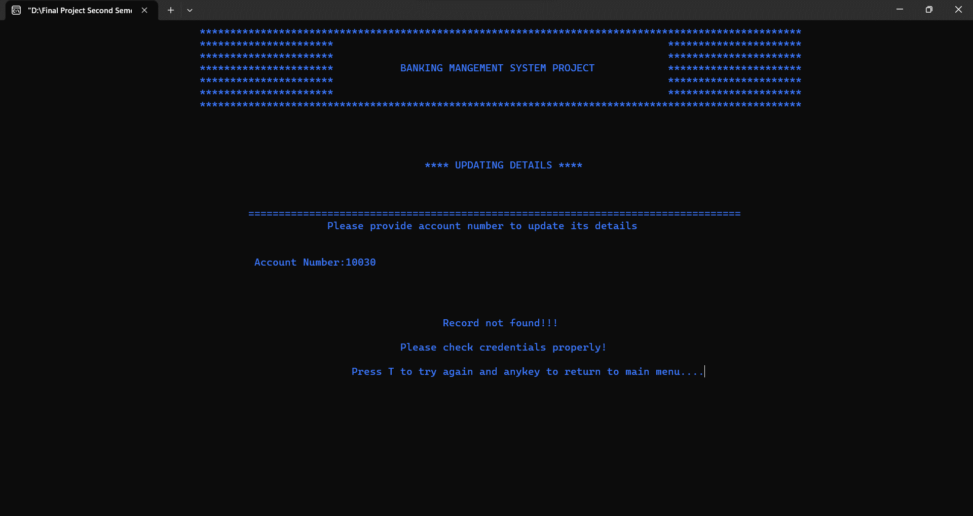

Fig: 31Update_acc Module (Negative)

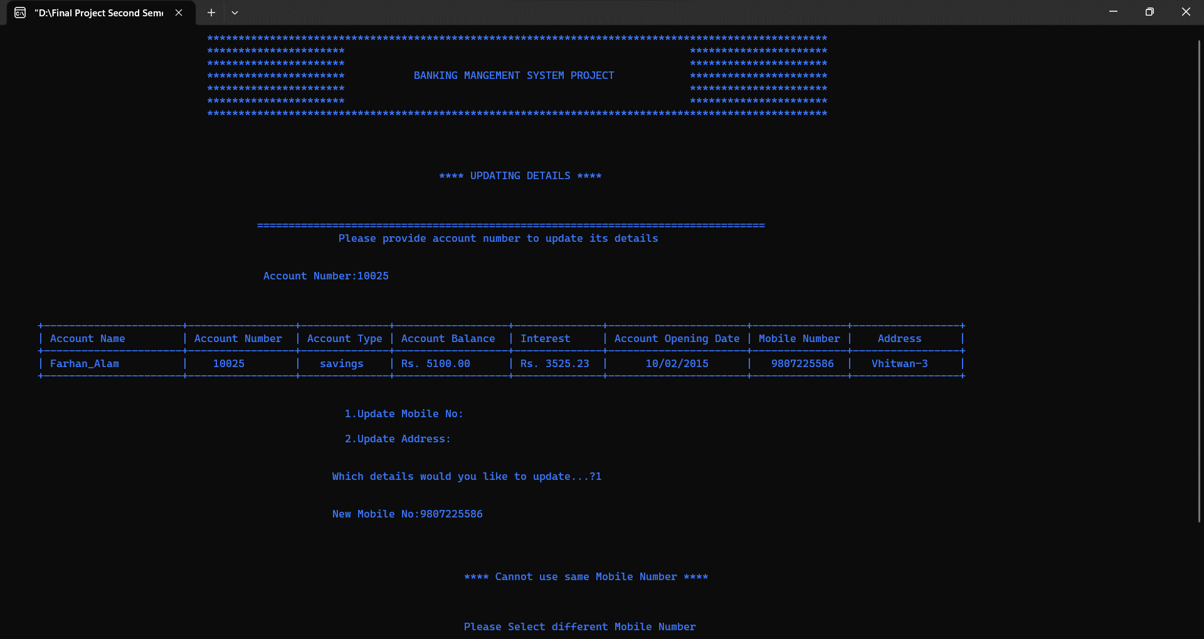

Fig: 32Update_acc Module_Mobile_no(Negative)

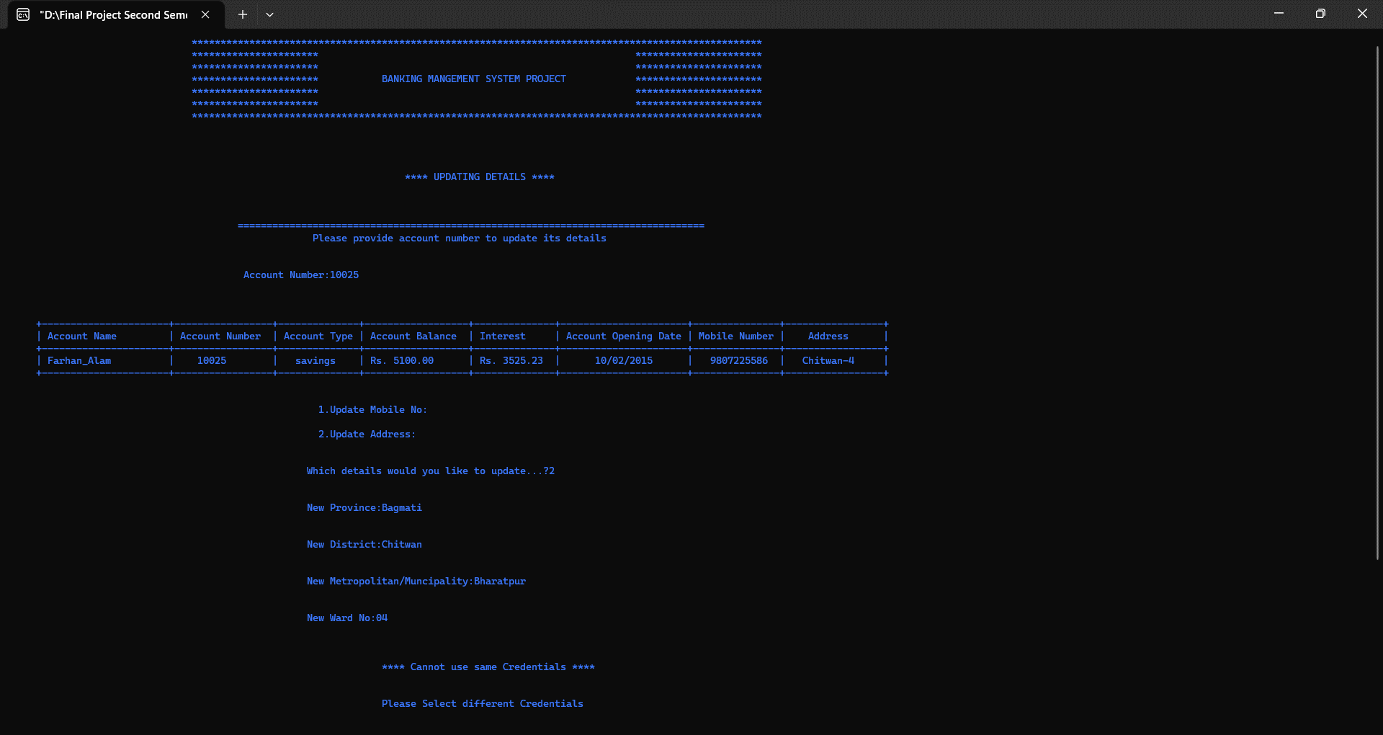

Fig: 33Update_acc Module _Address(Negative)

5.View_all_acc Module

Positive result:

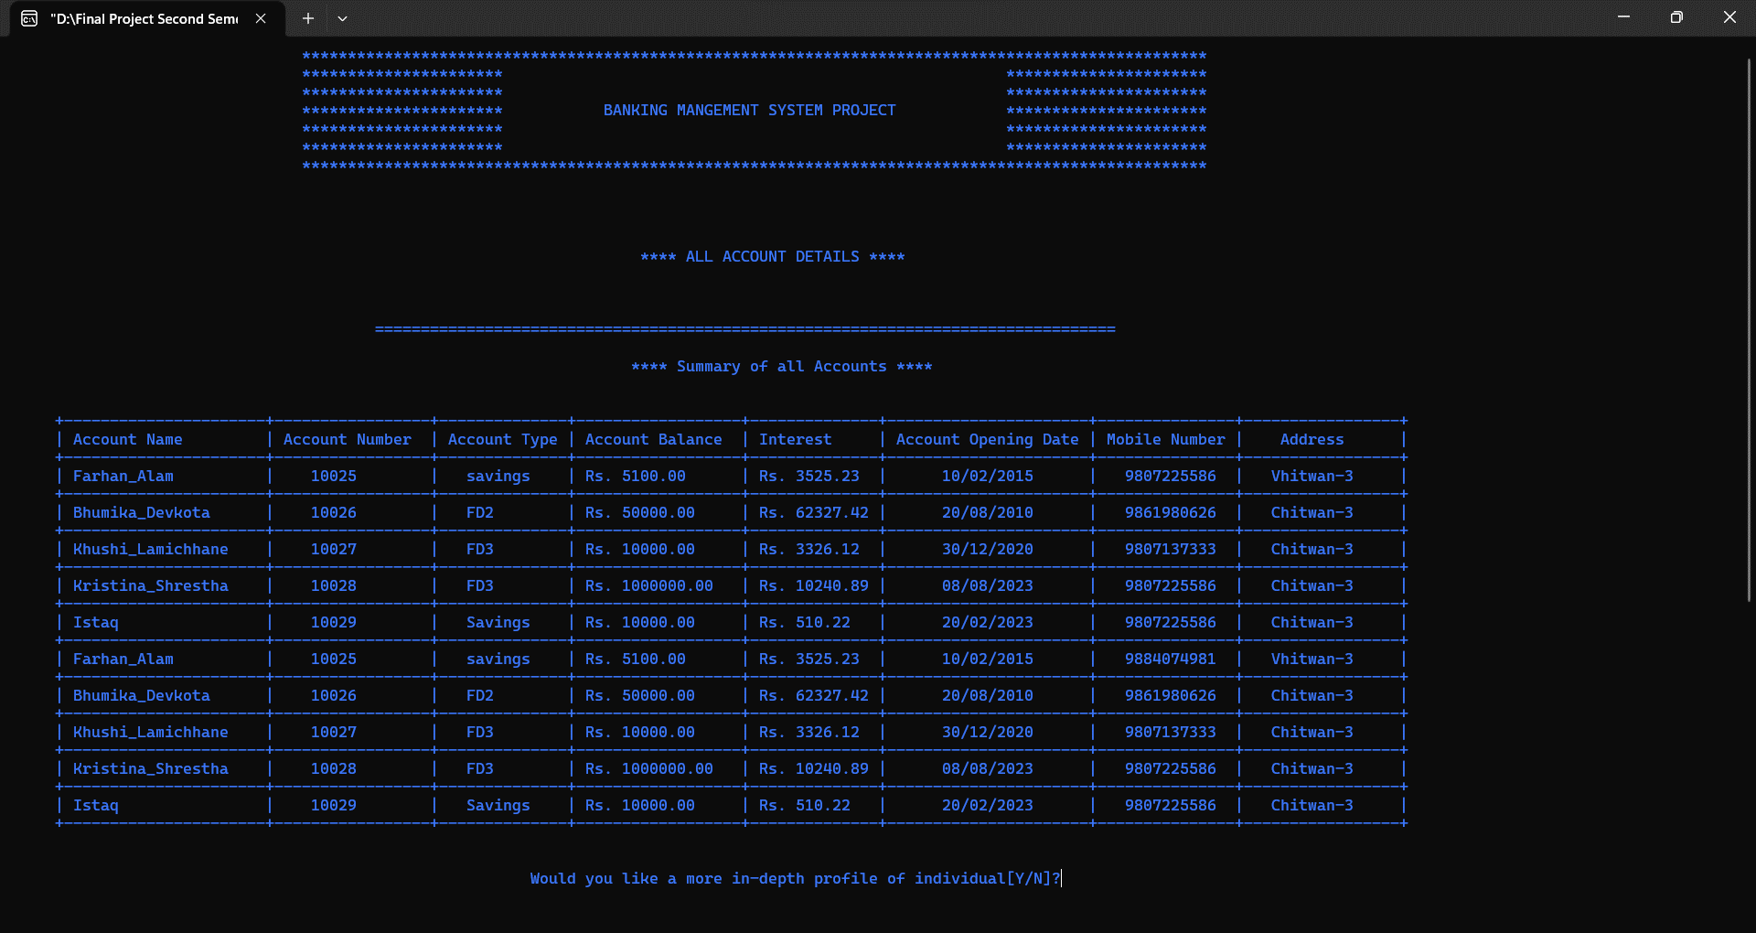

Fig: 34 View_all_acc Module(Positive)

Negative Results:

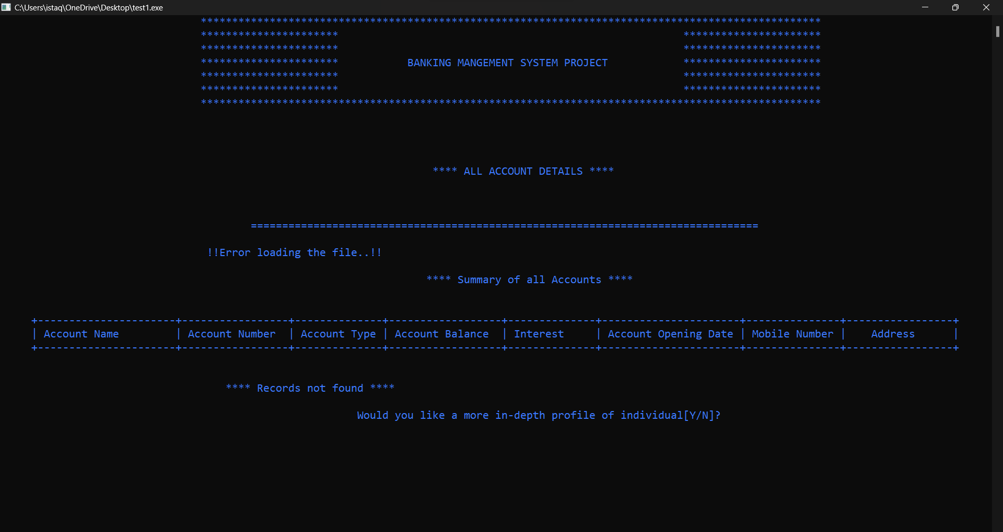

Fig: 35 View_all_acc Module(Negative)

6.Search_acc Module

Positive Result:

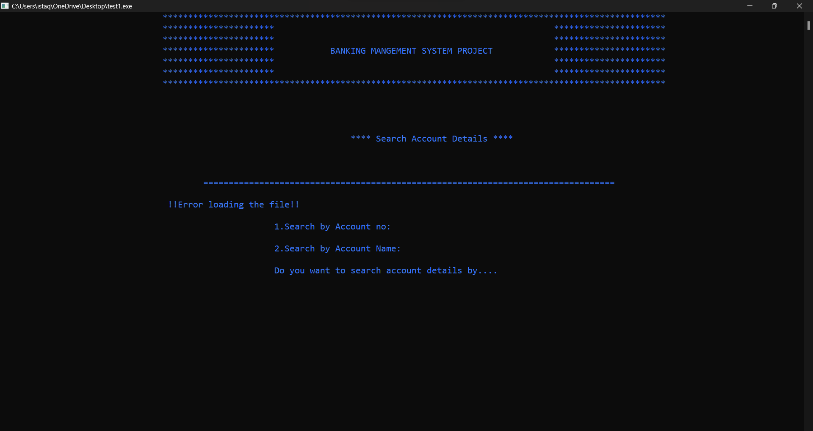

Fig: 36 Search_acc Module(Positive)

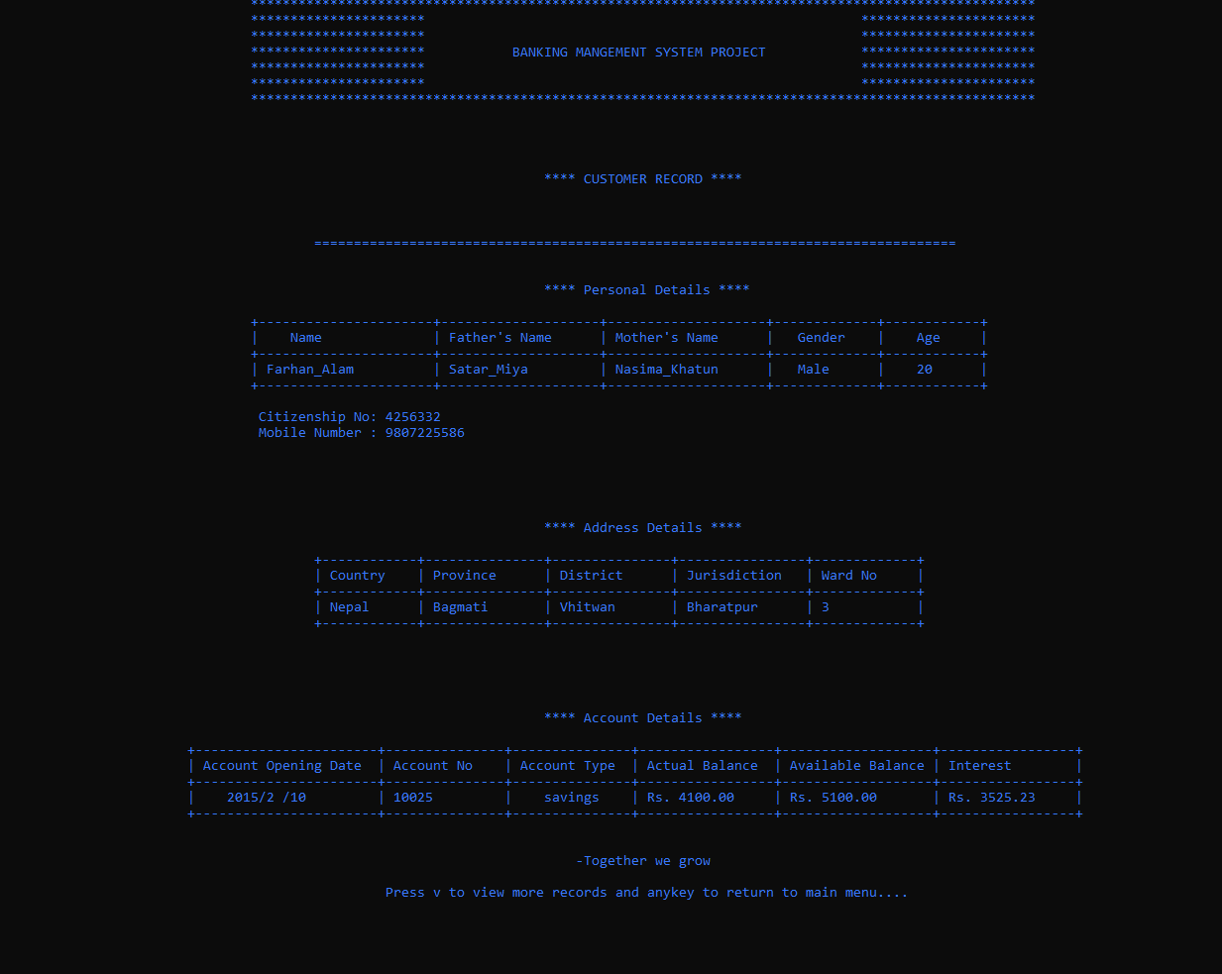

Fig: 37 Search_acc Module_Account_no(Positive)



Fig: 38 Search_acc Module_Account_Name(Positive)

Negative Results:

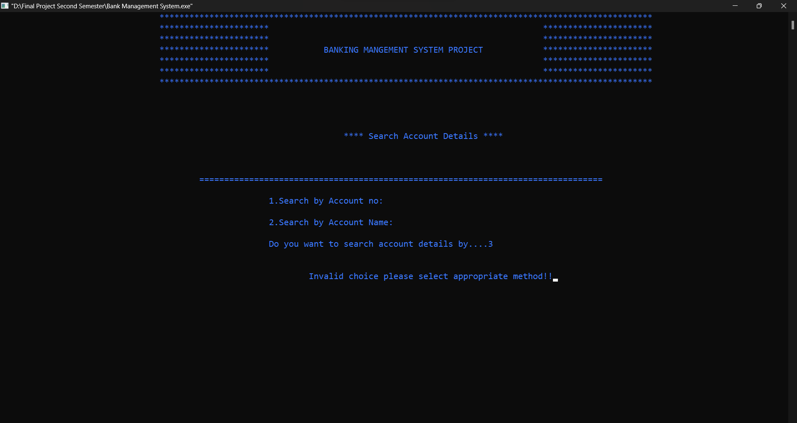

Fig: 39Search_acc Module(Negative)

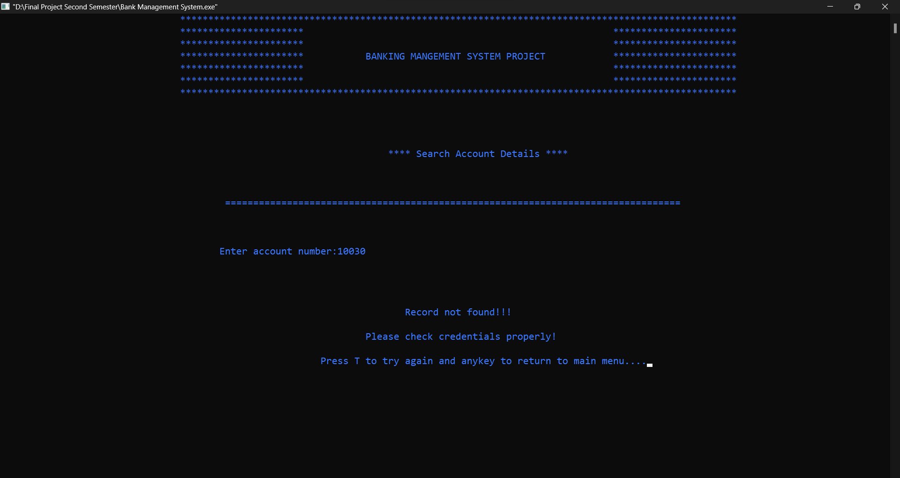

Fig: 40 Search_acc Module_Account_no(Negative)

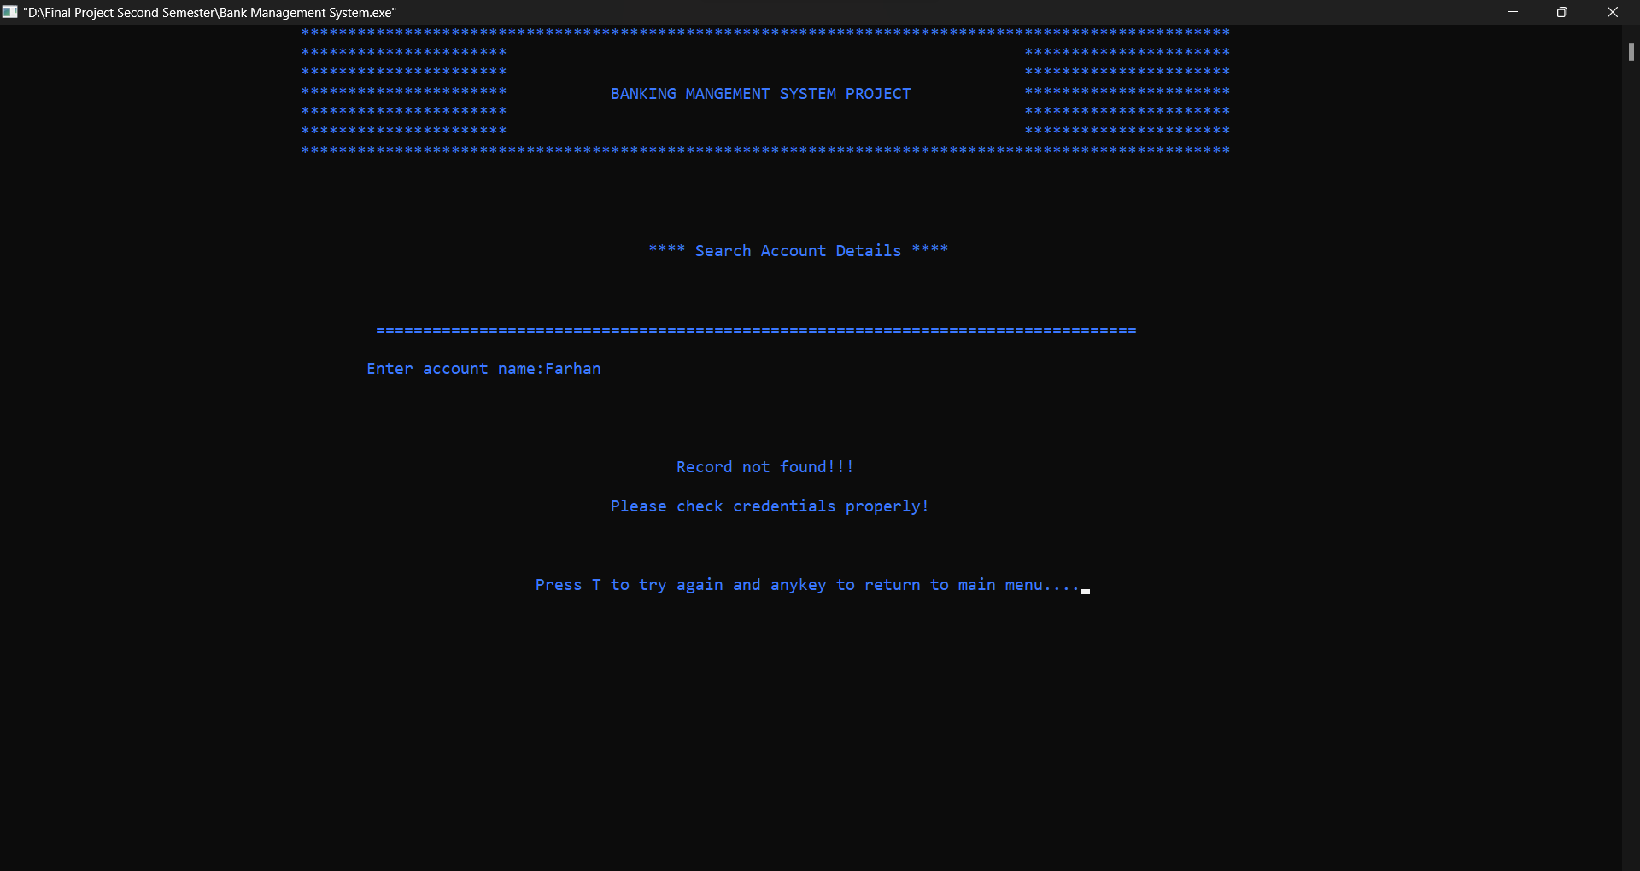

Fig: 41 Search_acc Module_Account_name(Negative)

7.Delete_acc Module

Positive Results:

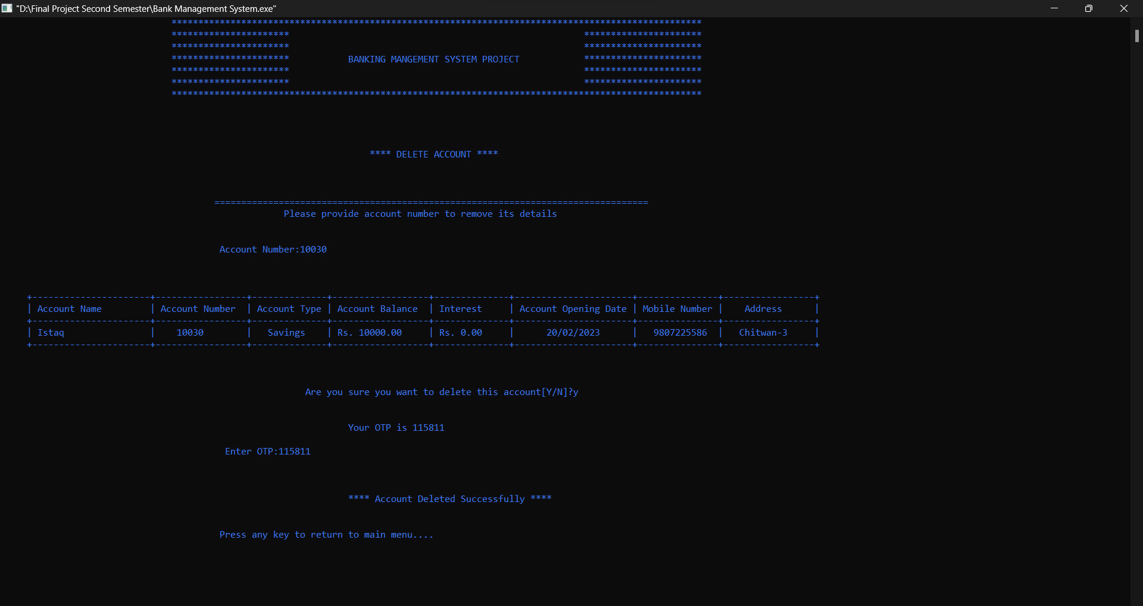

Fig: 42 Delete_acc Module(Positive)

Negative Results:

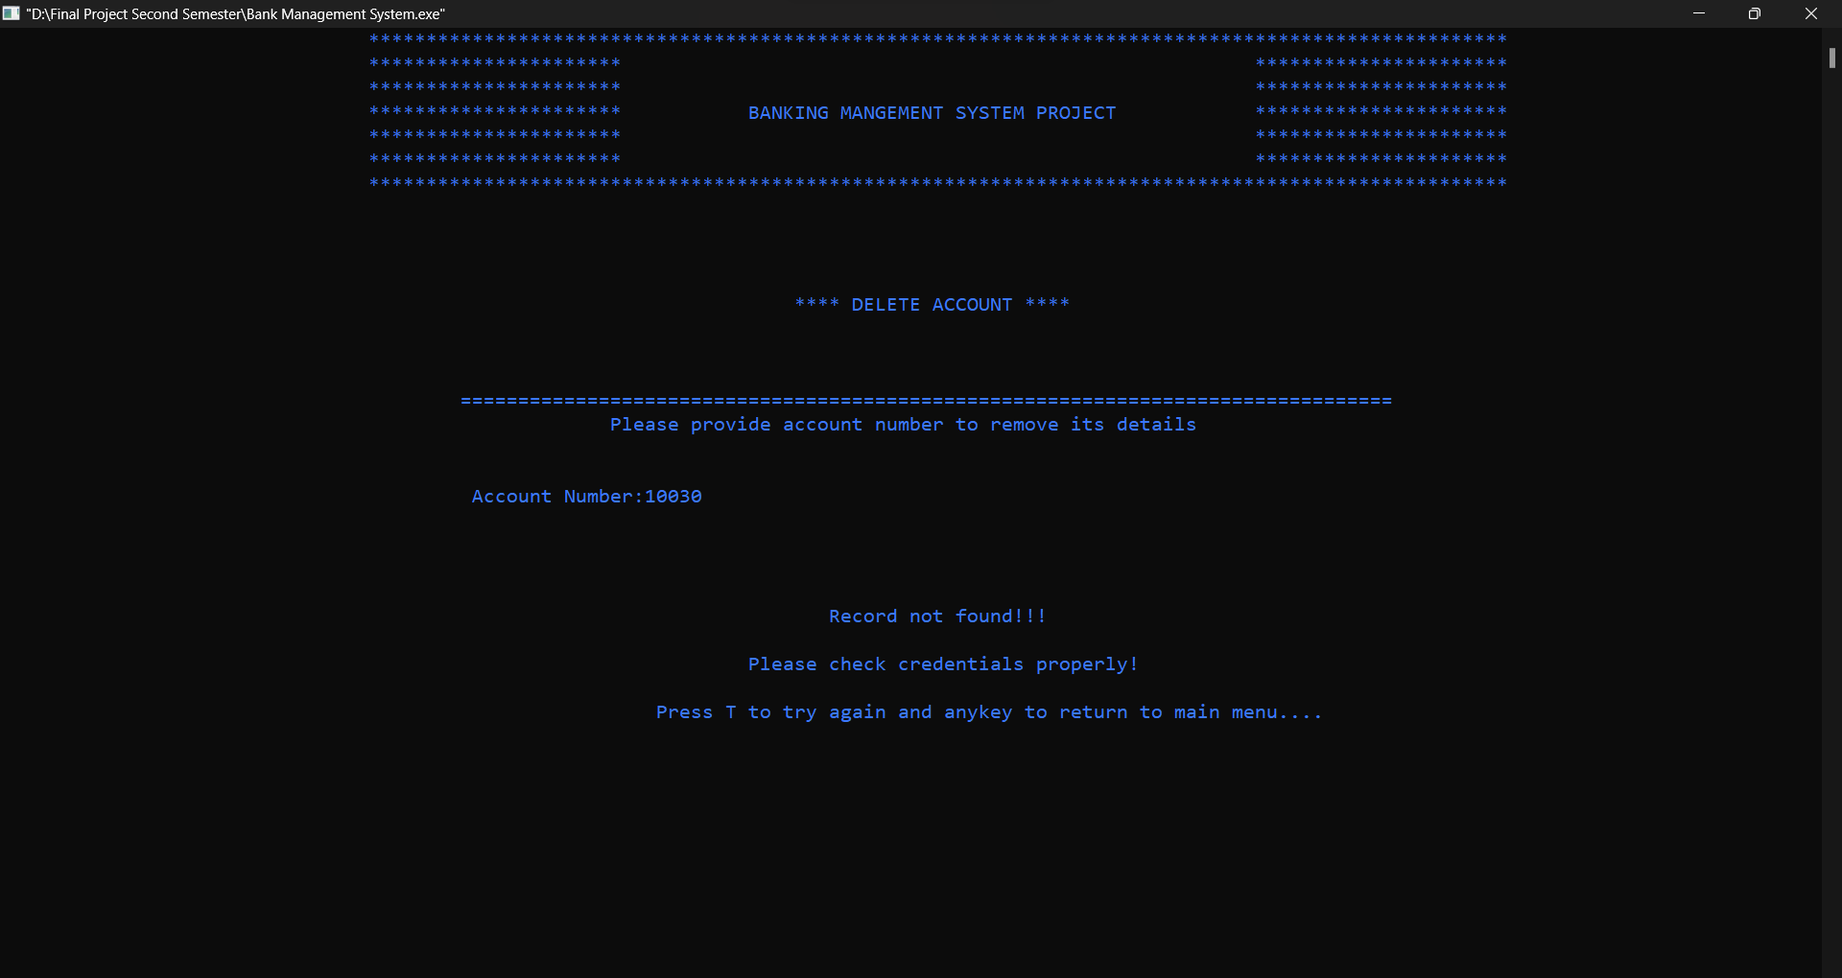

Fig: 43 Delete_acc Module(Negative)

8.Transactions

Positive Results:

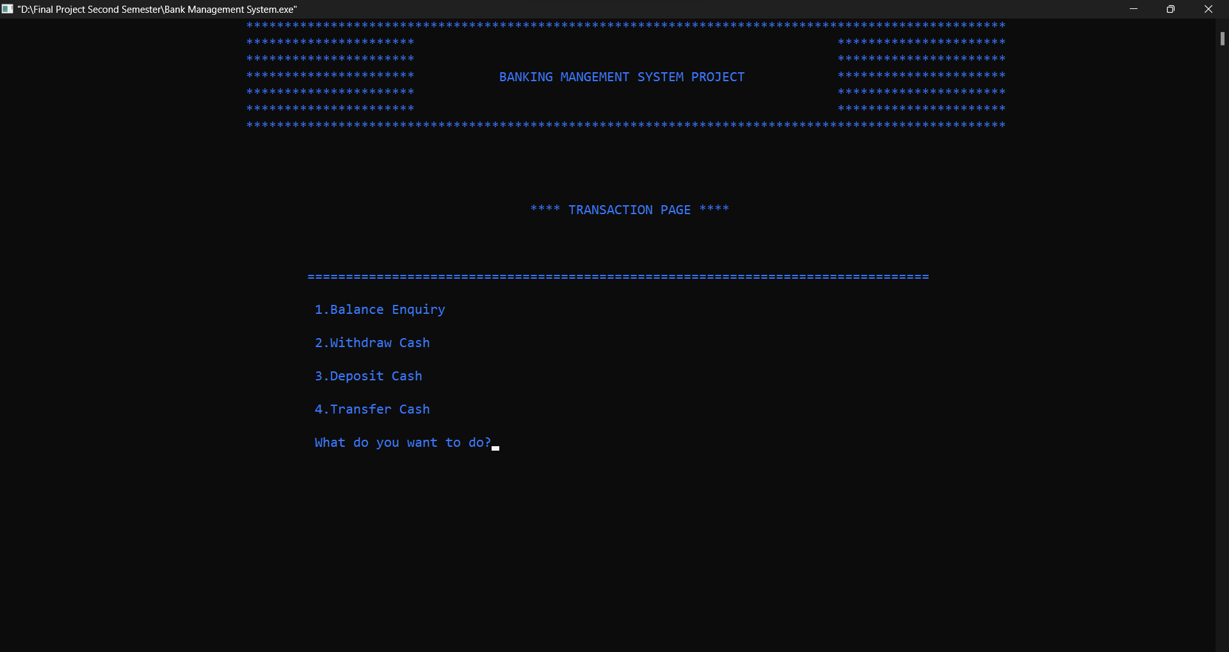

Fig: 44 Transaction Module(Positive)

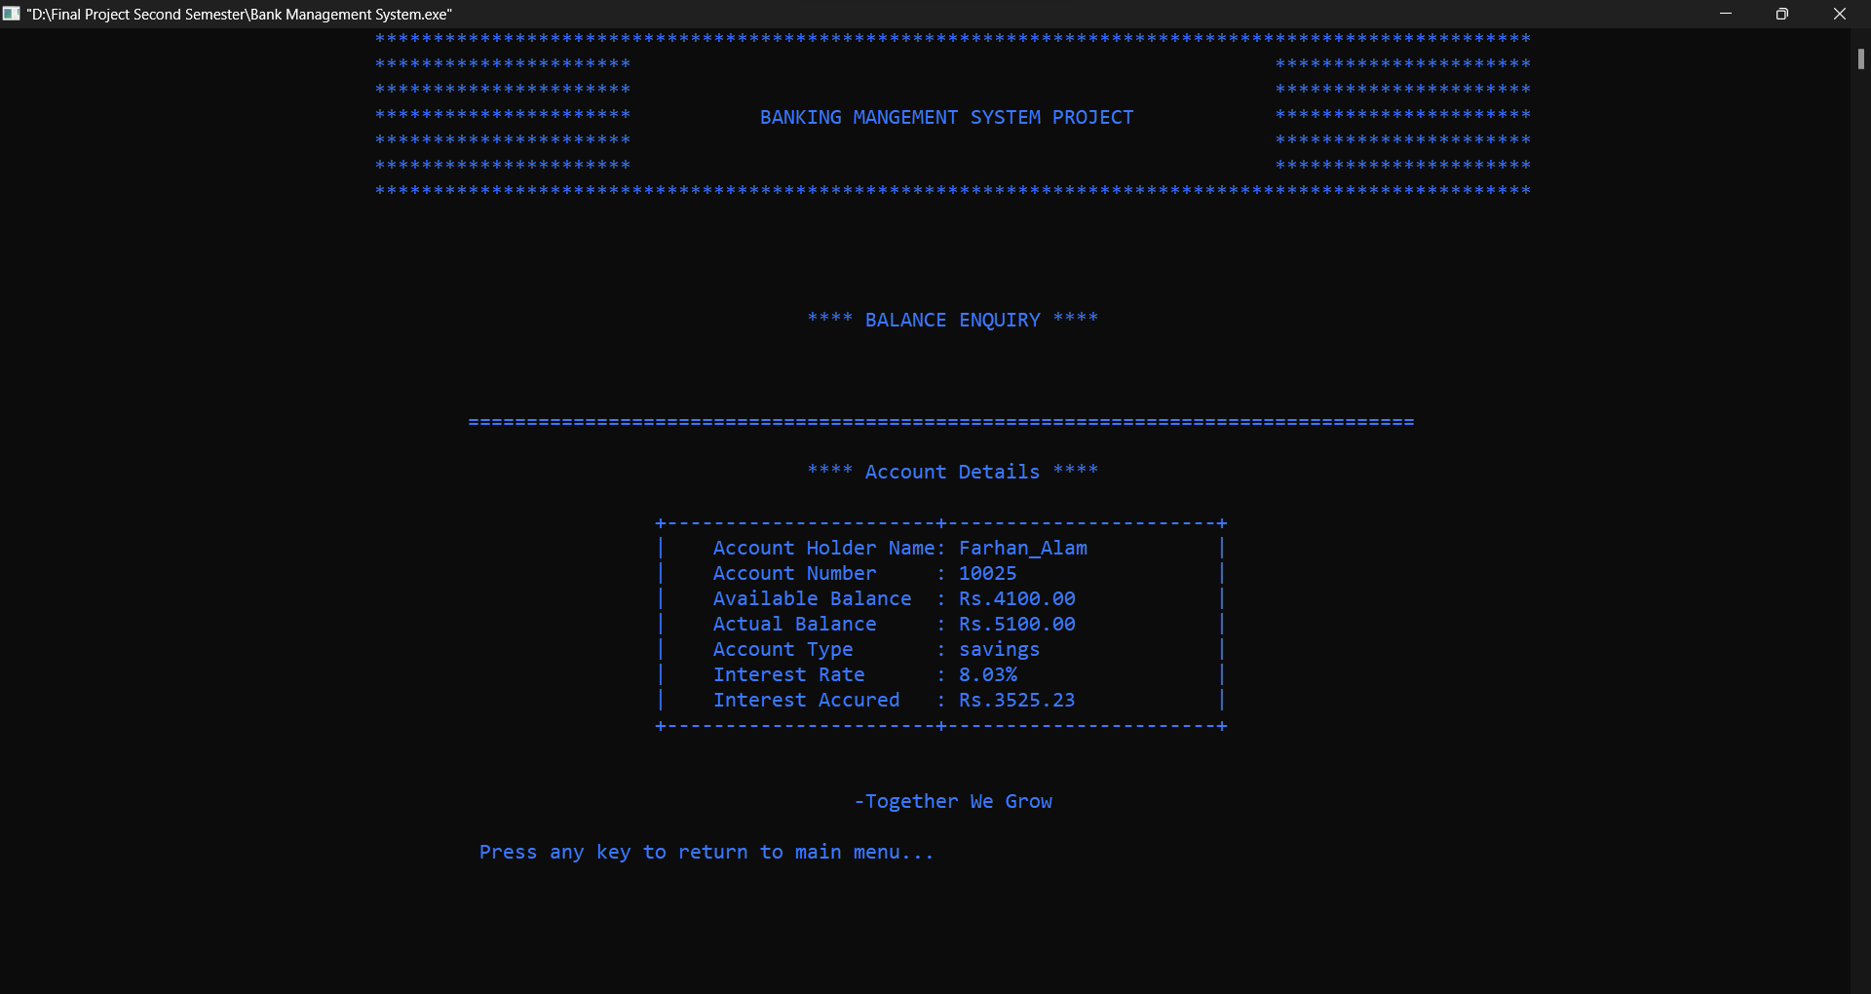

Fig: 45 Transaction Module_Balance_Enquiry(Positive)

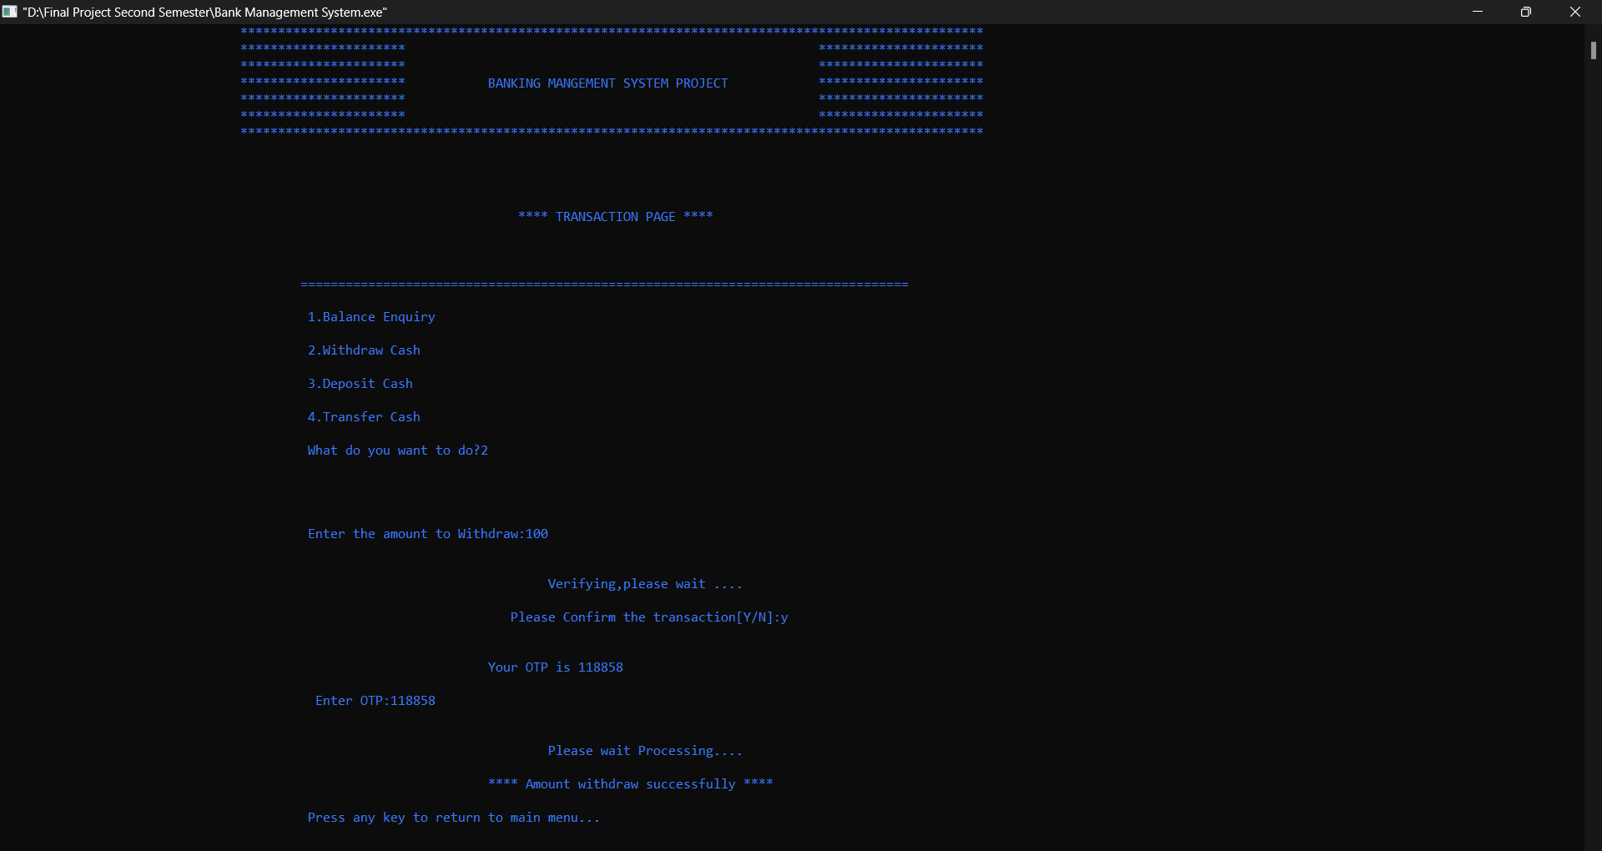

Fig: 46 Transaction Module_Withdraw(Positive)

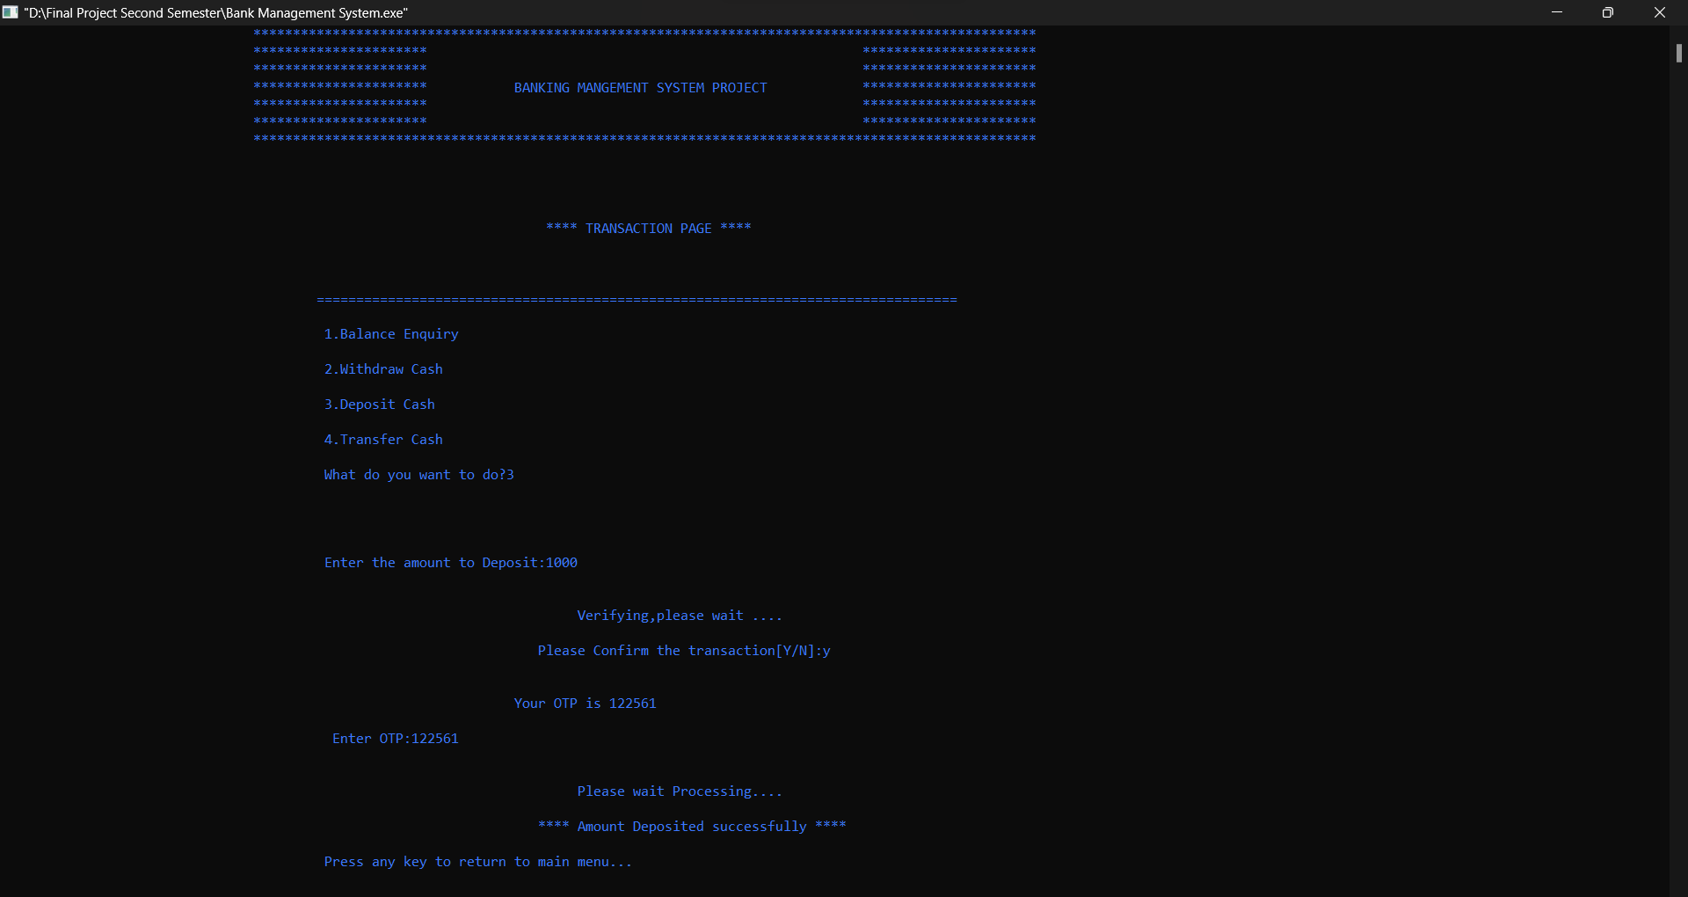

Fig: 47 Transaction Module_Deposit(Positive)

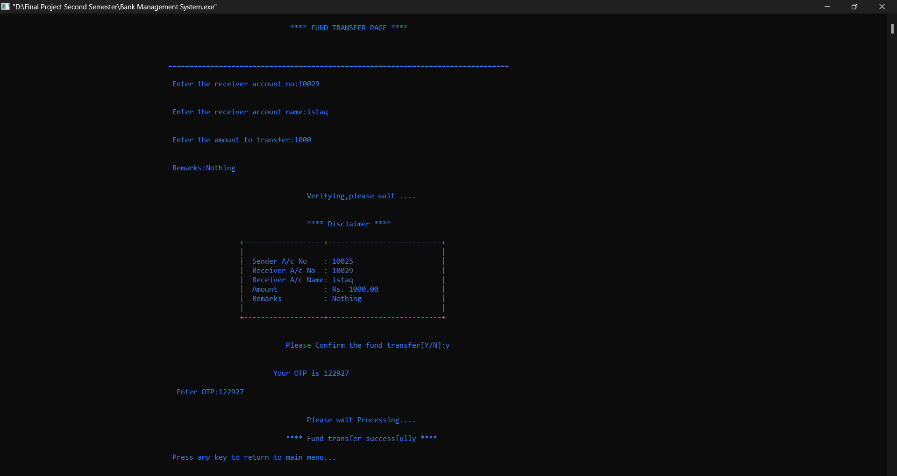

Fig: 48Transaction Module_Fund_Transfer(Positive)

Negative Results:

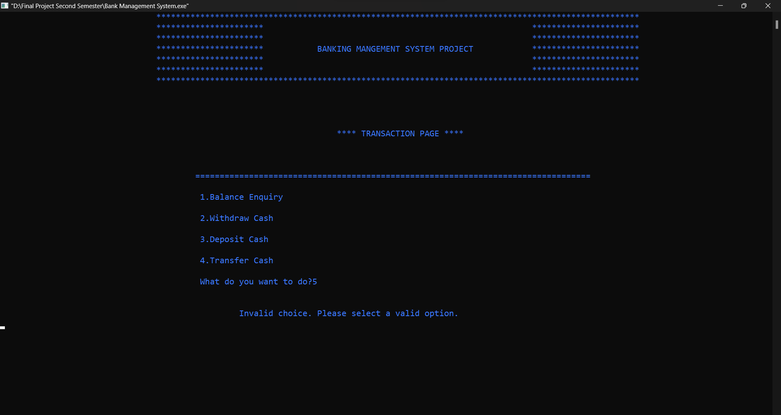

Fig: 49 Transaction Module(Negative)

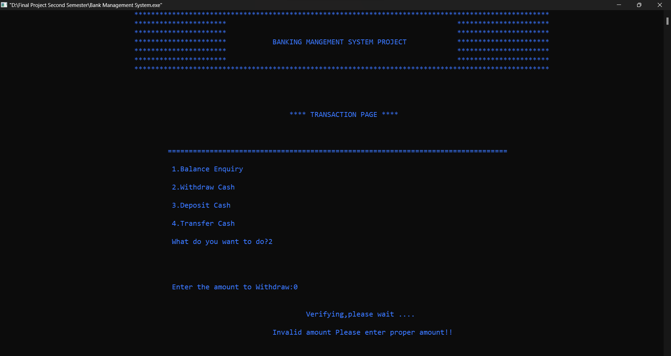

Fig: 50 Transaction Module_Withdraw(Negative)

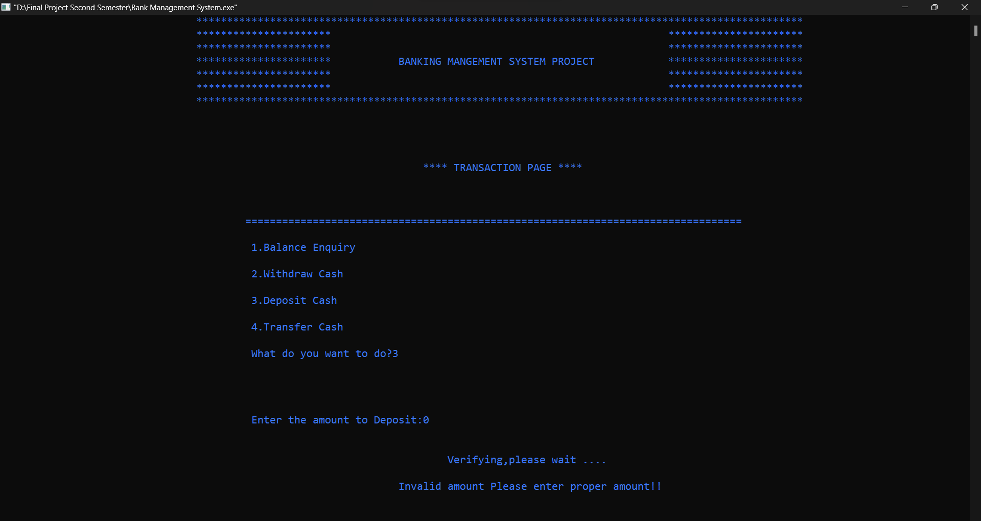

Fig: 51 Transaction Module_Withdraw(Positive)

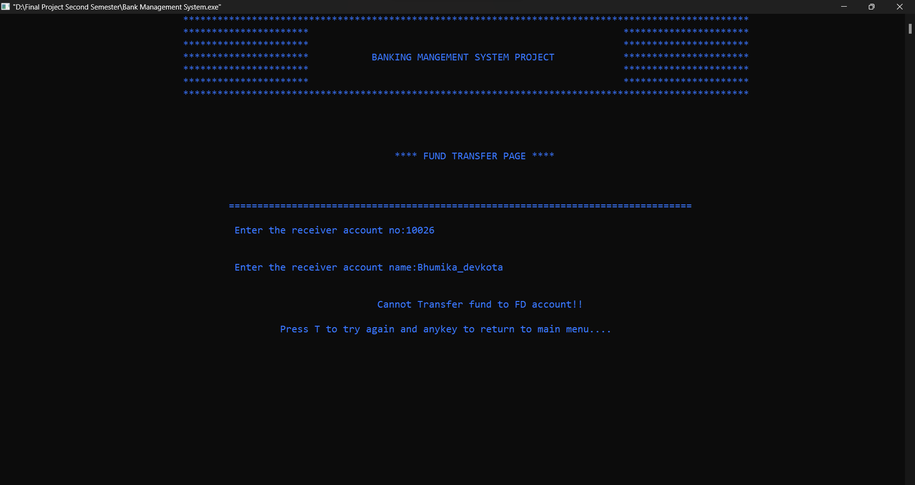

Fig: 52 Transaction Module_Fund_Transfer(Negative)

9.Update_Login_Credentials

Positive Results:

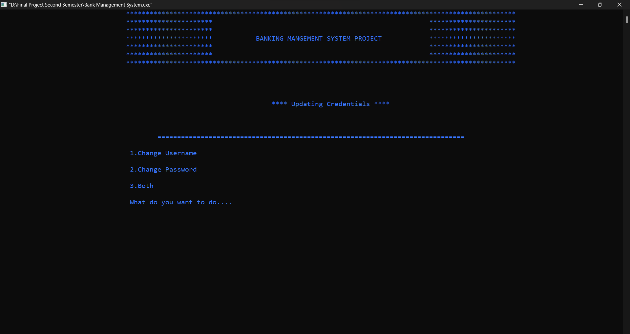

Fig: 53 Update_Login_Credentials(Positive)

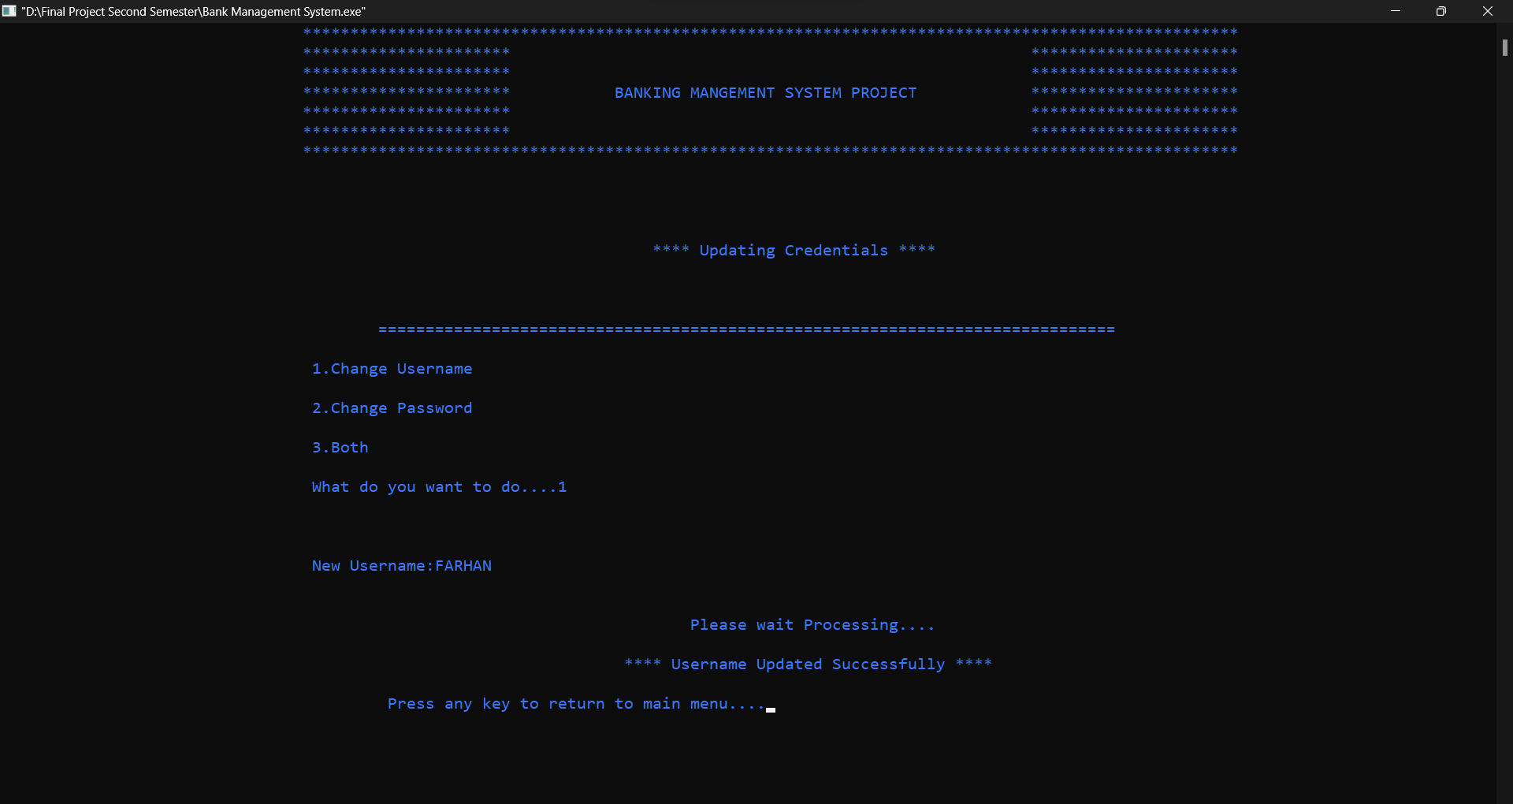

Fig: 54 Update_Login_Credentials_UserName(Positive)

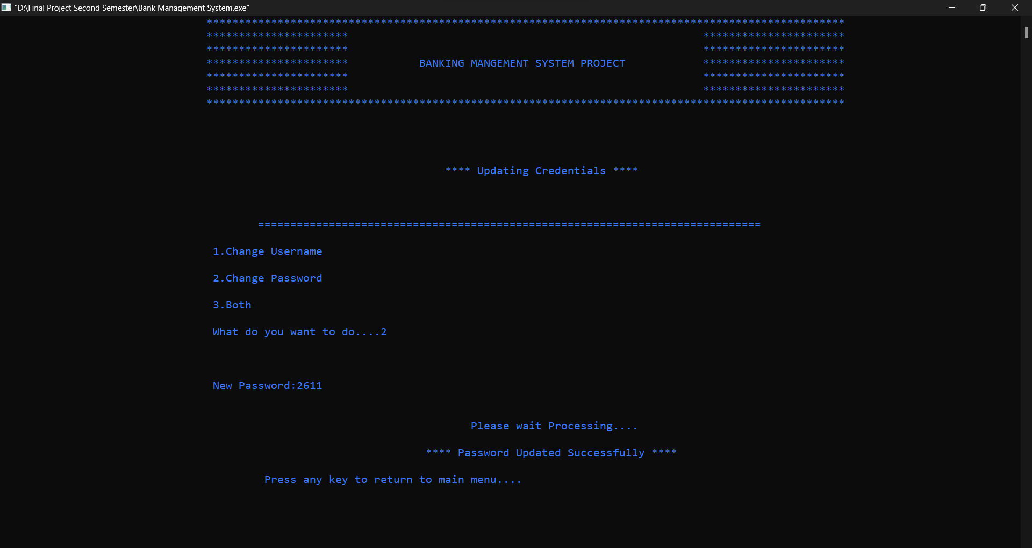

Fig: 55 Update_Login_Credentials_Password(Positive)

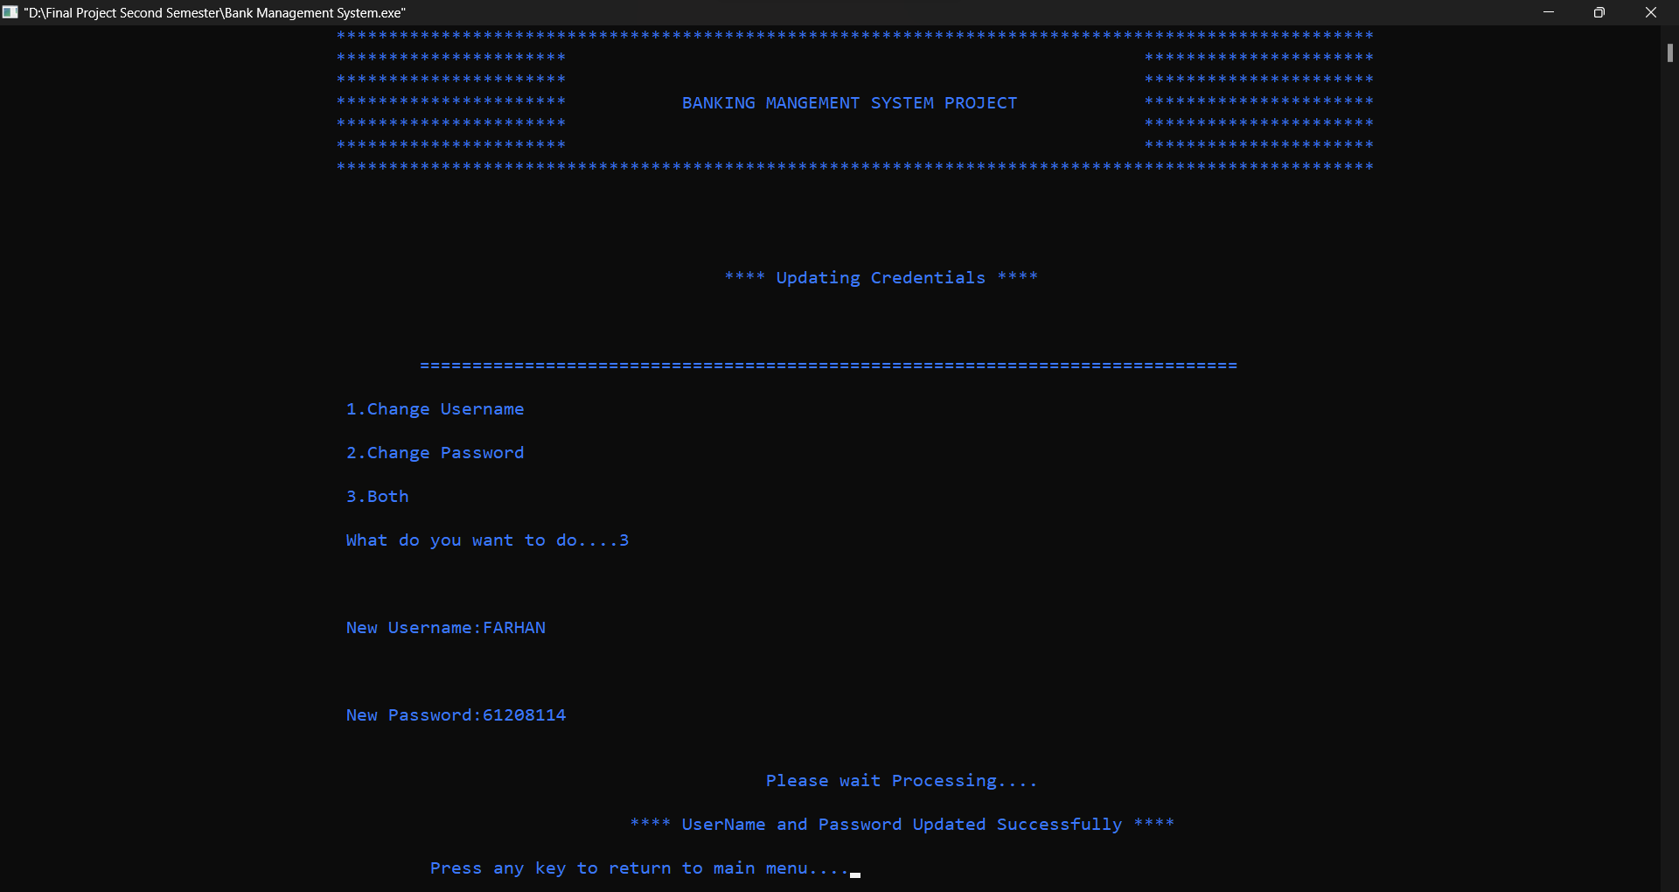

Fig: 56 Update_Login_Credentials_UserName&Password(Positive)

Negative Results:

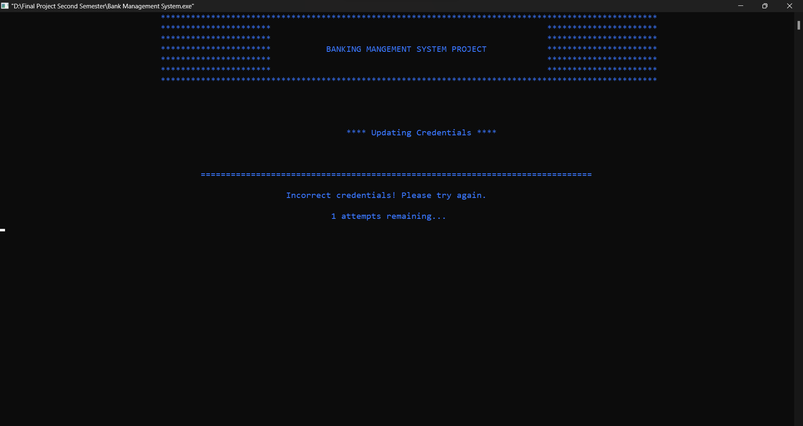

Fig: 57 Update_Login_Credentials(Negative)

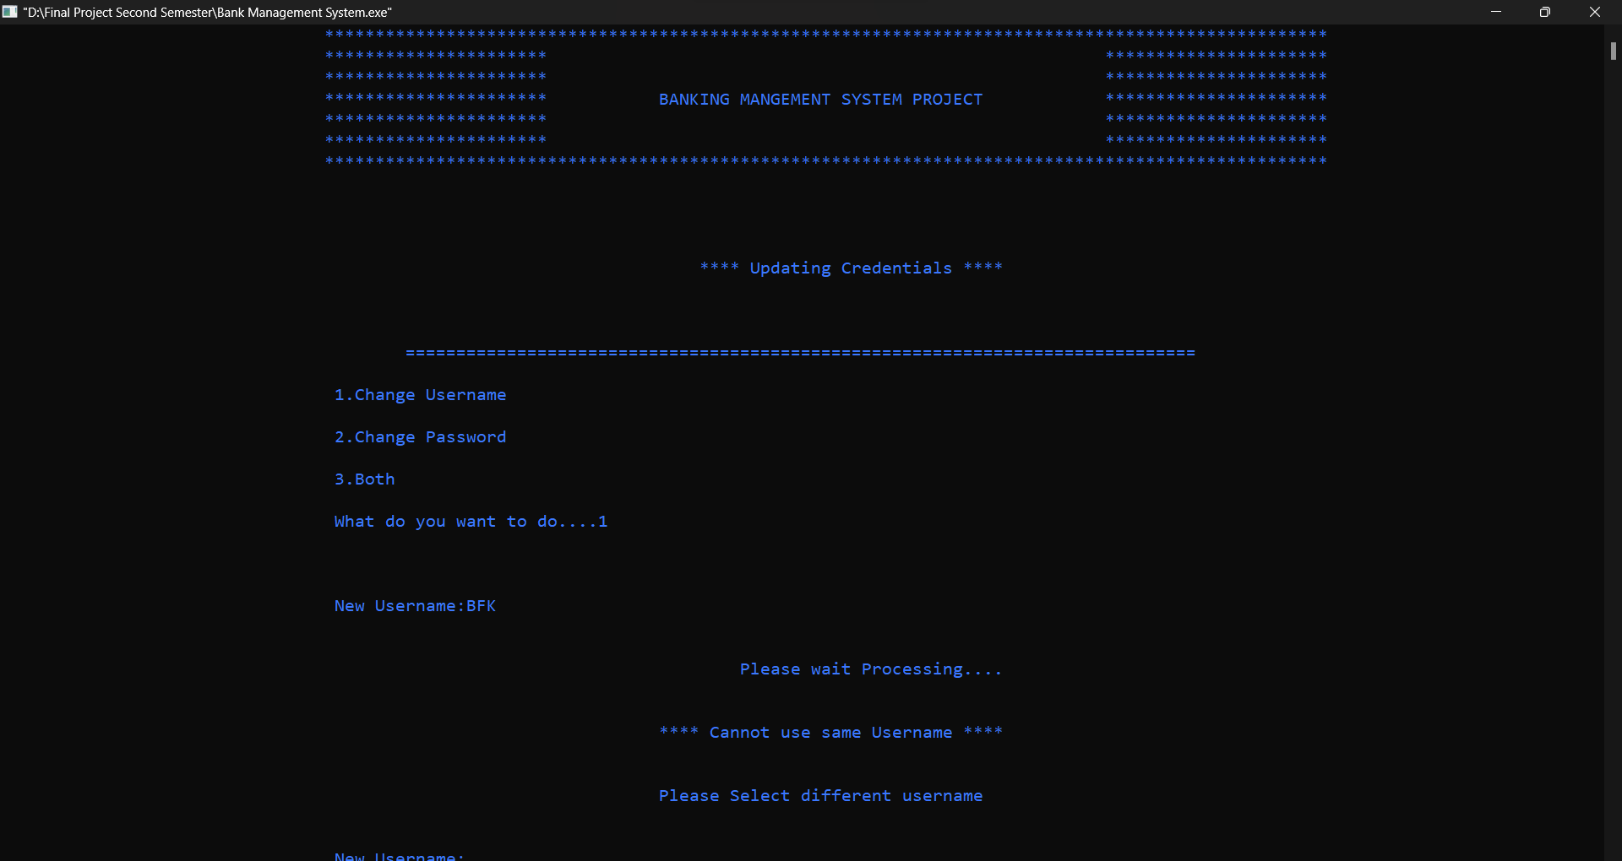

Fig: 58 Update_Login_Credentials_UserName(Negative)

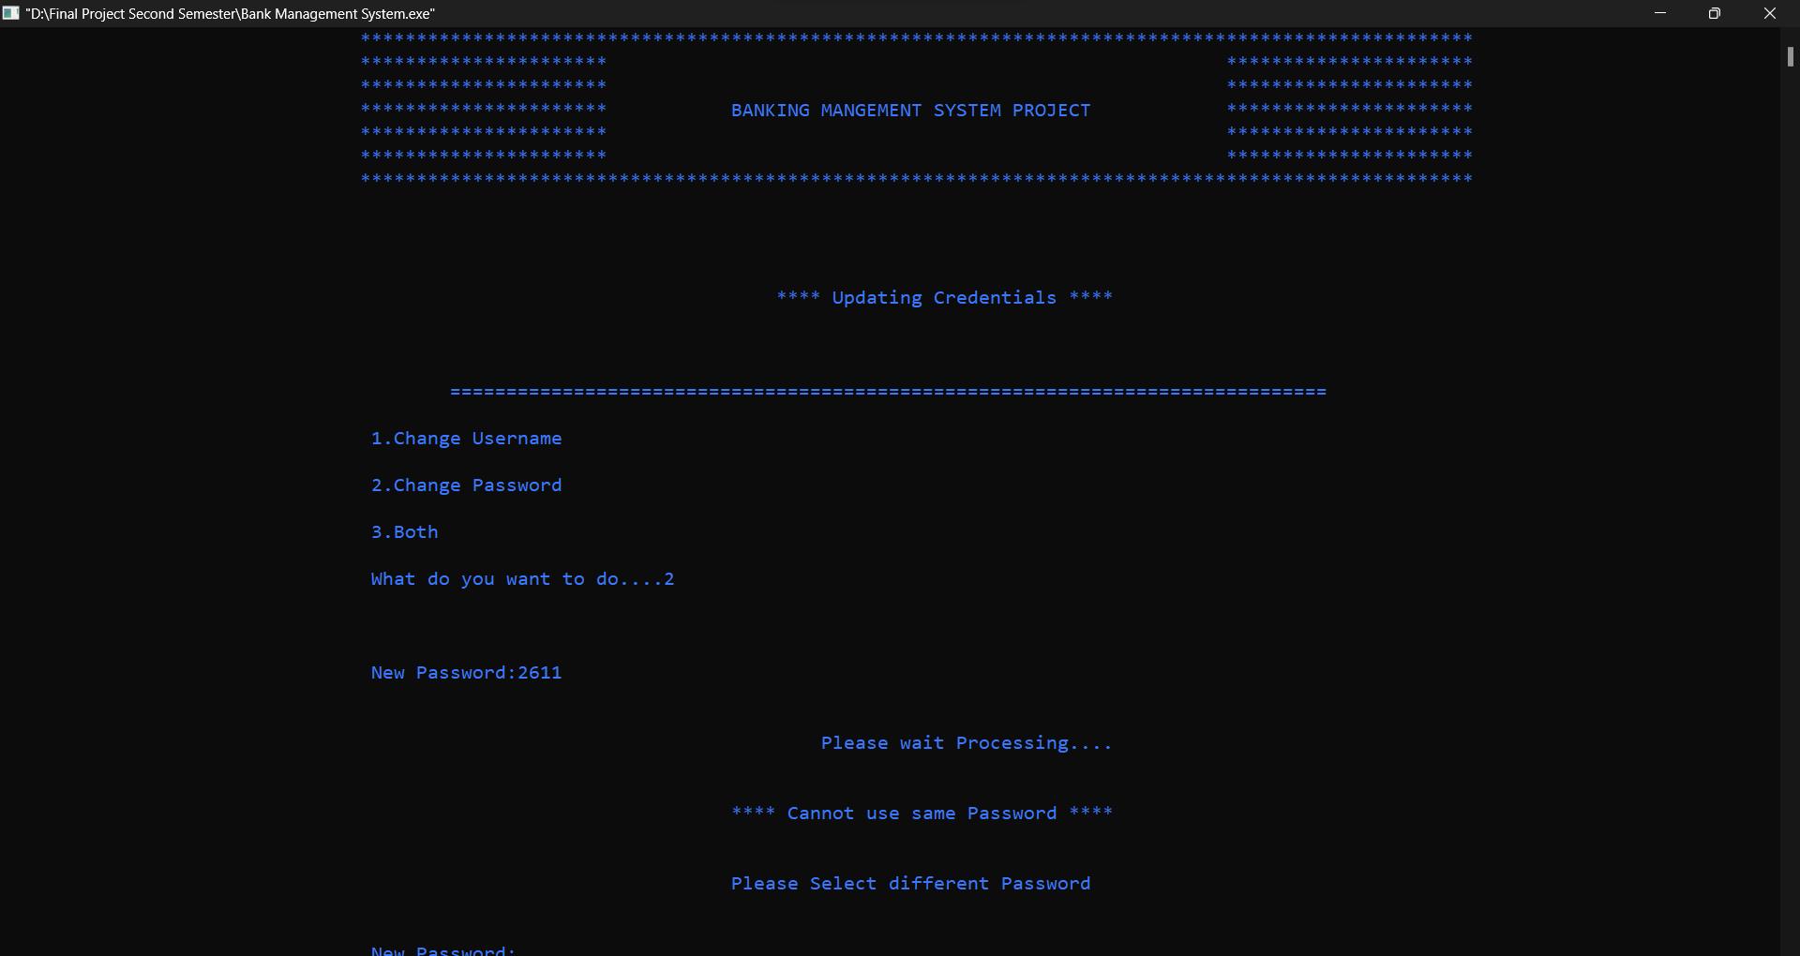

Fig: 59 Update_Login_Credentials_Password(Negative)

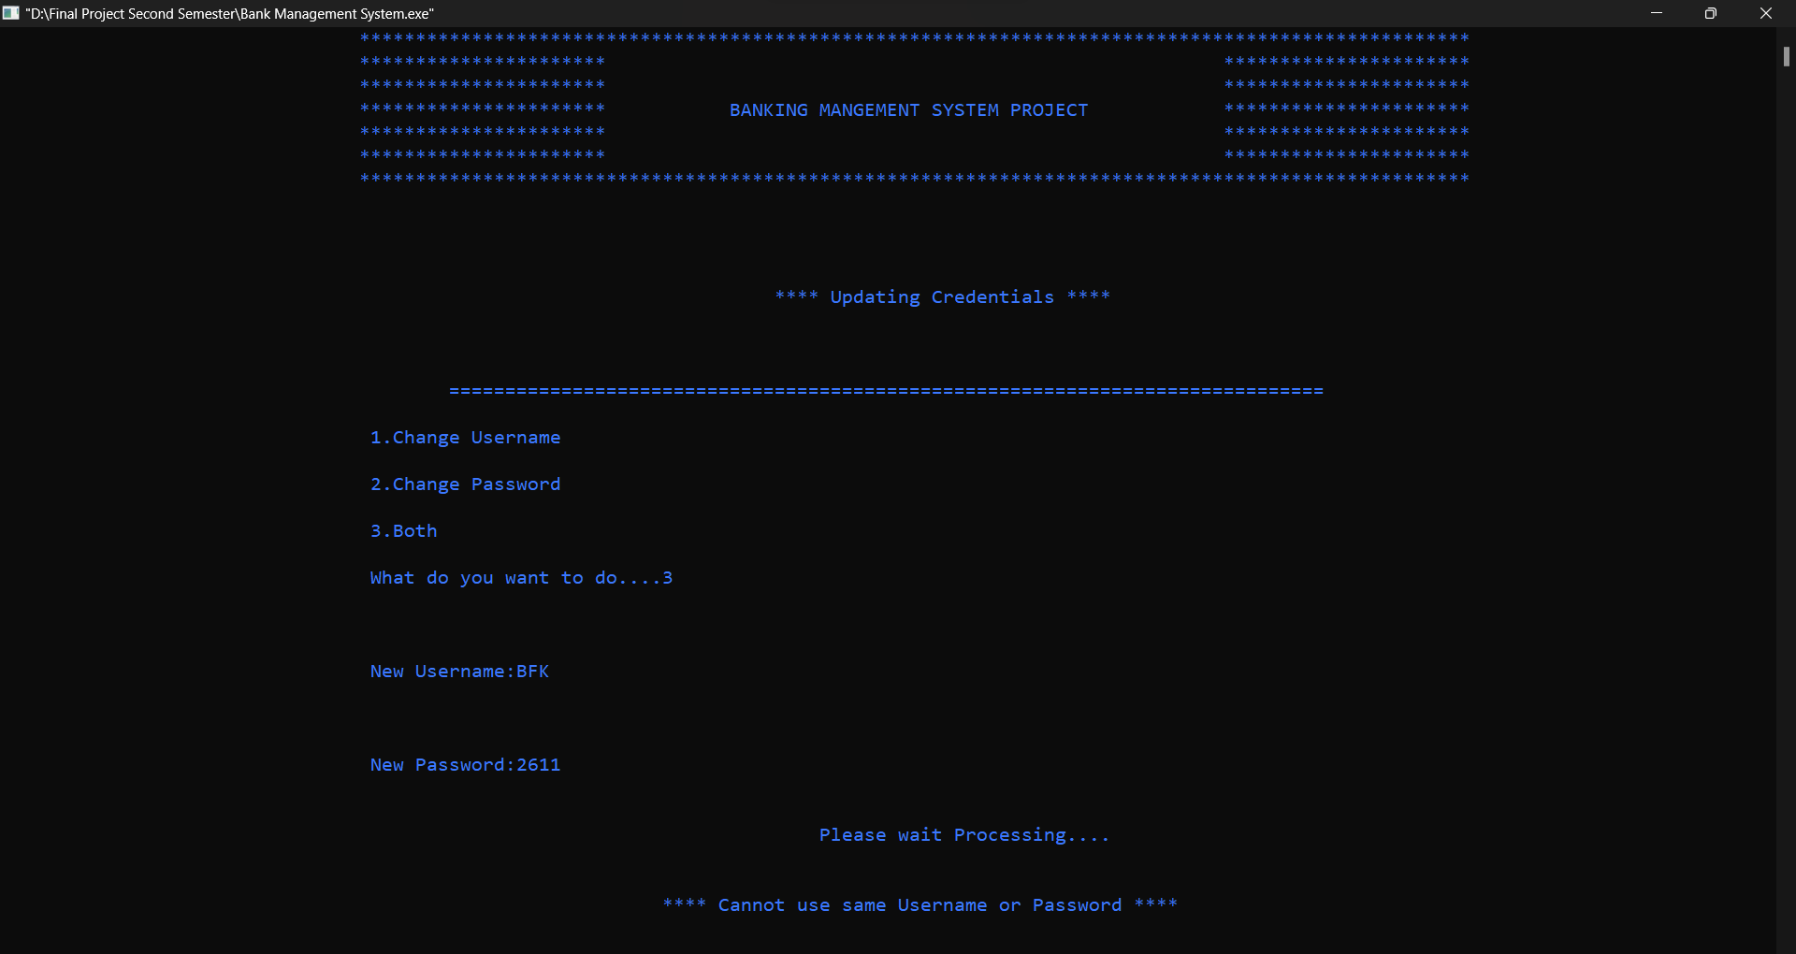

Fig: 60 Update_Login_Credentials_UserName&Password(Negative)

10.Close_app Module

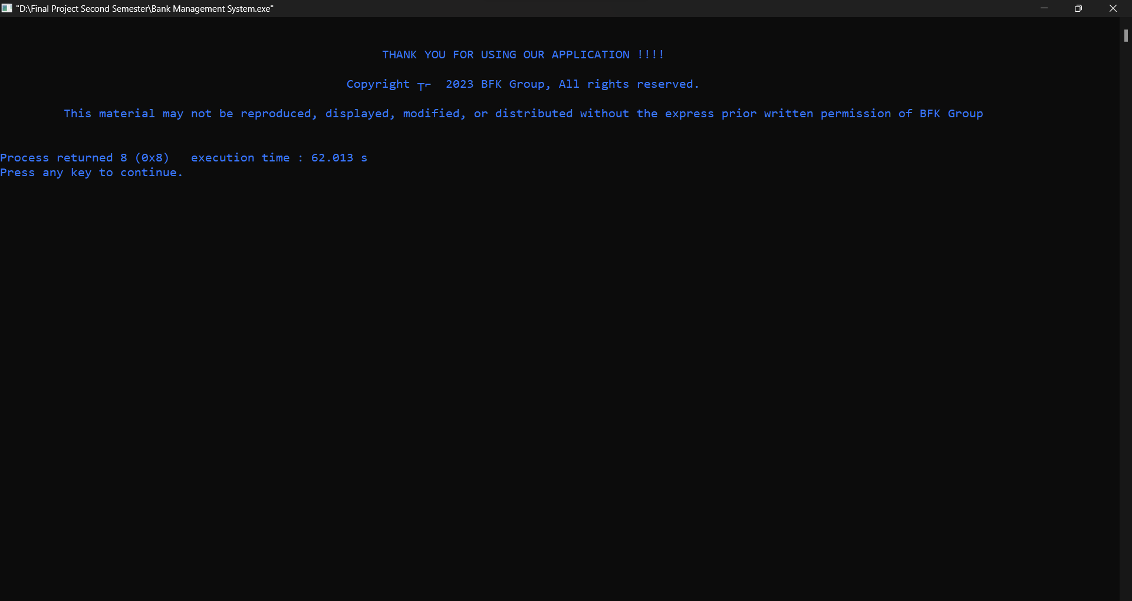

Fig: 61 Close_app Module

# Chapter 6: Conclusion and Recommendation

## 6.1 Conclusion:

The bank management system project aims to modernize and improve traditional banking operations through comprehensive automation, robust security measures, and an intuitive user interface. Its main achievement is automating essential functions such as creating, updating and deleting accounts, reducing administrative burden and allowing employees to focus on value-added tasks. Implementing one-time password (OTP) during login greatly improves security by generating unique OTPs for each login, protecting against unauthorized access and fraud. The project allows users to perform transactions such as deposits and transfers, with real-time tracking for accurate financial insights. User experience is prioritized through visual enhancements, creating attractive and user-friendly interfaces. Although the provided code shows progress, the overall impact of the project depends on the integration of all components to achieve the project's transformation goals. It strives to connect traditional banking operations with modern technology, improve customer interactions and redefine the banking landscape.

**Achievements and Contributions:**

**Automate core functions:**

The project has successfully automated key banking functions such as creating, updating and deleting accounts. This achievement has significantly reduced the administrative burden on bankers, allowing them to redirect their efforts towards value-added tasks.

**Advanced security measures:**

The implementation of a single-use password (OTP) mechanism at login has greatly improved security. Unique OTPs generated for each login protect against unauthorized access and fraud, contributing to a safer banking environment for customers.

**User Authorization:**

The project allows users to make transactions such as deposits and transfers through the system. This accountability promotes financial independence and convenience for customers.

**Improved user experience:**

Intuitive improvements to the user interface have created an engaging and user-friendly environment for customers. This contributes to an overall positive user experience. Purpose and objectives of the meeting:

The project has largely achieved its original purpose and goals. It has succeeded in automating essential functions, tightening security, empowering users and improving user experience. The integration of these elements has contributed to the transformational goal of connecting traditional banking operations with modern technology. However, there may be areas where the project's impact could be further optimized.

**The major key results and findings of the project are:**

* **Efficiency**: Automation of account-related functions led to reduced administrative workload and improved operational efficiency.
* **Security**: The OTP mechanism enhanced security, safeguarding against unauthorized access and fraudulent activities.
* **Transparency**: Real-time transaction tracking enabled users to monitor their financial activities accurately and make informed decisions.
* **User Satisfaction**: The user interface enhancements resulted in an improved overall user experience, making interactions with the banking system more user-friendly and engaging.

**Potential areas for improvement and challenges:**

While the project has achieved significant milestones, there may still be challenges and areas for improvement to consider:

**Built-in Complexity:**

Successful integration of all components is critical to maximizing project impact. Challenges can arise during the rollout, requiring careful planning and execution.

**User acceptance:**

Ensuring that customers accept and adopt the new system may require change management strategies and customer education efforts.

**Current maintenance:**

To maintain the benefits of the project, regular updates and maintenance are required to keep up with changing security threats and user needs. Ability of extension:

As the banking system evolves, the project must be designed to handle the growing volume of transactions without compromising performance and security.

**Comment integration:**

Continuously collecting user feedback and incorporating improvements based on their suggestions can improve project effectiveness over time.

In a nutshell, the bank management system project embarks on a journey to modernize and transform traditional banking operations by harnessing the power of automation, cutting-edge security measures, and responsive design. user centered. The main achievement of the project lies in successfully automating critical functions, enhancing security through the implementation of a single password, empowering users in financial transactions and improving the user experience. user experience through a user-friendly interface.

## 6.2 Recommendations

1. Continuous user training:

Provide structured training sessions for bankers and customers to familiarize them with the features, functions and benefits of the new system. Consider creating how-to videos, user guides, and FAQs for lasting reference.

1. User-centric testing:

Perform usability testing with a diverse set of users to identify areas of the system that can cause confusion or frustration. Incorporate user feedback to refine the user interface and optimize the user journey.

1. Multi-channel support:

Realize that different users prefer different channels to interact with the bank. Develop mobile apps, web interfaces and even voice interfaces to meet different user preferences and needs.

1. Powerful security audits:

Regularly perform comprehensive security testing using external security experts to identify vulnerabilities. Penetration testing and vulnerability assessment should be performed to ensure customer data is safe.

# References

## Book References

Bhandari, Hari Prasad. Programming Logics and Techniques, Gaindakot, Oxford College of Engineering and Management(OCEM), Quality Press

Boden, A. (2020). Banking on it how I disrupted an industry. Penguin Books Ltd.

Heffernan, S. A. (2012). Modern banking. Wiley.

## Web Reference

Bank: Meaning, characteristics, features, functions. iEduNote. (2023, August 30). https://www.iedunote.com/bank-meaning-characteristics-features-functions

Barone, A. (n.d.),Everything about banks. Investopedia,(2023, August 30). https://www.investopedia.com/terms/b/bank.asp#toc-what-is-a-bank